FSD-DWH-RET-001 · Version 0.2 · Draft for Review
Functional Specification Document
Data Warehouse Data Retention and Archiving using Azure Data Factory
Document ID | FSD-DWH-RET-001 (proposed)
Version | 0.2
Status | Draft for Review
Date | 30 October 2026
Source BRD | BRD-DWH-RET-001 v0.1
Prepared by | TBD
Approval status | Not approved
Table of Contents
Glossary and References 8
Acronyms 8
Business Terms 8
Technical Terms Introduced by this FSD 9
1. Document Information 10
2. Document Control 11
2.1 Revision History 11
2.2 Review History 11
2.3 Approval History 11
2.4 Distribution List 12
2.5 Document Conventions 12
3. Introduction 13
3.1 Purpose of the Document 13
3.2 Objectives 13
3.3 Intended Audience 13
3.4 Document Scope 13
3.5 Relationship Between BRD and FSD 13
3.6 Project Decisions Incorporated 14
3.7 Deviations Requiring BRD Alignment 14
4. Business Context and Requirements Overview 16
4.1 Business Background 16
4.2 Business Objectives 16
4.3 Business Requirements Summary 16
4.4 Business Process Overview 17
4.5 Business Constraints 17
4.6 Assumptions and Dependencies 17
5. Scope 18
5.1 In-Scope Functionalities 18
5.2 Out-of-Scope Functionalities 18
5.3 System Boundaries 19
5.4 Upstream and Downstream Systems 19
5.5 External Dependencies 19
6. Solution Overview 20
6.1 Solution Summary 20
6.2 System Context 20
6.3 Component Interaction 21
6.4 Data Flow 22
6.5 High-Level Process Flow 22
6.6 Key Design Decisions Summary 22
7. Functional Requirements 23
7.1 Functional Requirements Overview 23
7.2 Functional Requirement Specifications 23
8. Detailed Functional Design 39
8.1 PRC-01 Table Onboarding 39
8.2 PRC-02 Initial Cut-off Run 40
8.3 PRC-03 Daily Routine 42
8.4 Table Rebuild Procedure (part of PRC-02) 43
8.5 PRC-04 Expired Archive File Deletion 45
8.6 PRC-05 Rerun and Recovery 46
8.7 PRC-06 Configuration Change 47
8.8 PRC-07 Parent-Dated Processing of Child Tables 48
9. Business Rules 50
9.1 Business Rules from the BRD 50
9.2 Derived Business Rules (Require Confirmation) 51
10. Data Requirements and Data Processing 52
10.1 Data Sources and Source Data Objects 52
10.2 Required Attributes 52
10.3 Data Selection and Filtering Rules 52
10.4 Cut-off Date Calculation Examples 53
10.5 Data Validation 53
10.6 Physical Data Design – Schema ret 54
10.7 Functions, Triggers and Stored Procedures 60
10.8 Data Transformation, Retention and Deletion Rules 61
10.9 Data Reconciliation and Data Quality Controls 62
10.10 Data Lineage 62
10.11 Processing Frequency and Expected Data Volume 62
11. Interface and Integration Specifications 63
12. Processing Flow and Sequence Diagrams 65
12.1 Daily Routine – Sequence Diagram 65
12.2 Initial Cut-off Status – State Diagram 66
12.3 Restart and Recovery – Decision Flow 67
13. Error Handling and Recovery 68
13.1 Error Categories and Codes 68
13.2 Error Detection 68
13.3 Error Logging 69
13.4 Retry Rules 69
13.5 Partial Failure Scenarios 69
13.6 Duplicate Processing Prevention 69
13.7 Restart and Rerun Behaviour 70
13.8 Operational Escalation 70
14. Non-Functional Requirements 71
14.1 Additional Quality Attributes 71
15. Security and Audit Requirements 72
16. Scheduling and Operational Requirements 73
16.1 Execution Schedule 73
16.2 Daily Routine Activation 73
16.3 Processing Dependencies and Execution Order 73
16.4 Monitoring 73
16.5 Operational Alerts 73
16.6 Manual Intervention 73
16.7 Rerun Procedure 74
16.8 Stale Run Handling 74
16.9 Operational Responsibilities 74
16.10 Project Deliverables Related to Operations 74
19. Assumptions, Constraints, Dependencies, and Open Questions 75
19.1 Assumptions 75
19.2 Technical Constraints 75
19.3 Dependencies 75
19.4 Open Questions 76
19.5 Decisions Required 78
19.6 Risks and Potential Impacts 79

List of Figures
Figure 1 – System context 20
Figure 2 – Component interaction 21
Figure 3 – High-level data flow by segment 22
Figure 4 – Initial Cut-off Run – functional process flow per table 40
Figure 5 – Daily Routine – functional process flow per table 42
Figure 6 – Table rebuild – sequence 44
Figure 7 – Expired archive deletion – hierarchical traversal (example archive cut-off 2018-10-27) 46
Figure 8 – Parent-dated processing of a child table and its header table 48
Figure 9 – Daily Routine – sequence of calls for one run 65
Figure 10 – Initial Cut-off status lifecycle per table 66
Figure 11 – Restart and recovery decision flow 67

List of Tables
Table 1 – Acronyms 8
Table 2 – Key business terms 8
Table 3 – Technical terms 9
Table 6 – Document information 10
Table 7 – Revision history 11
Table 8 – Review history 11
Table 9 – Approval history 11
Table 10 – Distribution list 12
Table 11 – Document conventions 12
Table 12 – Source documents and hierarchy 14
Table 13 – Project decisions 14
Table 14 – Deviations requiring BRD alignment 15
Table 15 – Business objectives and FSD coverage 16
Table 16 – Business requirements summary 17
Table 17 – Data lifecycle segments (BRD 4.3) 17
Table 18 – Business constraints 17
Table 19 – In-scope functionalities 18
Table 20 – Out-of-scope functionalities 18
Table 21 – System boundaries 19
Table 22 – Upstream and downstream systems 19
Table 23 – Solution components 21
Table 24 – Key design decisions 22
Table 25 – Functional requirements overview 23
Table 26 – FR-001 – Retention Configuration Table 24
Table 27 – FR-002 – Configuration and Metadata Validation 25
Table 28 – FR-003 – Run Date and Cut-off Date Calculation 25
Table 29 – FR-004 – Table Selection for Processing 26
Table 30 – FR-005 – Eligible Data Identification 27
Table 31 – FR-006 – Archive Export to Parquet 28
Table 32 – FR-007 – Archive Storage Organisation and Naming 28
Table 33 – FR-008 – Archive Row-Count Validation 29
Table 34 – FR-009 – Batch Delete 30
Table 35 – FR-010 – Table Rebuild (Initial Cut-off Run Only) 30
Table 36 – FR-011 – Initial Cut-off Run Orchestration 31
Table 37 – FR-012 – Daily Routine Orchestration 31
Table 38 – FR-013 – Expired Archive File Deletion 32
Table 39 – FR-014 – Execution Logging 33
Table 40 – FR-015 – Log-Based Monitoring Support 33
Table 41 – FR-016 – Concurrency Control 34
Table 42 – FR-017 – Restart, Rerun and Resume 34
Table 43 – FR-018 – Cleanup of Archive Files from Failed Runs 35
Table 44 – FR-019 – Execution Window Control for the Initial Cut-off Run 35
Table 45 – FR-020 – Initial Cut-off Status and Daily Routine Activation 36
Table 46 – FR-021 – Retention Logic as Stored Procedures and Scripts in Schema ret 37
Table 47 – FR-022 – Table Analysis Support 37
Table 48 – FR-023 – Parent-Dated Retention of Child Tables 38
Table 49 – PRC-01 Table Onboarding – process specification 39
Table 50 – PRC-02 Initial Cut-off Run – process specification 41
Table 51 – PRC-03 Daily Routine – process specification 43
Table 52 – Table rebuild steps 45
Table 53 – PRC-04 Expired Archive File Deletion – process specification 45
Table 54 – PRC-05 Rerun and Recovery – process specification 47
Table 55 – Configuration change behaviour 47
Table 56 – PRC-07 Parent-Dated Processing of Child Tables – process specification 49
Table 57 – Business rules from the BRD 50
Table 58 – Derived business rules 51
Table 59 – Classification of candidate tables 52
Table 60 – Selection predicates 53
Table 61 – Cut-off date examples (3 + 5 years) 53
Table 62 – Validation checks 53
Table 63 – Schema ret tables (design table) 54
Table 64 – ret.RetentionConfig columns 54
Table 65 – ret.RetentionTableStatus columns 55
Table 66 – ret.RetentionParameter columns 55
Table 67 – ret.RetentionRunLog columns 56
Table 68 – ret.RetentionTableLog columns 57
Table 69 – ret.RetentionArchiveDate columns 58
Table 70 – ret.RetentionStepLog columns 58
Table 71 – ret.RetentionTableLock columns 58
Table 72 – ret.RetentionErrorCode columns 59
Table 73 – Mapping of BRD 7.4 attributes to log columns 59
Table 74 – Design table changes required 60
Table 75 – ret.RetentionParentKey columns (proposed) 60
Table 76 – Triggers (design table) 60
Table 77 – Functions (design table) 61
Table 78 – Stored procedures (proposed names) 61
Table 79 – Reconciliation controls 62
Table 80 – Interface specifications 63
Table 81 – Manual interfaces 63
Table 82 – Archive storage settings (recommended) 64
Table 83 – Error categories and codes 68
Table 84 – Retry rules 69
Table 85 – Partial failure scenarios 69
Table 86 – Non-functional requirements 71
Table 87 – Additional quality attributes 71
Table 88 – Security and audit requirements 72
Table 89 – Execution schedule 73
Table 90 – Manual intervention activities 74
Table 91 – Operations-related project deliverables 74
Table 98 – Assumptions 75
Table 99 – Dependencies 76
Table 100 – Open questions 78
Table 101 – Decisions required 79
Table 102 – Additional FSD risks 80

Glossary and References
This section defines the abbreviations and terms used in this document and lists the documents it is based on. Business terms defined in the BRD glossary are used with the same meaning.

Acronyms
Acronym | Meaning
ADF | Azure Data Factory
BRD | Business Requirements Document
CDC | Change Data Capture
DBA | Database Administrator
DDL | Data Definition Language
DR | Daily Routine
DWH | Data Warehouse: the database on Azure SQL Database that is subject to retention
ETL | Extract, Transform and Load
FK / PK | Foreign key / primary key
FSD | Functional Specification Document
IC | Initial Cut-off Run
IR | Integration Runtime
PITR | Point-in-time restore (Azure SQL Database automated backups)
RTM | Requirements Traceability Matrix
SLA | Service Level Agreement
SP | Stored procedure
TBC / TBD | To Be Confirmed / To Be Determined
UTC | Coordinated Universal Time
Table 1 – Acronyms

Business Terms
The following BRD terms are used unchanged: Active flag, Agreed baseline, Archive, Archive cut-off date, Archived segment, Batch delete, Business date, Configuration table, Daily Routine, DWH cut-off date, Execution log, Expired segment, Hypercare, Initial Cut-off Run, Integration Runtime, Parquet, Retained segment, Retention column, Retention period, Rolling window, Row-count validation, Run date, Schema ret, Stored procedure, Table rebuild, Technical assessment. The key definitions for this FSD are repeated below.
Term | Definition (BRD glossary)
DWH cut-off date | Run date minus the DWH retention period (default three years). Data with a business date before this date leaves the DWH.
Archive cut-off date | Run date minus the total retention period (default eight years). Data and archive files with a business date before this date are removed.
Retention period | DWH retention period (default three years) and total retention period covering the DWH and the archive (default eight years: three years in the DWH and five years in Azure Blob Storage).
Run date | The current date in UTC+7 at the time of execution.
Schema ret | The schema in the DWH database that holds the configuration table, log tables and stored procedures of the retention solution.
Table 2 – Key business terms

Technical Terms Introduced by this FSD
Term | Definition
Archive file | Parquet file holding the rows of one table for one business date, written by one run (FR-007).
Blob retention (years) | Years kept in Azure Blob Storage after the DWH period (default 5). Total retention = DWH retention + blob retention.
Export unit | Export of one table for one business date by one ADF Copy activity.
Initial Cut-off status | System-maintained state of a table: PENDING, RUNNING, FAILED, STOPPED or COMPLETED (FR-020).
New table | During a table rebuild, the table created with the definition of the original table and loaded with the retained rows (Section 8.4).
Child table | A table without its own business date column whose rows are dated through a join to its header table (FR-023). Also called parent-dated table.
Header table | The table that holds the business date for a child table (parent table). It must have its own retention column.
Orphan child row | A child row without a matching header row. It has no business date, is never removed by the retention process and is reported as a warning (DBR-21).
Pending resume | State in which an earlier run validated a range but did not complete its deletion (FR-017).
Pre-delete recount | Recount of DWH rows in the validated range immediately before data is removed (DBR-06).
RunId | Unique identifier of an execution in ret.RetentionRunLog; used in archive file names.
Snapshot | Per business date row counts recorded in ret.RetentionArchiveDate before export; the validation baseline (FR-005).
Table processing lock | Row in ret.RetentionTableLock that ensures only one run processes a table at a time (FR-016).
Validated range | Business-date range whose archive passed validation and whose rows may be removed from the DWH.
Table 3 – Technical terms

1. Document Information
Document Title | Functional Specification Document – Data Warehouse Data Retention and Archiving using Azure Data Factory
Document ID | FSD-DWH-RET-001 (proposed; aligned with BRD-DWH-RET-001)
Project Name | Data Warehouse Data Retention and Archiving using Azure Data Factory
Document Version | 0.2
Document Status | Draft for Review
Approval Status | Not approved. No review or approval evidence exists for this version.
Author | TBD. BRD Section 3 assigns preparation of the FSD to the Solution Architect / Data Engineer role (Agus Laksono). The author of this version is to be recorded by document control.
Reviewer | TBD
Approver | TBD
Creation Date | 29 October 2026
Last Updated Date | 30 October 2026
Source BRD | BRD-DWH-RET-001 v0.1, 29 October 2026, Draft for Review (REF-01). Its approval status is inconsistent (OQ-01).
Other sources | Design table workbook (REF-02), List Table DWH workbook (REF-03), project decisions MD-01 to MD-07 (REF-04).
Table 6 – Document information

2. Document Control

2.1 Revision History
Version | Date | Author | Description
0.1 | 29 October 2026 | TBD | Re-baselined FSD. Replaces the previous FSD file (REF-06), which was based on BRD v0.5. Aligned with BRD v0.1 (Azure SQL Database, schema ret, retention 3 + 5 = 8 years), with the physical design in the design table workbook, with the DWH table list, and with meeting decisions MD-01 to MD-04 (new table rebuild sequence). Changes are listed in Appendix B.
0.2 | 30 October 2026 | TBD | Incorporates project decisions MD-05 to MD-07: retention of child tables through their header table (new FR-023, ret.RetentionParentKey, V-10, V-11, DBR-18 to DBR-21); original table truncated and dropped in the table rebuild; archive layout year=/month=/day= with ArchiveContainer holding the container name only. Design table changes listed in Section 10.6.11. Changes are listed in Appendix B.2.
Table 7 – Revision history

2.2 Review History
Version | Review date | Reviewer | Role | Outcome / comments
0.1 | TBD | TBD | TBD | No review has been performed yet.
Table 8 – Review history

2.3 Approval History
Role | Name | Signature | Date | Decision
Business / Data Owner | TBD |  |  | Pending
Project Sponsor | TBD |  |  | Pending
Database Administrator | TBD |  |  | Pending
Solution Architect / Lead Data Engineer | TBD |  |  | Pending
Table 9 – Approval history
The approver roles mirror the approval roles of the BRD. Names are TBD because no approval of this FSD has been given. The BRD names Agus Laksono for all four roles; whether the same person approves the FSD is to be confirmed (OQ-02).

2.4 Distribution List
Role (BRD Section 3) | Purpose of distribution
Business / Data Owner | Review of business rules, retention behaviour, in-scope tables and acceptance criteria.
Project Sponsor | Approval of the FSD baseline.
Business Analyst | Traceability maintenance.
Solution Architect / Data Engineer | Design owner; implementation basis.
Database Administrator | Review of deletion, table rebuild, security and capacity on Azure SQL Database.
ETL / Reporting Team | Review of scheduling, downtime and impact.
Infrastructure Team | Review of dependencies D-01 and D-02 and of the security model.
Operations / Support Team | Review of logging, monitoring and rerun procedures.
QA / Test Team | Basis for test design (role not listed in the BRD; included as intended audience).
Table 10 – Distribution list

2.5 Document Conventions
Item | Meaning
FR-nnn | Functional requirement defined in this FSD.
PRC-nn / RB-nn | Functional process (Section 8) / step of the table rebuild (Section 8.4).
BR-nn | Business rule taken from the BRD (identifier unchanged).
DBR-nn | Derived business rule introduced by this FSD; requires confirmation.
MD-nn | Meeting decision (Section 3.6).
DV-nn | Deviation of the design from the BRD text; requires a BRD update or change request (Section 3.7).
V-nn | Validation check performed before processing (FR-002).
ERR-XXX-nn | Error code (Section 13).
PL-nn | Logical ADF pipeline (physical names TBD).
INT-nn / SEC-nn / TS-nnn | Interface / security requirement / test scenario.
OQ-nn / DEC-nn | Open question / decision required (Section 19).
ASM-nn / RSK-nn | FSD assumption / FSD risk (in addition to BRD A-nn and R-nn).
[BRD] | Content stated explicitly in the BRD.
[MD] | Content based on a meeting decision.
[DSN] | Content taken from the design table workbook (REF-02).
[DER] | Design detail derived from a requirement; requires review.
[REC] | Technical recommendation; requires approval before it becomes a requirement.
TBD / TBC | To Be Determined (value not available) / To Be Confirmed (proposed value requiring confirmation).
Table 11 – Document conventions
Dates are written as DD Month YYYY, or YYYY-MM-DD in technical content. All times are UTC+7 unless stated otherwise; 21:00 corresponds to the BRD notation 09:00 PM and 05:00 to 05:00 AM. Physical object names in schema ret are taken from the design table workbook; stored procedure names are proposals from REF-05.

3. Introduction

3.1 Purpose of the Document
This document translates the business requirements of BRD-DWH-RET-001 v0.1 into functional specifications for the automated, configuration-driven data retention and archiving solution of the Data Warehouse (DWH) on Azure SQL Database. It defines the functional behaviour, processing logic, data design, error handling, logging, security, scheduling, test scenarios and traceability that the development, database, data engineering, QA and operations teams need to build, verify and operate the solution.

3.2 Objectives
- Specify each functional requirement with a unique identifier, processing logic and testable acceptance criteria.
- Describe the Initial Cut-off Run, including the table rebuild sequence agreed in the latest meeting, and the Daily Routine as separate processes with their exception paths.
- Document the physical design of the schema ret objects from the design table workbook and the decisions that are still open.
- Assess the candidate in-scope tables from the DWH table list against the BRD rules.
- Separate what the BRD and the meeting decisions state from what this FSD derives or recommends.
- Provide traceability from BRD requirements to functional requirements, processes, business rules and test scenarios.

3.3 Intended Audience
Solution architects, data engineers, database engineers and DBAs, QA and test analysts, the operations and support team, the ETL and reporting team, the infrastructure team, and the business stakeholders who review and approve the specification (Section 2.4).

3.4 Document Scope
This FSD covers configuration, table onboarding, the Initial Cut-off Run (batch delete and table rebuild), the Daily Routine, archive export and validation, deletion of expired archive files, logging and log-based monitoring, and the related non-functional, security, operational and testing requirements. Infrastructure provisioning, alerting and reporting changes are outside scope, consistent with BRD Section 2.2.

3.5 Relationship Between BRD and FSD
The BRD is the primary source of business needs and scope. Each functional requirement references the BRD items it implements. Where the BRD does not define a detail needed to build or test a requirement, this FSD proposes one and marks it [DER] or [REC]; such items are not approved until the related decision in Section 19 is closed. Where the design table workbook or the meeting decisions differ from the BRD text, the difference is recorded as a deviation (Section 3.7) and is not resolved silently.
Source | Hierarchy level | Use in this FSD
Meeting decisions MD-01 to MD-04 | Level 1 once formally recorded (OQ-02); until then treated as the latest stakeholder decisions | MD-01 to MD-03 are already reflected in BRD v0.1. MD-04 defines the table rebuild sequence (FR-010).
BRD-DWH-RET-001 v0.1 | Level 3 (approval to be confirmed, OQ-01) | Primary source of requirements, rules, scope and acceptance criteria.
Design table workbook | Level 4–5 (draft technical design) | Physical names and attributes of schema ret objects.
List Table DWH workbook | Level 5 (draft analysis) | Candidate in-scope tables and proposed retention columns.
DB objects script v0.3 | Level 5 (draft, not executed) | Proposed stored procedure names and call contract.
Table 12 – Source documents and hierarchy

3.6 Project Decisions Incorporated
MD-01 to MD-04 come from the latest project meeting and were communicated on 29 October 2026. MD-05 to MD-07 were communicated on 30 October 2026 as decisions on the options proposed in FSD v0.1. Formal minutes are to be recorded (OQ-02).
ID | Decision | Effect on this FSD | BRD status
MD-01 | The DWH database is on Azure SQL Database. | Platform C-01; server time is UTC, so UTC+7 is computed explicitly (FR-003); no cross-database processing. | Reflected (BRD 1.2, C-01).
MD-02 | Retention tables and stored procedures are created in the same database as the DWH tables and are separated only by schema name ret. | All objects in schema ret (Section 10.6); configuration needs no database selection (DV-01). | Reflected (C-05); TBC-11 can be closed (OQ-28).
MD-03 | Retention is 3 years in the DWH plus 5 years in Azure Blob Storage, 8 years in total. | Archive cut-off = run date − 8 years; configuration stores DWH years and blob years (DV-02). | Reflected (BR-02, A-01).
MD-04 | Table rebuild: (1) insert rows of the last 3 years from the old table into a new table; (2) add the primary key and constraints copied from the old table to the new table; (3) archive rows between 3 and 8 years old from the old table to Azure Blob Storage; (4) truncate the old table; (5) rename the new table to the old table name. | Defines FR-010 and Section 8.4. This FSD adds validation and control steps required by BR-08 and the platform, listed in Section 8.4 and requiring approval (DEC-13, DEC-14). | Refines BRQ-09 and IC-02 to IC-04; BRD text to be aligned (OQ-02).
MD-05 | Child tables without their own date column are retained through their header table (option A of OQ-03): the business date of a child row is the date of its header row, found through configured join keys. | New FR-023, ret.RetentionParentKey, checks V-10 and V-11, rules DBR-18 to DBR-21, processing order child before header. | Not in BRD; change request required (DV-04, OQ-32).
MD-06 | In the table rebuild, the original table is truncated and then dropped (option A of DEC-08). | Section 8.4 RB-08; KeepRebuildStagingTable no longer needed. | Within BRQ-09.
MD-07 | Archive layout <BlobPath>/year=YYYY/month=MM/day=DD/; ArchiveContainer holds only the container name; BlobPath is <schema>/<table> in lower case. | FR-007, FR-013, Section 10.6.11; container name still from D-02. | Within BRQ-06, BRQ-11.
Table 13 – Project decisions

3.7 Deviations Requiring BRD Alignment
ID | Topic | BRD text | Design / decision | Proposed handling
DV-01 | Database name attribute | BRD 7.3 lists “Database name” as a configuration attribute. | Design table omits the column: all tables are in the same database as schema ret (MD-02), and Azure SQL Database cannot process other databases. | Update BRD 7.3 and close TBC-11 (OQ-28).
DV-02 | Retention period attributes | BRD 7.3: “DWH retention (years)” and “Total retention (years)”, example 8 (3 + 5). | Design table stores DwhRetentionYears and BlobRetentionYears; total = sum, computed by ret.fn_GetCutoffDates. | Update BRD 7.3 wording or approve as change request (OQ-29). BR-02 is unchanged.
DV-03 | Table rebuild sequence | BRQ-09: rebuilt table replaces the original with the same definition; IC-02 to IC-04 order: archive, validate, remove. | MD-04: build the new table first, then archive from the old table, then truncate and rename. | Same outcome; FSD adds validation gates before truncation (DEC-14). Record in BRD 5.2 (OQ-02).
DV-04 | Retention column of child tables | BR-06: the retention column must be of a date type; BR-13: tables and retention columns are taken from the configuration table. Both assume a column of the table itself. | MD-05: a child table has no retention column of its own; it inherits the retention column of its configured header table. | Change request to amend BR-06, BR-13 and BRD 7.3, and to add a requirement for parent-dated retention (OQ-32).
Table 14 – Deviations requiring BRD alignment

4. Business Context and Requirements Overview

4.1 Business Background
The DWH runs on Azure SQL Database. Daily database backups are scheduled and none of the in-scope tables is partitioned (BRD 4.1). The Customer requires an automated mechanism that keeps the most recent three years of data in the DWH, keeps the following five years as Parquet files in Azure Blob Storage, and removes data older than eight years. The process is orchestrated by Azure Data Factory (ADF) and controlled through a central configuration table in schema ret of the DWH database, so that multiple tables are managed without code changes (BRD 1.2).
The DWH table list (REF-03) contains 422 tables in schemas BI, bos, sli and dbo with about 825 GB of allocated space. 102 tables have an entry in the retention column field; they account for about 777 GB (Appendix A).

4.2 Business Objectives
ID | Objective (BRD 1.3) | Primary FSD coverage
OBJ-01 | Keep only the most recent three years of data in the DWH, based on the business date. | FR-003, FR-009 to FR-012
OBJ-02 | Keep data more than three and up to eight years old as Parquet files in Azure Blob Storage. | FR-006 to FR-008, FR-013
OBJ-03 | Run retention and archiving automatically every day. | FR-012, FR-020
OBJ-04 | Manage retention for multiple tables through configuration rather than code. | FR-001, FR-002, FR-004
OBJ-05 | Delete data in a way that minimises impact on ETL and reporting workloads. | FR-009, FR-016, FR-019, Section 14
OBJ-06 | Record every execution in log tables for operational follow-up. | FR-014, FR-015
Table 15 – Business objectives and FSD coverage

4.3 Business Requirements Summary
BRD ID | Summary | FSD reference
BRQ-01 | Review and analyse business and technical requirements. | This FSD; FR-022
BRQ-02 | Analyse DWH tables; Customer users enter tables and retention columns in the configuration table. | FR-022, FR-001, Appendix A
BRQ-03 | Central configuration table in schema ret with the attributes of BRD 7.3. | FR-001, Section 10.6
BRQ-04 | Add, change or remove tables by configuration only. | FR-001, FR-004
BRQ-05 | Initial Cut-off Run per table. | FR-011, PRC-02
BRQ-06 | Export archived data to Parquet organised by table and date. | FR-006, FR-007
BRQ-07 | Row-count validation before deletion; no deletion on mismatch. | FR-008
BRQ-08 | Batch delete 10,000 rows with a 3-second pause, adjustable. | FR-009
BRQ-09 | Table rebuild for the Initial Cut-off Run with the same table definition. | FR-010, Section 8.4
BRQ-10 | Daily Routine by ADF schedule at 21:00 UTC+7. | FR-012
BRQ-11 | Daily Routine deletes Parquet files older than the archive cut-off date. | FR-013
BRQ-12 | Record each execution in log tables in schema ret. | FR-014
BRQ-13 | Log-based monitoring and troubleshooting. | FR-015
BRQ-14 | Retention logic in stored procedures and scripts in schema ret. | FR-021
BRQ-15 | Documentation (design, configuration, setup, operational guidance). | Section 16.10
BRQ-16 | Knowledge transfer to the operations team. | Section 16.10
BRQ-17 | Hypercare until 31 March 2027. | Section 16.10
Table 16 – Business requirements summary

4.4 Business Process Overview
- Table onboarding (BRD 5.1) – analysis of tables, technical assessment of size category and Initial Cut-off Run method, and entry of each in-scope table in the configuration table by Customer users.
- Initial Cut-off Run (BRD 5.2, IC-01 to IC-05) – executed once per table. Archives the archived segment (more than three and up to eight years old), validates the row count, then removes all data older than the DWH cut-off date, including expired data, by batch delete or table rebuild.
- Daily Routine (BRD 5.3, DR-01 to DR-06) – scheduled daily at 21:00 UTC+7. Exports newly eligible data, validates it, deletes it from the DWH by batch delete, and deletes expired Parquet files. It starts on the day after the Initial Cut-off Run has been completed for all in-scope tables of the initial implementation; a table added later is included from the day after its own Initial Cut-off Run.
Segment | Business date condition | Initial Cut-off Run | Daily Routine | Example, run date 27 Oct 2026
Retained | On or after the DWH cut-off date | Unchanged in the DWH | Unchanged in the DWH | 27 Oct 2023 onwards
Archived | On or after the archive cut-off date and before the DWH cut-off date | Exported, validated, removed from the DWH | Exported, validated, deleted from the DWH (normally one business date per day) | 27 Oct 2018 to 26 Oct 2023
Expired | Before the archive cut-off date | Removed from the DWH without archiving, only after the archived segment is validated (BR-08, BR-09) | Parquet files deleted from Azure Blob Storage (BR-14) | Before 27 Oct 2018
Table 17 – Data lifecycle segments (BRD 4.3)

4.5 Business Constraints
ID | Constraint (BRD 8.2) | Design implication
C-01 | The DWH platform is Azure SQL Database. | Server time is UTC; cross-database queries are not available; resources (log rate, storage, compute) are governed by the service tier (OQ-24).
C-02 | Archive files are Parquet files in Azure Blob Storage. | ADF Copy activity with Parquet sink (FR-006).
C-03 | All dates are evaluated in UTC+7. | Run date = UTC + 7 hours (ret.fn_TodayUtc7); GETDATE() is not used (FR-003).
C-04 | No changes to source systems and no major schema redesign. | No partitioning or redesign of in-scope tables. Child tables are handled through their header table without schema change (FR-023); index additions require approval (OQ-23).
C-05 | Configuration table, log tables and stored procedures are in the DWH database, separated only by schema ret. | All solution objects in schema ret (Section 10.6).
Table 18 – Business constraints

4.6 Assumptions and Dependencies
BRD assumptions A-01 to A-05 and dependencies D-01 to D-07 apply unchanged. They are listed in Section 19 together with the assumptions made by this FSD (ASM-nn).

5. Scope

5.1 In-Scope Functionalities
BRD ID | In-scope item (BRD 2.1) | FSD coverage
IS-01 | Review and analysis of business and technical requirements. | This document; FR-022
IS-02 | Identification of in-scope DWH tables and their retention columns. | FR-022, FR-001, Appendix A
IS-03 | Configuration-driven approach supporting multiple tables. | FR-001, FR-002, FR-004
IS-04 | Retention logic in stored procedures and scripts in schema ret. | FR-021, Section 10.7
IS-05 | Archiving of eligible DWH data as Parquet files in Azure Blob Storage. | FR-006, FR-007, FR-008
IS-06 | Deletion of archived Parquet files older than the total retention period. | FR-013
IS-07 | Batch deletion, and table rebuild for the Initial Cut-off Run. | FR-009, FR-010
IS-08 | Initial Cut-off Run and Daily Routine as separate processes. | FR-011, FR-012, PRC-02, PRC-03
IS-09 | ADF pipelines for automated daily execution. | FR-012, Section 6.3
IS-10 | Execution logging and log-based monitoring. | FR-014, FR-015
IS-11 | Documentation. | Section 16.10
IS-12 | Knowledge transfer. | Section 16.10
IS-13 | Hypercare until 31 March 2027. | Section 16.10
Table 19 – In-scope functionalities
Table scope: the solution processes only tables that are registered in ret.RetentionConfig and pass validation (FR-002). Of the 102 candidates in the DWH table list, 68 have their own retention column and 32 are child tables that are processed through their header table (FR-023, MD-05) once their join keys are confirmed (Appendix A.2). The 2 unconfirmed tables wait for OQ-05. Retention columns that are last-update timestamps require confirmation (OQ-04).

5.2 Out-of-Scope Functionalities
BRD ID | Out-of-scope item (BRD 2.2) | FSD treatment
OS-01 | Archive platforms other than Parquet in Azure Blob Storage. | Not designed.
OS-02 | Changes to source systems. | Not designed.
OS-03 | Major schema redesign of DWH tables. | No partitioning or redesign; child tables handled without schema change (FR-023). Index additions raised as OQ-23.
OS-04 | Changes to reports or dashboards. | Not designed. Impact of reduced history raised as OQ-27.
OS-05 | Network and infrastructure, including connectivity, Integration Runtime, database service and storage account provisioning. | Dependencies D-01 and D-02.
OS-06 | Automated alerts and notifications, performance reporting, monitoring integration. | No alert is specified; monitoring is log-based (FR-015).
OS-07 | Removal of deleted data from database backups. | Not designed (R-03 accepted).
OS-08 | Dedicated performance reports, dashboards or monitoring interfaces. | Only documented SQL queries over the log tables (FR-015).
Table 20 – Out-of-scope functionalities

5.3 System Boundaries
Component | Inside boundary (built by the project) | Outside boundary
Azure Data Factory | Pipelines, datasets, linked-service definitions, schedule trigger, parameters. | ADF instance (TBC), Integration Runtime and networking (D-01).
Azure SQL Database (DWH database) | Schema ret: tables, triggers, functions, stored procedures, deployment and analysis scripts. Controlled table rebuild of configured tables. | Database service and tier, automated backups, DWH table definitions, ETL processes.
Azure Blob Storage | Folder structure and Parquet files written by the process; deletion of expired and failed-run files. | Storage account and container provisioning (D-02), networking, storage policies (OQ-18).
Table 21 – System boundaries

5.4 Upstream and Downstream Systems
Type | System | Relationship to the retention process
Upstream | ETL processes loading the DWH | Continue to load data unchanged and share the resources of the same Azure SQL Database (R-12). Writes to a table must be stopped during its table rebuild (Section 8.4). Back-dated transactions are assumed not to occur (A-03).
Downstream | Reports and dashboards reading the DWH | Find only data on or after the DWH cut-off date after the Initial Cut-off Run. No report changes are in scope (OS-04).
Downstream | Consumers of the Parquet archive | No archive retrieval requirement exists in the BRD (OQ-19).
Table 22 – Upstream and downstream systems

5.5 External Dependencies
D-01 (network connectivity and Integration Runtime), D-02 (storage account and container), D-04 (scheduling with the ETL Owner), D-05 (technical assessment), D-06 (agreed performance baseline) and D-07 (downtime for the table rebuild). They are listed with their impact in Section 19.3.

6. Solution Overview

6.1 Solution Summary
The solution consists of the schema ret objects in the DWH database (configuration, status, parameter and log tables, functions and stored procedures), four logical ADF pipelines, and a Parquet archive in Azure Blob Storage. ADF orchestrates the processing table by table: it obtains the tables and cut-off dates from schema ret, exports eligible rows per business date with the Copy activity, calls the procedures that validate counts and remove data, deletes expired archive folders, and records every step in the log tables.
- Configuration-driven – tables, retention columns, retention periods, blob paths and Initial Cut-off Run methods come from ret.RetentionConfig (BR-13).
- Parent-dated retention – a child table without its own date column takes the business date of its header row through configured join keys, and is processed before its header table (FR-023).
- Archive before delete – data is removed from the DWH only after a successful row-count validation (BR-08).
- Incremental deletion – batch delete with a pause between batches; table rebuild only for large tables in the Initial Cut-off Run (BR-10, BR-11).
- Fail-safe and resumable [DER] – a failed run never deletes unvalidated data and can be rerun without duplicating archive content (FR-017, FR-018).
- Deterministic dates – the run date is fixed at the start of a run and calculated in UTC+7 (FR-003).

6.2 System Context
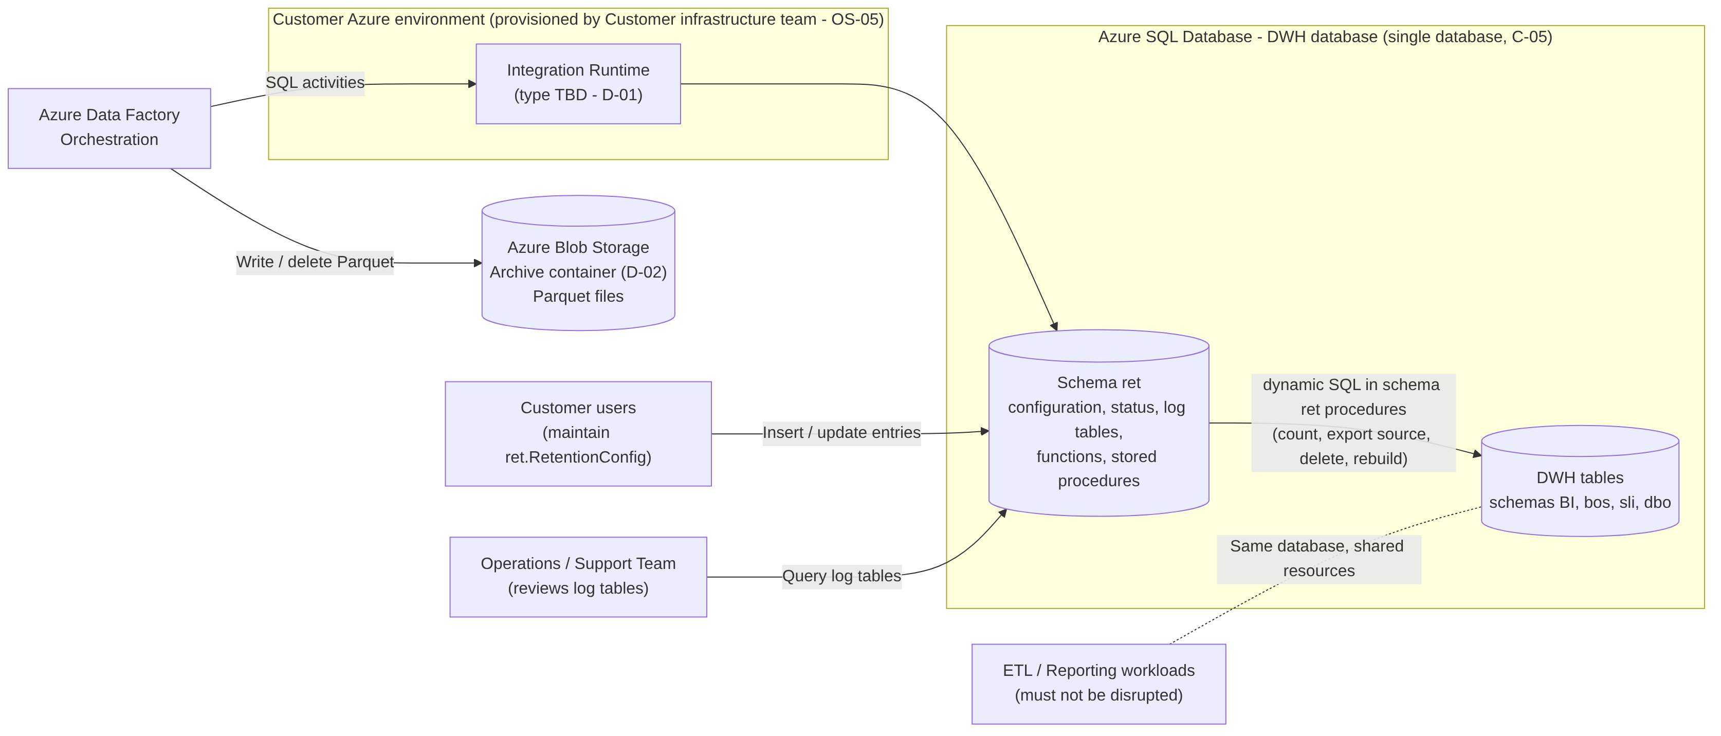
Figure 1 – System context
ADF reaches the DWH database through the Integration Runtime provided by the Customer infrastructure team. The schema ret procedures read and change the DWH tables in the same database with dynamic SQL; ADF writes and deletes Parquet files in the archive container. Customer users maintain the configuration table; the operations team reviews the log tables. ETL and reporting run in the same database and must not be disrupted.

6.3 Component Interaction
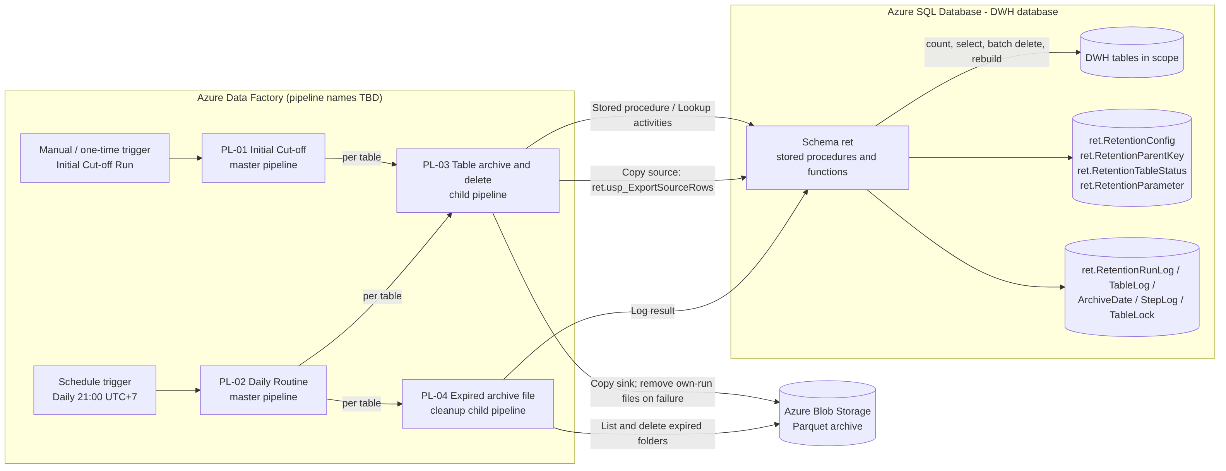
Figure 2 – Component interaction
ID | Component | Type | Responsibility | Source
PL-01 | Initial Cut-off master pipeline | ADF pipeline | Runs the Initial Cut-off Run for an explicitly supplied list of tables, sequentially; triggered manually within the agreed window. | BRQ-05, BR-12, BR-16, BR-17
PL-02 | Daily Routine master pipeline | ADF pipeline | Scheduled daily at 21:00 UTC+7; selects eligible tables and runs PL-03 and PL-04 for each. | BRQ-10, BR-18
PL-03 | Table archive-and-delete child pipeline | ADF pipeline | Per table: begin, resume, count, export per business date, validate, batch delete or rebuild, post-check, cleanup, end. | IC-01 to IC-05, DR-01 to DR-04
PL-04 | Expired archive cleanup child pipeline | ADF pipeline | Per table: lists business-date folders and deletes those before the archive cut-off date. | DR-05, BRQ-11
– | ret.RetentionConfig, ret.RetentionTableStatus, ret.RetentionParameter | Tables [DSN] | Configuration, system-maintained status and global parameters (Section 10.6). | BRQ-03, BR-12
– | ret.RetentionParentKey; ParentTableConfigId in ret.RetentionConfig | Table and column [DER, MD-05] | Join keys between a child table and its header table (Section 10.6.11). | FR-023
– | ret.RetentionRunLog, ret.RetentionTableLog, ret.RetentionArchiveDate, ret.RetentionStepLog | Tables [DSN] | Execution history and validation baseline (Section 10.6). | BRQ-12, BRD 7.4
– | ret.RetentionTableLock, ret.RetentionErrorCode | Tables [DSN] | Concurrency control and error code reference. | FR-016, Section 13
– | ret.fn_* functions | Functions [DSN] | UTC+7 time, cut-off calculation, window check, archive names, delay string (Section 10.7). | BR-03, BR-04
– | ret.usp_* procedures | Stored procedures (names proposed, REF-05) | Run and table control, validation, export source, batch delete, rebuild, post-check, logging, administration (Section 10.7). | BRQ-14
– | Archive container | Azure Blob Storage | Parquet files organised by table and business date (FR-007). | BRQ-06, D-02
Table 23 – Solution components

6.4 Data Flow
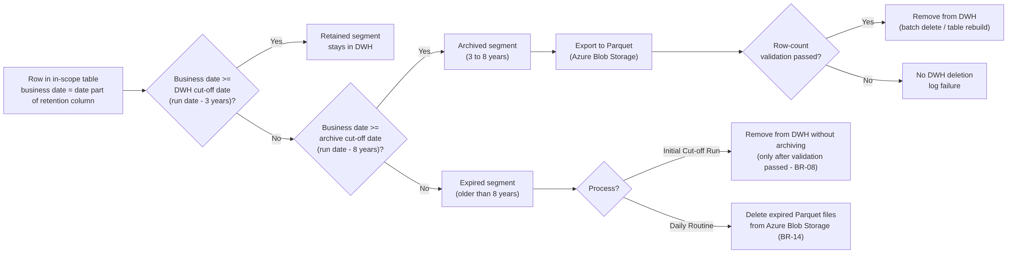
Figure 3 – High-level data flow by segment
Every row of an in-scope table is classified by its business date. The archived segment is exported and validated before any deletion. Expired rows are removed from the DWH only during the Initial Cut-off Run and only after the archived segment has been validated. In the Daily Routine, expired data exists only as Parquet files, which are deleted from Azure Blob Storage.

6.5 High-Level Process Flow
- Table onboarding (PRC-01): analysis, technical assessment and entry in ret.RetentionConfig.
- Initial Cut-off Run (PRC-02): once per table; child tables before their header tables; small and medium tables by batch delete first, then large tables by table rebuild within the approved downtime.
- Activation of the Daily Routine (FR-020): ret.usp_ActivateDailyRoutine sets the start date to the day after the last initial completion, and the schedule trigger is started.
- Daily Routine (PRC-03, PRC-04): daily archive, validation, deletion and expired archive cleanup.
- Recovery and rerun (PRC-05) and configuration changes (PRC-06) when required.

6.6 Key Design Decisions Summary
ID | Design | Status
DEC-01 | Run date = UTC+7 date from ret.fn_TodayUtc7 (Azure SQL Database runs in UTC); an override may only be earlier. | Proposed
DEC-02 | System-maintained Initial Cut-off status in ret.RetentionTableStatus. | In design table; approval pending
DEC-03 | Row-count validation: DWH count per business date versus ADF Copy activity rows read and written. | Proposed
DEC-04 | Archive layout <BlobPath>/year=YYYY/month=MM/day=DD/, one file per business date with the RunId in its name; no overwrite. | Decided (MD-07)
DEC-08 | Original table truncated and dropped inside the RB-08 transaction. | Decided (MD-06)
DEC-13 | Rebuild name swap: truncate, drop and rename in one transaction. | Proposed clarification of MD-04
DEC-14 | Rebuild validation gates before truncation (retained count, archive count, recount). | Proposed addition to MD-04
DEC-15 | Child tables retained through their header table (option A). | Decided (MD-05); BRD change request pending (OQ-32)
Table 24 – Key design decisions

7. Functional Requirements
This section lists the functional requirements. Requirements whose origin is [DER] are controls that the BRD does not state explicitly; they are proposed to make the BRD requirements safe and testable and require approval (Section 19). Detailed behaviour is described in Section 8 and the physical design in Section 10.

7.1 Functional Requirements Overview
FR ID | Name | BRD reference | Origin
FR-001 | Retention configuration table | BRQ-02, BRQ-03, BRQ-04, NFR-02, BR-13 | BRD / DSN (DV-01, DV-02)
FR-002 | Configuration and metadata validation | BR-06, BR-13, A-04, R-07 | BRD / DER
FR-003 | Run date and cut-off date calculation | BR-03, BR-04, BR-05, BR-07, C-03 | BRD
FR-004 | Table selection for processing | BRQ-04, BR-12, BR-16, AC-15, AC-16 | BRD / DER
FR-005 | Eligible data identification | IC-01, DR-01 | BRD
FR-006 | Archive export to Parquet | BRQ-06, IC-02, DR-02, C-02 | BRD
FR-007 | Archive storage organisation and naming | BRQ-06, BRQ-11 | BRD / MD-07
FR-008 | Archive row-count validation | BRQ-07, BR-08, IC-03, DR-03 | BRD
FR-009 | Batch delete | BRQ-08, NFR-01, BR-10 | BRD
FR-010 | Table rebuild (Initial Cut-off Run only) | BRQ-09, BR-10, BR-11, BR-16, MD-04 | BRD / MD / DER
FR-011 | Initial Cut-off Run orchestration | BRQ-05, IC-01 to IC-05, BR-08, BR-09, BR-12, BR-17 | BRD
FR-012 | Daily Routine orchestration | BRQ-10, NFR-03, DR-01 to DR-06, BR-07, BR-18 | BRD
FR-013 | Expired archive file deletion | BRQ-11, BR-14, IS-06 | BRD
FR-014 | Execution logging | BRQ-12, BR-15, BRD 7.4 | BRD
FR-015 | Log-based monitoring support | BRQ-13, R-01 | BRD
FR-016 | Concurrency control | Supports NFR-08, R-10 | DER
FR-017 | Restart, rerun and resume | Supports NFR-03, NFR-08, BR-08 | DER
FR-018 | Cleanup of archive files from failed runs | Supports BR-08, NFR-08 | DER
FR-019 | Execution window control for the Initial Cut-off Run | BR-17 | DER
FR-020 | Initial Cut-off status and Daily Routine activation | BR-12, BR-16, AC-15, AC-16 | BRD / DSN
FR-021 | Retention logic as stored procedures and scripts in schema ret | BRQ-14, C-05 | BRD
FR-022 | Table analysis support | BRQ-01, BRQ-02 | BRD / DER
FR-023 | Parent-dated retention of child tables | BRQ-02, BRQ-04, BRQ-05, BRQ-10, BR-08 (BR-06, BR-13 to be amended) | MD / DER (DV-04)
Table 25 – Functional requirements overview

7.2 Functional Requirement Specifications

7.2.1 FR-001 Retention Configuration Table
Functional Requirement ID | FR-001
Requirement Name | Retention Configuration Table
Origin | [BRD] BRQ-03, BRD 7.3; [DSN] physical design of ret.RetentionConfig; deviations DV-01 and DV-02.
Description | The solution shall provide the table ret.RetentionConfig with one row per table under retention, holding the attributes of BRD 7.3 as implemented in the design table (Section 10.6.1).
Business Requirement Reference | BRQ-02, BRQ-03, BRQ-04, NFR-02, BR-01, BR-02, BR-11, BR-13; BRD 7.3
Trigger | Customer users insert, update or deactivate a row (maintenance tool TBD, e.g. SQL script).
Preconditions | Schema ret deployed. Customer users have write permission on the Customer-maintained columns only (SEC-03).
Input | SchemaName, TableName, RetentionColumn or ParentTableConfigId (child table), DwhRetentionYears (default 3), BlobRetentionYears (default 5), BlobPath, InitialCutoffMethod, IsActive, SizeCategory; for a child table its join keys in ret.RetentionParentKey.
Processing Logic | - Enforce in the database: unique table per schema and name; unique BlobPath without leading or trailing slash; DwhRetentionYears ≥ 1 and BlobRetentionYears ≥ 1 (DBR-01); InitialCutoffMethod ∈ {BATCH_DELETE, TABLE_REBUILD}; SizeCategory ∈ {SMALL, MEDIUM, LARGE}; IsActive ∈ {0, 1}.  - Exactly one of RetentionColumn and ParentTableConfigId is filled; a child table inherits the retention column and the retention periods of its header table (FR-023, DBR-20).  - BlobPath is <schema>/<table> in lower case (MD-07).  - Total retention is not stored; it is DwhRetentionYears + BlobRetentionYears (DV-02).  - The database of the table is always the current database (MD-02, DV-01).  - Trigger ret.trg_RetentionConfig_AfterInsert creates the status row with status PENDING.  - Trigger ret.trg_RetentionConfig_AfterUpdate sets ModifiedBy and ModifiedAt and rejects changes to schema, table, retention column or blob path once archiving has started for the table (PRC-06).  - Tables and columns are never detected automatically (BR-13).
Output | Persisted configuration row with audit columns.
Postconditions | A new row has Initial Cut-off status PENDING and is not processed by the Daily Routine until FR-020 conditions are met.
Business Rules | BR-01, BR-02, BR-11, BR-13, DBR-01, DBR-11
Exception Handling | Constraint violation: insert or update rejected; no partial row stored. Object existence and data type are checked at run time (FR-002).
Acceptance Criteria | - A table can be added to or removed from processing by changing configuration only (AC-02).  - A row with DwhRetentionYears = 0 or BlobRetentionYears = 0 is rejected.  - A duplicate schema and table, or a duplicate blob path, is rejected.  - Setting IsActive = 0 excludes the table from the next Daily Routine.  - Changing RetentionColumn of a table with a validated range is rejected by the update trigger.
Priority | Not specified in the BRD (TBD).
Table 26 – FR-001 – Retention Configuration Table

7.2.2 FR-002 Configuration and Metadata Validation
Functional Requirement ID | FR-002
Requirement Name | Configuration and Metadata Validation
Origin | [BRD] BR-06, BR-13; [DER] check set V-01 to V-09.
Description | Before any data is exported or removed for a table, the solution shall validate the configuration row and the table metadata. A table that fails validation shall not be exported or changed.
Business Requirement Reference | BR-06, BR-13, A-04, R-07, BRQ-02
Trigger | Start of processing of each table (ret.usp_BeginTable).
Preconditions | Run record exists; table lock acquired (FR-016).
Input | Configuration row; catalog metadata of the current database; ret.RetentionParameter.
Processing Logic | Execute checks V-01 to V-11 (Section 10.5). V-10 and V-11 apply to child tables only. V-04 (NULL values) is a full count in the Initial Cut-off Run; in the Daily Routine its mode is set by DailyNullCheckMode (FULL or METADATA, OQ-14). For a child table V-02 to V-04 are applied to the retention column of the header table.
Output | Validation result per check, written to ret.RetentionStepLog.
Postconditions | Validated table proceeds; a failed table is logged FAILED with an ERR-CFG code.
Business Rules | BR-06, BR-13, DBR-11
Exception Handling | Any failed check: no export, no deletion, table FAILED, lock released, next table processed. In the Daily Routine expired archive deletion (FR-013) still runs if V-05 and V-06 passed (BR-14).
Acceptance Criteria | - A retention column of type varchar is rejected with ERR-CFG-03 and no data is changed.  - A retention column with NULL values is rejected in the Initial Cut-off Run with ERR-CFG-04.  - A configured table that does not exist is rejected with ERR-CFG-01 and other tables are still processed.
Priority | Not specified in the BRD (TBD).
Table 27 – FR-002 – Configuration and Metadata Validation

7.2.3 FR-003 Run Date and Cut-off Date Calculation
Functional Requirement ID | FR-003
Requirement Name | Run Date and Cut-off Date Calculation
Origin | [BRD] Derived from the referenced BRD requirements.
Description | The solution shall determine the run date in UTC+7 and calculate the DWH cut-off date and archive cut-off date for each table from its configured retention periods.
Business Requirement Reference | BR-03, BR-04, BR-05, BR-07, C-01, C-03; BRD glossary
Trigger | Start of every Initial Cut-off Run and Daily Routine (ret.usp_StartRun).
Preconditions | None.
Input | Optional run date supplied by ADF or by an operator; DwhRetentionYears and BlobRetentionYears per table.
Processing Logic | - RunDate = ret.fn_TodayUtc7() = date part of DATEADD(HOUR, 7, SYSUTCDATETIME()) when no run date is supplied. Azure SQL Database runs in UTC, so GETDATE() is not used [DEC-01].  - A supplied run date later than the current UTC+7 date is rejected (DBR-15).  - Via ret.fn_GetCutoffDates: TotalRetentionYears = DWH + blob years; DwhCutoffDate = DATEADD(YEAR, −DwhRetentionYears, RunDate); ArchiveCutoffDate = DATEADD(YEAR, −TotalRetentionYears, RunDate).  - RunDate and the cut-off dates are fixed for the whole run, including runs that continue after midnight (DBR-02).  - Predicates compare the unmodified retention column with the date-typed cut-off (col < @DwhCutoffDate), which ignores the time part (BR-05) and keeps the predicate index-friendly.
Output | RunDate, DwhCutoffDate, ArchiveCutoffDate per table; stored in the run and table logs.
Postconditions | All later steps of the run use the fixed dates.
Business Rules | BR-03, BR-04, BR-05, BR-07, DBR-02, DBR-15
Exception Handling | Run date in the future: run rejected with ERR-SYS-02; nothing is processed.
Acceptance Criteria | - For run date 27 October 2026 with 3 + 5 years: DwhCutoffDate = 27 October 2023, ArchiveCutoffDate = 27 October 2018 (BRD 4.3).  - A row with business date-time 26 October 2023 23:59:59 is eligible; a row with 27 October 2023 00:00:00 is retained.  - A run triggered at 21:00 UTC+7 (14:00 UTC) gets the UTC+7 calendar date.  - The leap-day cases in Section 10.4 produce the documented dates.
Priority | Not specified in the BRD (TBD).
Table 28 – FR-003 – Run Date and Cut-off Date Calculation

7.2.4 FR-004 Table Selection for Processing
Functional Requirement ID | FR-004
Requirement Name | Table Selection for Processing
Origin | [BRD] BR-12, BR-16; [DER/DSN] selection based on ret.RetentionTableStatus and DailyRoutineStartDate.
Description | The solution shall select the tables processed in each run according to the process type, the configuration and the Initial Cut-off status.
Business Requirement Reference | BRQ-04, BR-12, BR-13, BR-16, AC-15, AC-16
Trigger | Start of each run (ret.usp_GetTablesToProcess).
Preconditions | Run record created; RunDate fixed.
Input | Process type; for the Initial Cut-off Run an explicit list of TableConfigId values and an optional downtime reference; configuration, status and parameters.
Processing Logic | - Initial Cut-off Run: process only the listed tables where IsActive = 1 (DBR-11) and status ∈ {PENDING, FAILED, STOPPED}. A LARGE table or a table with method TABLE_REBUILD is accepted only with a downtime reference on the run; a LARGE table additionally only when all active SMALL and MEDIUM tables are COMPLETED (DBR-05). A header table is accepted only when all its active child tables are COMPLETED (DBR-18).  - Daily Routine: only when RunDate ≥ DailyRoutineStartDate; process tables where IsActive = 1, status = COMPLETED and completion date < RunDate (DBR-04).  - Order: Initial Cut-off Run in the order supplied; Daily Routine with child tables first, then all other tables, each by ascending TableConfigId (DBR-19). Processing is sequential (DEC-07).  - Daily Routine: if a child table did not end SUCCEEDED or NODATA, its header table skips DWH removal in that run; expired archive deletion still runs (DBR-19).
Output | Ordered table list with cut-off dates, blob path and method.
Postconditions | Listed but ineligible tables receive a SKIPPED table log (ERR-CFG-07).
Business Rules | BR-12, BR-16, DBR-04, DBR-05, DBR-11
Exception Handling | Empty selection: run completes SUCCEEDED with zero tables. Daily Routine before activation: no table selected; reason logged.
Acceptance Criteria | - A table whose Initial Cut-off Run completed on day D is first processed by the Daily Routine with run date D+1 (AC-16).  - An inactive table is not processed.  - A LARGE table is skipped by the Initial Cut-off Run while an active SMALL or MEDIUM table is not COMPLETED.
Priority | Not specified in the BRD (TBD).
Table 29 – FR-004 – Table Selection for Processing

7.2.5 FR-005 Eligible Data Identification
Functional Requirement ID | FR-005
Requirement Name | Eligible Data Identification
Origin | [BRD] Derived from the referenced BRD requirements.
Description | The solution shall count, per table and per business date, the rows to export and, in the Initial Cut-off Run, the expired and retained rows, and shall store the per-date counts as the validation baseline.
Business Requirement Reference | IC-01, DR-01, BRQ-07
Trigger | After validation (FR-002) and resume handling (FR-017) – ret.usp_IdentifyEligibleData.
Preconditions | Cut-off dates fixed.
Input | Table, retention column, DwhCutoffDate, ArchiveCutoffDate.
Processing Logic | - Initial Cut-off Run: rows per business date with col >= ArchiveCutoffDate AND col < DwhCutoffDate; expired count col < ArchiveCutoffDate; retained count col >= DwhCutoffDate.  - Daily Routine: rows per business date with col < DwhCutoffDate (BRD 5.3 as written; OQ-10).  - Child table: the same predicates are applied to the header retention column through EXISTS on the join keys; the business date is the date of the header row (FR-023).  - One row per business date in ret.RetentionArchiveDate with ExpectedRows, FolderPath and FileName (ExportStatus PENDING).  - Totals in ret.RetentionTableLog (EligibleRows = rows to remove; ArchivedSegmentRows, ExpiredSegmentRows, RetainedRowsBefore).  - NextAction: EXPORT if rows to export > 0; VALIDATE if only expired rows exist (IC, DBR-03); NONE otherwise.
Output | Snapshot per business date; totals; next action.
Postconditions | Snapshot available for FR-006 and FR-008.
Business Rules | BR-03, BR-05, DBR-03
Exception Handling | Query failure: table FAILED (ERR-SYS-01) with no data change.
Acceptance Criteria | - The per-date counts equal an independent COUNT query on the same range.  - With no eligible rows in the Daily Routine, DR-02 to DR-04 are skipped and DR-05 is executed.
Priority | Not specified in the BRD (TBD).
Table 30 – FR-005 – Eligible Data Identification

7.2.6 FR-006 Archive Export to Parquet
Functional Requirement ID | FR-006
Requirement Name | Archive Export to Parquet
Origin | [BRD] Derived from the referenced BRD requirements.
Description | The solution shall export eligible rows to Parquet files in Azure Blob Storage, one export unit per table and business date, without transforming the data.
Business Requirement Reference | BRQ-06, IC-02, DR-02, OBJ-02, C-02
Trigger | NextAction = EXPORT (FR-005), or step RB-06 of the table rebuild.
Preconditions | Snapshot recorded; ADF has write access to the archive container (SEC-05).
Input | Export plan (ret.usp_GetExportPlan, paged by 5,000 dates); source rows from ret.usp_ExportSourceRows.
Processing Logic | - For each PENDING business date in ascending order: ADF Copy activity with stored-procedure source ret.usp_ExportSourceRows (all columns in ordinal order, col >= d AND col < d + 1 day) and Parquet sink at FolderPath/FileName.  - Child table: the source joins the header table on the join keys and returns only the child columns (FR-023).  - Fault tolerance (skipping incompatible rows) is disabled.  - After each copy, ret.usp_LogExportResult records rows read, rows written and status.  - Initial Cut-off Run: the window is checked before each date (FR-019).  - Compression codec: TBC (snappy proposed [REC]).
Output | One Parquet file per business date; per-date results in ret.RetentionArchiveDate.
Postconditions | All dates exported, or the export is marked FAILED or STOPPED and cleanup is required (FR-018).
Business Rules | BR-02, DBR-07, DBR-13
Exception Handling | Copy failure after retries: remaining dates not exported, files of the run removed (FR-018), table FAILED (ERR-EXP-01), nothing removed from the DWH.
Acceptance Criteria | - For each exported business date one file exists that contains only rows of that business date.  - Column names, count and values of sampled files match the source rows (TS-042).  - An incompatible row fails the export instead of being skipped.
Priority | Not specified in the BRD (TBD).
Table 31 – FR-006 – Archive Export to Parquet

7.2.7 FR-007 Archive Storage Organisation and Naming
Functional Requirement ID | FR-007
Requirement Name | Archive Storage Organisation and Naming
Origin | [BRD] BRQ-06 “organised by table and date”; [MD] MD-07 layout; [DSN] ret.fn_ArchiveFileName; ret.fn_ArchiveFolderPath to be changed (Section 10.6.11).
Description | The solution shall store each table’s archive under its BlobPath, organised by business date, with file names that identify the table, business date and run.
Business Requirement Reference | BRQ-06, BRQ-11, BR-14
Trigger | Every export unit (FR-006).
Preconditions | Container name in ret.RetentionParameter.ArchiveContainer (D-02) and BlobPath configured.
Input | ArchiveContainer, BlobPath, schema, table, business date, RunId.
Processing Logic | - Container: the value of ArchiveContainer (container name only; 3–63 characters, lower-case letters, digits and hyphens).  - Table root folder: BlobPath = <schema>/<table> in lower case, for example bos/jti_sd_branddistdetail.  - Folder per business date: <BlobPath>/year=YYYY/month=MM/day=DD (MD-07).  - File: <schema>_<table>_<yyyyMMdd>_<RunId>.parquet (design table).  - Example: <container>/bos/jti_sd_branddistdetail/year=2019/month=03/day=01/bos_JTI_SD_BrandDistDetail_20190301_123.parquet.  - Files are never overwritten; a rerun writes new names (DBR-07).  - For a child table the business date is the date of its header row (FR-023).
Output | Deterministic archive layout recorded in ret.RetentionArchiveDate.
Postconditions | Each archived row is in exactly one file of exactly one business date.
Business Rules | DBR-07, DBR-12
Exception Handling | Target file exists: export fails (ERR-EXP-02); not expected because RunId is unique.
Acceptance Criteria | - The archive of a table contains one day folder per exported business date under the year and month folders of the agreed pattern.  - No file of an earlier run is overwritten by a later run.  - A blob path with upper-case letters or a container name with “/” is rejected by the configuration constraints.
Priority | Not specified in the BRD (TBD).
Table 32 – FR-007 – Archive Storage Organisation and Naming

7.2.8 FR-008 Archive Row-Count Validation
Functional Requirement ID | FR-008
Requirement Name | Archive Row-Count Validation
Origin | [BRD] Derived from the referenced BRD requirements.
Description | Before removing any data from the DWH, the solution shall confirm that the rows written to Parquet equal the rows in the DWH for the same range, per business date and in total. Nothing is removed if the counts differ.
Business Requirement Reference | BRQ-07, BR-08, IC-03, DR-03, AC-05, SC-02
Trigger | After all export units of the table (ret.usp_ValidateArchive); in the table rebuild at step RB-07.
Preconditions | Snapshot and per-date export results available.
Input | ExpectedRows, RowsRead, RowsWritten, ExportStatus per date; snapshot totals.
Processing Logic | - Per date: PASSED if ExportStatus = SUCCEEDED and ExpectedRows = RowsRead = RowsWritten.  - Total: rows written = rows to export.  - On success: IsValidated = 1, ValidatedRangeFrom = NULL, ValidatedRangeTo = DwhCutoffDate, ValidatedRowCount = EligibleRows (IC: archived + expired).  - Pre-delete recount immediately before removal must equal ValidatedRowCount (DBR-06).  - The counting method for the Parquet side is DEC-03 (OQ-09).
Output | ValidationResult per date and in total.
Postconditions | PASSED: removal may start. FAILED: no data removed, including expired data in the Initial Cut-off Run.
Business Rules | BR-08, DBR-06
Exception Handling | Mismatch: files of the run removed (FR-018), table FAILED (ERR-VAL-01 or ERR-VAL-02). The Daily Routine continues with FR-013.
Acceptance Criteria | - A simulated mismatch results in zero rows removed from the DWH, including expired rows, and a FAILED log record (AC-05).  - A row inserted into the validated range after export makes the recount fail and nothing is removed.
Priority | Not specified in the BRD (TBD).
Table 33 – FR-008 – Archive Row-Count Validation

7.2.9 FR-009 Batch Delete
Functional Requirement ID | FR-009
Requirement Name | Batch Delete
Origin | [BRD] Derived from the referenced BRD requirements.
Description | The solution shall delete rows from the DWH in batches of a configurable size with a configurable pause, each batch in its own short transaction.
Business Requirement Reference | BRQ-08, NFR-01, BR-10, BR-11, IC-04, DR-04, AC-06
Trigger | After validation (Daily Routine; Initial Cut-off Run with BATCH_DELETE) or on resume – ret.usp_BatchDelete.
Preconditions | Range validated; table lock held by the run.
Input | Validated range; BatchSize (default 10,000), BatchPauseSeconds (default 3), DeleteRetryCount, DeleteLockTimeoutMs.
Processing Logic | - Loop: DELETE TOP (BatchSize) within the range together with the progress update in one short transaction; stop when fewer than BatchSize rows were deleted; otherwise wait BatchPauseSeconds (ret.fn_DelayString) and repeat.  - Deadlock (1205) and lock timeout (1222): retry the batch up to DeleteRetryCount times.  - Initial Cut-off Run: range = all rows with col < DwhCutoffDate (archived and expired); window checked before each batch (FR-019).  - After the loop no row may remain in the range; deleted total must equal ValidatedRowCount (otherwise warning ERR-DEL-03).
Output | Rows deleted, batch count, step log.
Postconditions | No rows remain in the range; DeleteStatus = COMPLETED.
Business Rules | BR-08, BR-10, DBR-09, DBR-14
Exception Handling | Error after retries: DeleteStatus = FAILED, resumable (FR-017). Rows remaining after the loop: ERR-DEL-02 and integrity flag.
Acceptance Criteria | - 25,000 eligible rows with defaults are deleted in three batches of 10,000, 10,000 and 5,000 with pauses of at least 3 seconds (AC-06).  - Changing BatchSize or BatchPauseSeconds changes the behaviour without code change.  - No transaction deletes more than BatchSize rows.
Priority | Not specified in the BRD (TBD).
Table 34 – FR-009 – Batch Delete

7.2.10 FR-010 Table Rebuild (Initial Cut-off Run Only)
Functional Requirement ID | FR-010
Requirement Name | Table Rebuild (Initial Cut-off Run Only)
Origin | [BRD] BRQ-09; [MD] MD-04 steps 1 to 5; [DER] validation gates and name-swap details (DEC-13, DEC-14).
Description | For tables configured with TABLE_REBUILD, the Initial Cut-off Run shall build a new table with the retained rows and the definition of the original table, archive the archived segment from the original table, and replace the original table with the new table under the original name.
Business Requirement Reference | BRQ-09, BR-08, BR-10, BR-11, BR-16, BR-17, R-05, R-06, D-07, AC-03, AC-14, MD-04
Trigger | Initial Cut-off Run, table with method TABLE_REBUILD.
Preconditions | - Downtime approved and its reference on the run (D-07); ETL writes to the table stopped for the whole rebuild.  - Valid restore point confirmed (R-02).  - Dependent objects reviewed (R-05): incoming foreign keys, schema-bound and indexed views, triggers, CDC, change tracking, temporal tables.  - Free space in the database for the new table and its indexes, and transaction log capacity agreed with the DBA (R-06, OQ-24).
Input | Table, retention column, cut-off dates, downtime reference.
Processing Logic | Steps RB-01 to RB-10 (Section 8.4): script the definition; create the new table and insert retained rows (MD-04 step 1); add primary key, constraints and indexes (step 2); check retained count; export the archived segment from the original table (step 3); validate the archive and recount the original table; in one transaction truncate and drop the original table (step 4, MD-06) and rename the new table to the original name (step 5); re-create triggers, re-apply permissions, reseed identity; post-check. For a child table the retained rows are all rows whose header date is not before the DWH cut-off, including orphan rows (FR-023, DBR-21).
Output | Table with the original name containing only retained rows; archive files for the archived segment.
Postconditions | No rows older than the DWH cut-off date; definition equal to the original.
Business Rules | BR-08, BR-10, BR-11, BR-16, BR-17, DBR-05, DBR-16, DBR-17
Exception Handling | Failure before truncation: new table dropped, files of the run removed, original unchanged (ERR-RBD-01). Failure in the truncate-and-rename transaction: rolled back, original unchanged (ERR-RBD-02). Failure after the swap: ERR-RBD-03 and DBA procedure. Unsupported table: ERR-RBD-04, nothing changed.
Acceptance Criteria | - After the rebuild the table contains exactly the rows with business date ≥ DWH cut-off date with unchanged values (AC-03).  - Columns, data types, nullability, identity, keys, indexes, constraints, triggers and permissions match the definition captured at RB-02.  - The archive contains the archived segment with a row count equal to the rows removed for that range (AC-04).  - The rebuild runs only within the approved downtime (AC-14).
Priority | Not specified in the BRD (TBD).
Table 35 – FR-010 – Table Rebuild (Initial Cut-off Run Only)

7.2.11 FR-011 Initial Cut-off Run Orchestration
Functional Requirement ID | FR-011
Requirement Name | Initial Cut-off Run Orchestration
Origin | [BRD] Derived from the referenced BRD requirements.
Description | The solution shall provide a pipeline that executes the Initial Cut-off Run (IC-01 to IC-05) once for each selected table.
Business Requirement Reference | BRQ-05, IC-01 to IC-05, BR-08, BR-09, BR-11, BR-12, BR-16, BR-17, AC-03, AC-04, AC-05, AC-14
Trigger | Manual or one-time trigger of PL-01 by an authorised operator within 21:00–05:00 UTC+7, scheduled with the ETL Owner (D-04).
Preconditions | Tables onboarded (PRC-01); restore point confirmed; ETL Owner agreement recorded (reference TBD).
Input | TableConfigId list; optional run date; downtime reference for LARGE or TABLE_REBUILD tables.
Processing Logic | Per table: begin (FR-016, FR-002, FR-017) → BATCH_DELETE: count (FR-005), export (FR-006), validate (FR-008), batch delete (FR-009); TABLE_REBUILD: FR-010 → post-check and completion (FR-020) → end (FR-014). Detailed flow in PRC-02.
Output | Archive files; reduced DWH table; status COMPLETED; logs.
Postconditions | AC-03 and AC-04 satisfied for each completed table.
Business Rules | BR-08 to BR-12, BR-16, BR-17, DBR-03, DBR-05, DBR-13
Exception Handling | A failed table does not stop the remaining tables. Window end: FR-019.
Acceptance Criteria | - AC-03, AC-04, AC-05 and AC-14 are met (TS-012 to TS-019).
Priority | Not specified in the BRD (TBD).
Table 36 – FR-011 – Initial Cut-off Run Orchestration

7.2.12 FR-012 Daily Routine Orchestration
Functional Requirement ID | FR-012
Requirement Name | Daily Routine Orchestration
Origin | [BRD] Derived from the referenced BRD requirements.
Description | The solution shall provide a pipeline, triggered by an ADF schedule every day at 21:00 UTC+7, that executes DR-01 to DR-06 for every selected table without manual intervention.
Business Requirement Reference | BRQ-10, NFR-03, DR-01 to DR-06, BR-07, BR-10, BR-12, BR-14, BR-18, AC-07, AC-15
Trigger | ADF schedule trigger, daily 21:00, time zone SE Asia Standard Time (UTC+7).
Preconditions | Daily Routine activated (FR-020); pipeline concurrency = 1.
Input | Configuration, parameters, status, earlier table logs (resume).
Processing Logic | Per selected table: begin → resume (FR-017) → count → export → validate → batch delete → post-check → expired archive deletion (FR-013, always when V-05 and V-06 passed) → end. Method is always batch delete (BR-10). Detailed flow in PRC-03.
Output | Archive files for newly eligible dates; DWH rows before the DWH cut-off deleted; expired archive files deleted; logs.
Postconditions | Run SUCCEEDED when all tables ended SUCCEEDED or NODATA, otherwise COMPLETED_WITH_ERRORS; ret.usp_EndRun then raises an error so that the ADF run shows as failed [REC].
Business Rules | BR-07, BR-10, BR-12, BR-14, BR-18, DBR-04
Exception Handling | A failed table does not stop other tables. A run still active at the next trigger time causes the next run to queue.
Acceptance Criteria | - The pipeline starts at 21:00 UTC+7 without manual action (AC-07).  - After a successful run no processed table contains rows before the DWH cut-off date (AC-07, SC-01; see OQ-06 for days with a validation failure).
Priority | Not specified in the BRD (TBD).
Table 37 – FR-012 – Daily Routine Orchestration

7.2.13 FR-013 Expired Archive File Deletion
Functional Requirement ID | FR-013
Requirement Name | Expired Archive File Deletion
Origin | [BRD] Derived from the referenced BRD requirements.
Description | The Daily Routine shall delete, for each processed table, all archive files whose business date is before the archive cut-off date.
Business Requirement Reference | BRQ-11, BR-14, DR-05, IS-06, AC-08, SC-03
Trigger | Daily Routine, per table, after the DWH steps or after any earlier outcome of the table.
Preconditions | V-05 and V-06 passed.
Input | Table root folder (BlobPath); ArchiveCutoffDate.
Processing Logic | Hierarchical traversal of the MD-07 layout (Figure 7):  - Level year: list year=YYYY folders of BlobPath; delete every year before the year of ArchiveCutoffDate.  - Level month: in the cut-off year, list month=MM folders; delete every month before the cut-off month.  - Level day: in the cut-off month, list day=DD folders; delete every day before the cut-off day.  - ret.usp_GetExpiredArchiveFolders receives the Get Metadata child items of one level and returns the folders to delete and the folder to descend into.  - ADF Delete activity deletes each returned folder recursively; ret.usp_LogExpiredArchiveResult records folders and files deleted.  - Items not matching year=, month= or day= with valid numbers are never deleted and are logged as a warning (DBR-12).
Output | Folders and files deleted; warnings.
Postconditions | No archive file before the archive cut-off date remains for the table.
Business Rules | BR-14, DBR-12
Exception Handling | Listing or deletion error: ERR-ARC-01; the DWH result of the table is kept; the next Daily Routine deletes what remains.
Acceptance Criteria | - After the Daily Routine no Parquet file with business date before the archive cut-off date remains, also on days when DWH validation failed (AC-08).  - Folders on or after the archive cut-off date are untouched.
Priority | Not specified in the BRD (TBD).
Table 38 – FR-013 – Expired Archive File Deletion

7.2.14 FR-014 Execution Logging
Functional Requirement ID | FR-014
Requirement Name | Execution Logging
Origin | [BRD] Derived from the referenced BRD requirements.
Description | The solution shall record every execution in log tables at run, table, business-date and step level, including all attributes listed in BRD 7.4.
Business Requirement Reference | BRQ-12, BRQ-13, BR-15, BRD 7.4, AC-09, SC-04
Trigger | Start and end of every run, table, export unit and step.
Preconditions | Log tables deployed.
Input | Process context and results.
Processing Logic | - ret.RetentionRunLog: created by ret.usp_StartRun (RUNNING), closed by ret.usp_EndRun.  - ret.RetentionTableLog: one row per table per run with the BRD 7.4 attributes.  - ret.RetentionArchiveDate: one row per table log and business date.  - ret.RetentionStepLog: one row per step.  - ADF failure paths always call ret.usp_EndTable and ret.usp_EndRun with the activity error.
Output | Log records.
Postconditions | Every run and processed table has a final status.
Business Rules | BR-15
Exception Handling | If the log cannot be written (database unreachable), the failure is visible only in ADF monitoring (RSK-17); a run left RUNNING is closed per Section 16.8.
Acceptance Criteria | - Every execution produces a run record and a table record per processed table with all BRD 7.4 attributes (AC-09).  - Failed executions include an error code and message.
Priority | Not specified in the BRD (TBD).
Table 39 – FR-014 – Execution Logging

7.2.15 FR-015 Log-Based Monitoring Support
Functional Requirement ID | FR-015
Requirement Name | Log-Based Monitoring Support
Origin | [BRD] Derived from the referenced BRD requirements.
Description | The solution shall support operational monitoring and troubleshooting from the log tables through documented SQL queries in the operational guide.
Business Requirement Reference | BRQ-13, R-01, OS-06, OS-08
Trigger | Operator review (daily, R-01).
Preconditions | Read access to schema ret log tables (SEC-04).
Input | Log, status and lock tables.
Processing Logic | Documented queries for: latest runs; failed, stopped or skipped tables; Initial Cut-off status and flags per table; pending resume ranges; reconciliation of eligible, exported and deleted rows; locks held.
Output | Query results.
Postconditions | None.
Business Rules | BR-15
Exception Handling | Not applicable.
Acceptance Criteria | - Each documented query returns the expected rows for a prepared set of log records (TS-043).
Priority | Not specified in the BRD (TBD).
Table 40 – FR-015 – Log-Based Monitoring Support

7.2.16 FR-016 Concurrency Control
Functional Requirement ID | FR-016
Requirement Name | Concurrency Control
Origin | [DER] Not in the BRD. Protects data integrity (NFR-08) and handles R-10. Design table: ret.RetentionTableLock (DEC-11).
Description | The solution shall prevent the same table from being processed by more than one run at a time and prevent overlapping executions of the same master pipeline.
Business Requirement Reference | Supports NFR-08, R-10, BR-08
Trigger | Start of each table and each master pipeline.
Preconditions | None.
Input | TableConfigId, RunId.
Processing Logic | - PL-01 and PL-02 have pipeline concurrency = 1.  - ret.usp_BeginTable inserts a row into ret.RetentionTableLock; a primary-key violation means the lock is held (ERR-LCK-01).  - ret.usp_EndTable, ret.usp_EndRun and ret.usp_AdminCloseStaleRun release locks.
Output | Lock state.
Postconditions | At most one active processing per table.
Business Rules | DBR-10
Exception Handling | Stale lock: table skipped until released by an operator (Section 16.8).
Acceptance Criteria | - Starting PL-01 for a table currently processed by PL-02 results in the table being SKIPPED by the second run with ERR-LCK-01 and no data change.
Priority | Not specified in the BRD (TBD).
Table 41 – FR-016 – Concurrency Control

7.2.17 FR-017 Restart, Rerun and Resume
Functional Requirement ID | FR-017
Requirement Name | Restart, Rerun and Resume
Origin | [DER] Not in the BRD. Ensures reruns never lose archived data or duplicate it (DEC-06).
Description | A rerun after any failure shall not remove unvalidated data, shall not overwrite archive files and shall not export the same rows twice.
Business Requirement Reference | Supports NFR-03, NFR-08, BR-08
Trigger | Every table processing (resume detection in ret.usp_BeginTable); manual rerun.
Preconditions | Earlier table logs available.
Input | Table logs with IsValidated = 1 and DeleteStatus ∈ {NOT_STARTED, IN_PROGRESS, FAILED}.
Processing Logic | Oldest pending range first: check that the rows remaining in the validated range do not exceed ValidatedRowCount − RowsDeleted; remove the remaining rows of that range only, without export, using the method of the owning run; mark the range COMPLETED with ResumedByRunId; then continue normal processing. For a table rebuild that failed before the swap, the whole rebuild is repeated from RB-01 (the original table is unchanged).
Output | Completed removal of the earlier range.
Postconditions | No pending resume for the table.
Business Rules | DBR-06 to DBR-09
Exception Handling | Remaining rows exceed the expected count: ERR-VAL-03, integrity flag, nothing removed, manual investigation.
Acceptance Criteria | - After an interrupted batch delete the next run completes it without writing new files for that range, and each row is archived exactly once (TS-032).  - A rerun after a successful run for the same run date exports and deletes nothing (TS-033).
Priority | Not specified in the BRD (TBD).
Table 42 – FR-017 – Restart, Rerun and Resume

7.2.18 FR-018 Cleanup of Archive Files from Failed Runs
Functional Requirement ID | FR-018
Requirement Name | Cleanup of Archive Files from Failed Runs
Origin | [DER] Avoids duplicates in the archive after a failed export or validation.
Description | When export or validation fails, the solution shall delete only the archive files written by the current run for the affected table.
Business Requirement Reference | Supports BR-08, NFR-08
Trigger | Any result with CleanupRequired = 1 (export failure, validation failure, window stop, failed recount, rebuild failure before truncation).
Preconditions | Files carry the RunId (FR-007).
Input | BlobPath, RunId, exported dates.
Processing Logic | ADF deletes files *_<RunId>.parquet of the table; ret.usp_LogCleanupResult sets the dates to REMOVED and revokes validation if no row was removed yet.
Output | Archive state equal to the state before the run.
Postconditions | A rerun can export the same dates without duplicates.
Business Rules | DBR-08
Exception Handling | Cleanup failure: orphan-file flag (ERR-EXP-03); the table is blocked by V-09 until an operator removes the files and clears the flag.
Acceptance Criteria | - After a forced validation failure the archive contains no file with the failed RunId.
Priority | Not specified in the BRD (TBD).
Table 43 – FR-018 – Cleanup of Archive Files from Failed Runs

7.2.19 FR-019 Execution Window Control for the Initial Cut-off Run
Functional Requirement ID | FR-019
Requirement Name | Execution Window Control for the Initial Cut-off Run
Origin | [DER] Derived from BR-17. Stop behaviour proposed (DEC-10).
Description | The Initial Cut-off Run shall not continue processing past the end of the agreed window and shall stop in a resumable state.
Business Requirement Reference | BR-17, D-04, NFR-05, NFR-07, R-11
Trigger | Before each export date and before each delete batch; before starting a table rebuild.
Preconditions | IcWindowStart and IcWindowEnd configured (21:00 and 05:00).
Input | Current UTC+7 time (ret.fn_IsWithinWindow).
Processing Logic | - Export phase: stop, remove the files of the run (FR-018), status STOPPED (ERR-WIN-01); nothing removed.  - Batch-delete phase: finish the current batch, stop; the range is resumed by the next run (FR-017).  - Table rebuild: started only if the operator confirms the expected duration fits the remaining window and downtime; once RB-03 has started it is not interrupted by the window check, but a failure before RB-08 leaves the original table unchanged.
Output | STOPPED status with progress recorded.
Postconditions | The table can be resumed in a later window.
Business Rules | BR-17, DBR-13
Exception Handling | Not applicable.
Acceptance Criteria | - No export unit or delete batch of the Initial Cut-off Run starts after the window end (TS-017, TS-018).
Priority | Not specified in the BRD (TBD).
Table 44 – FR-019 – Execution Window Control for the Initial Cut-off Run

7.2.20 FR-020 Initial Cut-off Status and Daily Routine Activation
Functional Requirement ID | FR-020
Requirement Name | Initial Cut-off Status and Daily Routine Activation
Origin | [BRD] BR-12, BR-16, AC-15, AC-16; [DSN] ret.RetentionTableStatus, DailyRoutineStartDate, ret.usp_ActivateDailyRoutine.
Description | The solution shall maintain the Initial Cut-off status per table and ensure that the Daily Routine starts only on the day after the Initial Cut-off Run has been completed for all in-scope tables of the initial implementation, and that later tables enter the Daily Routine only on the day after their own Initial Cut-off Run.
Business Requirement Reference | BR-12, BR-16, BRD 5.1, AC-15, AC-16
Trigger | Completion of an Initial Cut-off Run for a table; activation at go-live.
Preconditions | Post-check passed (ret.usp_PostCheck).
Input | TableConfigId, RunId.
Processing Logic | - ret.usp_PostCheck sets status COMPLETED and InitialCutoffCompletionDate = ret.fn_TodayUtc7() (the completion date, not the run date).  - Lifecycle: PENDING → RUNNING → COMPLETED, or FAILED / STOPPED (Figure 10).  - ret.usp_ActivateDailyRoutine is allowed only when every active table is COMPLETED; it sets DailyRoutineStartDate to the day after the last completion date (or later). The operator then starts the schedule trigger.  - FR-004 excludes any table that is not COMPLETED or whose completion date is not before the run date.
Output | Status, completion date, Daily Routine start date.
Postconditions | Table eligible for the Daily Routine from the next calendar day.
Business Rules | BR-12, BR-16, DBR-04, DBR-05
Exception Handling | Post-check fails: status FAILED (ERR-DEL-02).
Acceptance Criteria | - No Daily Routine processes a table before the day after the last initial table completed (AC-15).  - A table added later is not processed until the day after its Initial Cut-off Run completed, including when the run finishes after midnight (AC-16).
Priority | Not specified in the BRD (TBD).
Table 45 – FR-020 – Initial Cut-off Status and Daily Routine Activation

7.2.21 FR-021 Retention Logic as Stored Procedures and Scripts in Schema ret
Functional Requirement ID | FR-021
Requirement Name | Retention Logic as Stored Procedures and Scripts in Schema ret
Origin | [BRD] Derived from the referenced BRD requirements.
Description | All database-side retention logic shall be implemented as functions, triggers and stored procedures in schema ret of the DWH database, deployed by versioned, re-runnable scripts.
Business Requirement Reference | BRQ-14, IS-04, C-05, AC-10
Trigger | Deployment.
Preconditions | Deployment permissions granted.
Input | Source scripts.
Processing Logic | - Objects per Section 10.6 and 10.7.  - Dynamic SQL: object names validated against the catalog and quoted with QUOTENAME; values passed as parameters through sp_executesql (SEC-07).  - Scripts use CREATE OR ALTER for code objects and create tables only when missing [REC].
Output | Deployed objects in schema ret.
Postconditions | Objects available in the target database.
Business Rules | Not applicable.
Exception Handling | Deployment error: the script stops and reports the failing object.
Acceptance Criteria | - Retention logic is delivered as stored procedures and scripts, and the configuration table, log tables and procedures exist in schema ret (AC-10, TS-040).
Priority | Not specified in the BRD (TBD).
Table 46 – FR-021 – Retention Logic as Stored Procedures and Scripts in Schema ret

7.2.22 FR-022 Table Analysis Support
Functional Requirement ID | FR-022
Requirement Name | Table Analysis Support
Origin | [BRD] BRQ-01, BRQ-02; [DER] analysis content; first result in Appendix A.
Description | The project shall provide an analysis of DWH tables that supports identification of in-scope tables, retention columns and size category.
Business Requirement Reference | BRQ-01, BRQ-02, IS-01, IS-02, D-05, AC-01
Trigger | Onboarding (PRC-01).
Preconditions | Read access to the DWH catalog and data.
Input | Catalog; table data; List Table DWH workbook (REF-03).
Processing Logic | For each candidate: row count and size; date and datetime columns with data type and nullability (ret.usp_ListCandidateTables); NULL count, value range and rows per year of the proposed retention column (ret.usp_ProfileRetentionColumn); index on the column; incoming foreign keys and dependent objects; Parquet-incompatible columns. For each child table: header table, join keys, uniqueness of the key in the header table, index on the join columns of the child table, and number of orphan rows (Appendix A.2). The Business / Data Owner makes the final selection, which Customer users enter (BRQ-02).
Output | Table analysis deliverable (Appendix A is the first input).
Postconditions | Input available for the technical assessment (D-05).
Business Rules | BR-06, BR-11, BR-13
Exception Handling | Not applicable.
Acceptance Criteria | - The table analysis is delivered and the in-scope tables and retention columns are entered in the configuration table (AC-01).
Priority | Not specified in the BRD (TBD).
Table 47 – FR-022 – Table Analysis Support

7.2.23 FR-023 Parent-Dated Retention of Child Tables
Functional Requirement ID | FR-023
Requirement Name | Parent-Dated Retention of Child Tables
Origin | [MD] MD-05 (option A of OQ-03); [DER] configuration, checks and rules. Not in the BRD: change request required (DV-04, OQ-32).
Description | The solution shall apply retention to a child table that has no business date column of its own by taking, for each child row, the business date of its header row, found through configured join keys. A child table is archived and removed in the same way as any other table, and always before its header table.
Business Requirement Reference | BRQ-02, BRQ-04, BRQ-05, BRQ-10, BR-03, BR-08, BR-12; amends BR-06 and BR-13 (DV-04)
Trigger | Every Initial Cut-off Run and Daily Routine for a table with ParentTableConfigId set.
Preconditions | - Header table configured with its own RetentionColumn, active, and not itself a child table (one level only, DBR-20).  - Join keys recorded in ret.RetentionParentKey (child column, header column, ordinal).  - Same DwhRetentionYears and BlobRetentionYears as the header table (DBR-20).
Input | Child configuration row; header configuration row; join keys; cut-off dates of the header.
Processing Logic | - Eligibility predicate (child alias c, header alias p): EXISTS (SELECT 1 FROM <header> p WHERE p.k1 = c.k1 [AND p.k2 = c.k2 ...] AND p.<col> < @DwhCutoffDate); the IC adds p.<col> >= @ArchiveCutoffDate for the archived segment and p.<col> < @ArchiveCutoffDate for the expired segment.  - Business date of a child row = CAST(p.<col> AS date); snapshot, export units, folders and validation are per this date.  - Export source: SELECT c.<all child columns> FROM <child> c JOIN <header> p ON <keys> WHERE p.<col> >= @d AND p.<col> < DATEADD(DAY, 1, @d); only child columns are written (no transformation).  - Batch delete: DELETE TOP (@BatchSize) c FROM <child> c WHERE EXISTS (...).  - Table rebuild (LARGE child tables): the new table receives every child row that is not eligible, i.e. NOT EXISTS (... p.<col> < @DwhCutoffDate), so that orphan rows are kept (DBR-21).  - Orphan rows (no header row) are counted at every run, never removed and logged as warning ERR-PAR-01.  - Processing order and gates: child tables are processed before header tables; the IC of a header table is refused until all its active child tables are COMPLETED (DBR-18); in the Daily Routine a header table skips DWH removal when one of its child tables did not end SUCCEEDED or NODATA (DBR-19).  - Locking: when a child table is processed, ret.usp_BeginTable also checks that its header table is not locked by another run (ERR-LCK-01).
Output | Archive files and DWH removal for the child table; orphan count in the step log.
Postconditions | No child row whose header date is before the DWH cut-off remains in the child table.
Business Rules | BR-08, DBR-18 to DBR-21
Exception Handling | V-10 (header configuration invalid) or V-11 (join key not unique in the header): child FAILED, nothing changed (ERR-CFG-11, ERR-CFG-12). Orphan rows: warning ERR-PAR-01, not blocking. A failed child blocks DWH removal of its header for that run.
Acceptance Criteria | - For a header row dated D−4y, its child rows are archived in the folder of D−4y and removed; child rows of a header dated D−2y are kept.  - The IC of a header table is refused while one of its active child tables is not COMPLETED.  - When a child table fails validation in the Daily Routine, its header table removes no rows in that run and its expired archive deletion still runs.  - Orphan child rows are kept, counted and reported.  - A join key that is not unique in the header table fails V-11 and nothing is changed.
Priority | High for the initial implementation: 32 candidate tables (about 165 GB) and 21 header tables depend on it (Appendix A.2).
Table 48 – FR-023 – Parent-Dated Retention of Child Tables

8. Detailed Functional Design
This section describes how each process is executed. Normal flow and exception flow are described separately. Pseudocode illustrates the required logic and is not the final code. Procedure names are the proposals of REF-05.

8.1 PRC-01 Table Onboarding
Process ID and Name | PRC-01 Table Onboarding
Process Objective | Bring a table under retention: confirm it is in scope, register its configuration and determine its Initial Cut-off Run method.
Trigger and Execution Frequency | Initial implementation, and whenever a table is added later (BRD 5.1). Manual.
Preconditions | Table analysis available (FR-022, Appendix A). Retention periods agreed (A-01).
Required Inputs | Table analysis; size thresholds from the technical assessment (D-05, TBD); Business / Data Owner decision.
Processing Steps | 1. Analyse candidate tables (FR-022).  2. Business / Data Owner confirms the table and its retention column. For a child table, the header table and join keys are confirmed instead (Appendix A.2); unconfirmed tables wait for OQ-05.  3. Technical assessment assigns SizeCategory and InitialCutoffMethod (BR-11), and checks rebuild support (Section 8.4, RB-01).  4. Customer users insert the row in ret.RetentionConfig (header table first, then child tables with ParentTableConfigId) and, for a child table, its rows in ret.RetentionParentKey; the trigger creates status PENDING.  5. Data engineer runs a dry validation (process type VALIDATION, no data change) [REC].  6. The Initial Cut-off Run is scheduled with the ETL Owner (D-04); LARGE tables also need the downtime (D-07).
Decision Points | Own retention column or child table? Retention column valid (date type, no NULLs)? Join key unique in the header? Table LARGE or an exception? Rebuild supported?
Business Rules | BR-06, BR-11, BR-13, BR-16
Data Validation | V-01 to V-11 (Section 10.5).
Output | Configuration row with status PENDING; dry-validation evidence in the logs.
Error Handling | Validation failure: row corrected by Customer users or the table deactivated.
Logging and Monitoring | Dry validation recorded with process type VALIDATION.
Postconditions | Table ready for the Initial Cut-off Run.
Acceptance Criteria | AC-01, AC-02.
Table 49 – PRC-01 Table Onboarding – process specification

8.2 PRC-02 Initial Cut-off Run
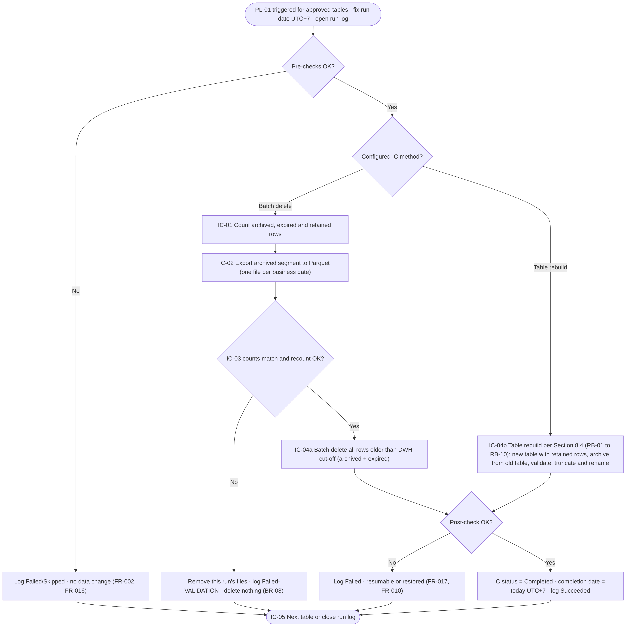
Figure 4 – Initial Cut-off Run – functional process flow per table
PL-01 executes the flow for each table in the supplied list, sequentially. The method configured for the table decides between the batch-delete path (IC-01 to IC-04a) and the table rebuild (IC-04b, Section 8.4).
Process ID and Name | PRC-02 Initial Cut-off Run
Process Objective | Archive the archived segment of a table once and remove all data older than the DWH cut-off date, including expired data (BRD 5.2).
Trigger and Execution Frequency | Manual or one-time trigger of PL-01 within 21:00–05:00 UTC+7 (BR-17). Once per table (BR-12); repeated only after a failure or stop.
Preconditions | PRC-01 complete; status PENDING, FAILED or STOPPED; restore point confirmed (R-02); ETL Owner agreement; for LARGE or TABLE_REBUILD tables a downtime reference (DBR-05); for a header table all active child tables COMPLETED (DBR-18).
Required Inputs | TableConfigId list, optional run date, downtime reference, configuration, parameters.
Processing Steps | Normal flow – BATCH_DELETE:  1. usp_StartRun fixes RunDate; usp_GetTablesToProcess validates the list (FR-004).  2. usp_BeginTable: lock, V-01 to V-09, pending resume (FR-017).  3. usp_IdentifyEligibleData: snapshot per business date (IC-01).  4. Per date: Copy activity → usp_LogExportResult (IC-02).  5. usp_ValidateArchive (IC-03).  6. usp_BatchDelete on col < DwhCutoffDate including expired rows (IC-04a).  7. usp_PostCheck: no rows before the DWH cut-off; retained rows not reduced; status COMPLETED.  8. usp_EndTable (IC-05); usp_EndRun after the last table.  Normal flow – TABLE_REBUILD: steps 1–2, then RB-01 to RB-10 (Section 8.4), then steps 7–8.  Child tables: same flow with the header-based predicates of FR-023; schedule child tables in an earlier window than their header table.  Exception flow:  E1 Pre-check failure → FAILED/SKIPPED, no change.  E2 Export failure or window end during export → files of the run removed, nothing removed from the DWH.  E3 Validation failure → files removed, nothing removed (also no expired data, BR-08).  E4 Window end during batch delete → STOPPED, resumed by the next run.  E5 Rebuild failure → Section 8.4 failure handling.
Decision Points | Pre-checks pass? Pending resume? Method? Rows to export > 0? Counts match? Window end reached? Post-check passed?
Business Rules | BR-03, BR-05, BR-08 to BR-12, BR-16, BR-17, DBR-02, DBR-03, DBR-05, DBR-06, DBR-13, DBR-16, DBR-17
Data Validation | V-01 to V-09; per-date and total row counts; pre-delete recount; post-check.
Output | Parquet files from the archive cut-off date to the day before the DWH cut-off date; reduced DWH table; status COMPLETED.
Error Handling | Section 13. A failed table never blocks other tables in the list.
Logging and Monitoring | Run, table, archive-date and step records.
Postconditions | Table contains only rows with business date ≥ DwhCutoffDate; Parquet row count equals rows removed for the archived range (AC-03, AC-04).
Acceptance Criteria | AC-03, AC-04, AC-05, AC-14; TS-012 to TS-019.
Table 50 – PRC-02 Initial Cut-off Run – process specification
Pseudocode – Initial Cut-off Run per table, batch-delete path:
runId, runDate := usp_StartRun('INITIAL_CUTOFF', runDate?) -- run date = today UTC+7
FOR EACH t IN usp_GetTablesToProcess(runId, list) SEQUENTIAL:
b := usp_BeginTable(runId, t) -- lock, V-01..V-09
IF b.result <> 'PROCEED' THEN usp_EndTable(b.tableLogId); CONTINUE
WHILE b.pendingResume IS NOT NULL: resume(b.pendingResume) -- FR-017
e := usp_IdentifyEligibleData(b.tableLogId) -- IC-01
IF e.nextAction = 'EXPORT':
FOR EACH d IN usp_GetExportPlan(b.tableLogId): -- IC-02
IF NOT usp_CheckExecutionWindow(runId) THEN stop(t); cleanup(t, runId); BREAK
r := Copy(source = usp_ExportSourceRows(b.tableLogId, d), sink = file(d, runId))
usp_LogExportResult(b.tableLogId, d, r.status, r.rowsRead, r.rowsCopied)
IF e.nextAction IN ('EXPORT','VALIDATE'):
v := usp_ValidateArchive(b.tableLogId) -- IC-03
IF v.result = 'FAILED' THEN cleanup(t, runId) -- nothing removed
ELSE usp_BatchDelete(runId, b.tableLogId) -- IC-04a, col < DwhCutoffDate
usp_PostCheck(b.tableLogId) -- COMPLETED + completion date
usp_EndTable(b.tableLogId) -- IC-05, release lock
usp_EndRun(runId)

8.3 PRC-03 Daily Routine
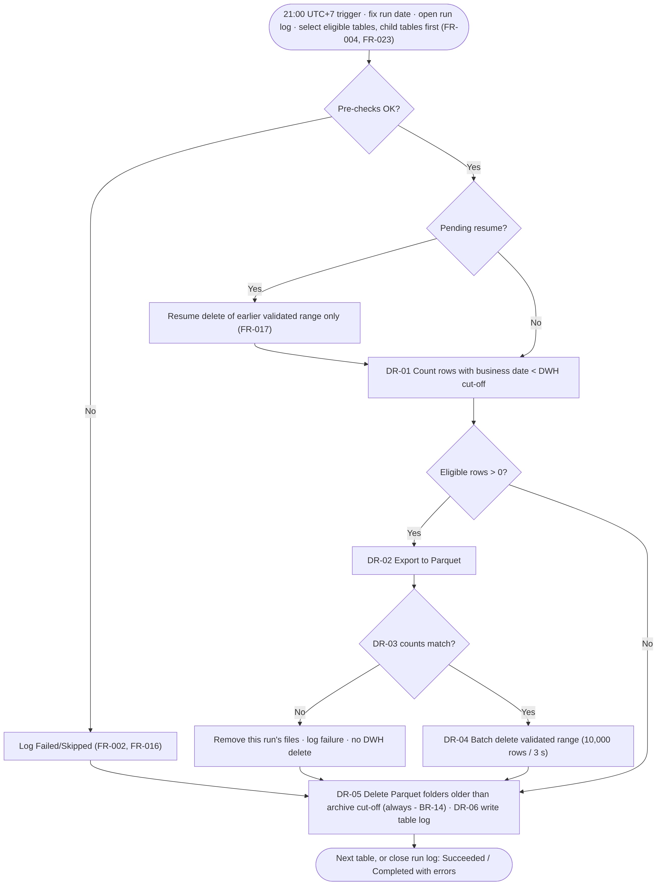
Figure 5 – Daily Routine – functional process flow per table
PL-02 executes the flow for each selected table. DR-05 (expired archive deletion) and DR-06 (logging) run for every table that passed V-05 and V-06, whatever happened earlier in the flow.
Process ID and Name | PRC-03 Daily Routine
Process Objective | Keep each table within the rolling retention window every day (BRD 5.3).
Trigger and Execution Frequency | ADF schedule trigger every day at 21:00 UTC+7 (BR-18).
Preconditions | Activated per FR-020; tables selected per FR-004.
Required Inputs | Configuration, parameters, status, earlier table logs (resume).
Processing Steps | Normal flow:  1. usp_StartRun; usp_GetTablesToProcess (active, COMPLETED, completion date < RunDate, RunDate ≥ DailyRoutineStartDate).  2. Per table: usp_BeginTable; resume pending ranges (FR-017).  3. DR-01 usp_IdentifyEligibleData (col < DwhCutoffDate); if 0 rows go to step 7.  4. DR-02 export each business date (normally one).  5. DR-03 usp_ValidateArchive.  6. DR-04 usp_BatchDelete; usp_PostCheck.  7. DR-05 Get Metadata → usp_GetExpiredArchiveFolders → Delete → usp_LogExpiredArchiveResult.  8. DR-06 usp_EndTable; after the last table usp_EndRun.  Exception flow:  E1 Pre-check failure → steps 3–6 skipped; step 7 if V-05/V-06 passed.  E2 Export failure → files of the run removed; continue at step 7.  E3 Validation failure → files removed, nothing deleted; continue at step 7 (BR-14).  E4 Delete failure → FAILED, resumed next day; step 7 still executed.  E5 Expired deletion failure → step FAILED; retried next day.
Decision Points | Pre-checks pass? Pending resume? Eligible rows > 0? Counts match? Folder older than the archive cut-off?
Business Rules | BR-03 to BR-08, BR-10, BR-12, BR-14, BR-18, DBR-02, DBR-04, DBR-06 to DBR-10, DBR-12
Data Validation | V-01 to V-09; per-date and total counts; recount; post-check.
Output | New Parquet files; rows deleted; expired folders deleted; logs.
Error Handling | Section 13. One table’s failure never stops other tables.
Logging and Monitoring | Run, table, archive-date and step records; ADF run marked failed when any table failed [REC].
Postconditions | Each successfully processed table has no rows before DwhCutoffDate and no archive files before ArchiveCutoffDate.
Acceptance Criteria | AC-07, AC-08, AC-15, AC-16; TS-020 to TS-028.
Table 51 – PRC-03 Daily Routine – process specification
Pseudocode – batch delete (ret.usp_BatchDelete):
recount := COUNT(*) WHERE col < @Upper [AND col >= @Lower]
IF first attempt AND recount <> ValidatedRowCount THEN revoke validation; ERR-VAL-02; RETURN -- DBR-06
IF resume AND recount > ValidatedRowCount - RowsDeleted THEN integrity flag; ERR-VAL-03; RETURN
LOOP
IF IC AND NOT fn_IsWithinWindow(now UTC+7, IcWindowStart, IcWindowEnd) THEN STOPPED; RETURN
BEGIN TRAN
DELETE TOP (@BatchSize) FROM <table> WHERE col < @Upper [AND col >= @Lower]
UPDATE ret.RetentionTableLog SET RowsDeleted += @@ROWCOUNT, DeleteBatchCount += 1
COMMIT -- retry on 1205 / 1222 up to DeleteRetryCount
IF rows < @BatchSize THEN EXIT LOOP
WAITFOR DELAY fn_DelayString(@BatchPauseSeconds)
END LOOP
IF COUNT(*) in range > 0 THEN ERR-DEL-02 ELSE DeleteStatus := 'COMPLETED'

8.4 Table Rebuild Procedure (part of PRC-02)
The table rebuild follows the five steps of MD-04. This FSD adds the controls needed to meet BR-08 (no removal before successful validation), BRQ-09 (same table definition) and the behaviour of Azure SQL Database. Steps marked [MD] come from the meeting decision; steps marked [DER] are additions that require approval (DEC-13, DEC-14).
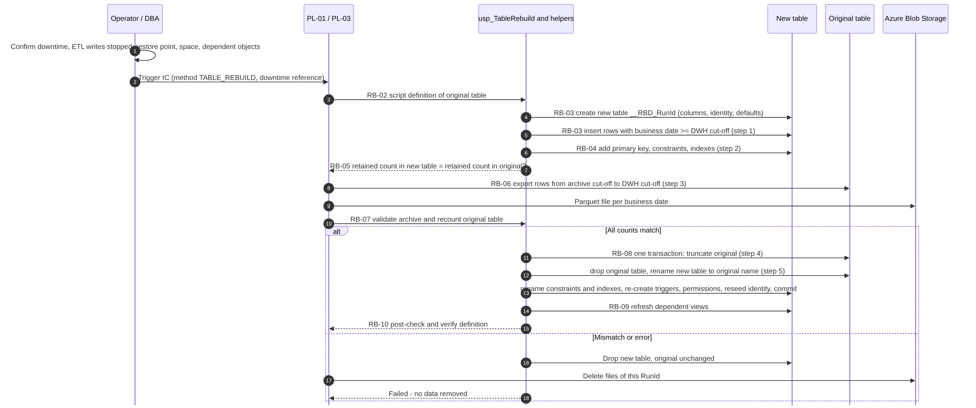
Figure 6 – Table rebuild – sequence
Step | MD-04 | Activity | Control / on failure
RB-01 | – | [DER] Confirm preconditions: downtime reference on the run; ETL writes to the table stopped until RB-10; restore point confirmed (R-02); free database space for the new table and its indexes and log capacity agreed with the DBA (OQ-24). Reject unsupported tables: incoming foreign keys, schema-bound or indexed views, CDC, change tracking, temporal or replicated tables, rowversion or GENERATED ALWAYS columns. | Unsupported → ERR-RBD-04, nothing changed. The table must use batch delete or an approved table-specific script (OQ-11).
RB-02 | – | [DER] Script the full definition of the original table: columns (type, collation, nullability, identity seed, increment and current value, computed columns, defaults), primary key, unique and check constraints, outgoing foreign keys, clustered and non-clustered indexes (keys, included columns, filters, compression), triggers, object permissions, extended properties. Record the retained row count (col >= DwhCutoffDate), the archived count and the expired count. | Definition snapshot is the reference for RB-10.
RB-03 | Step 1 | [MD] Create the new table in the same schema under a temporary name (proposed <table>__RBD_<RunId>) with the scripted columns, identity and defaults, and insert the rows with business date on or after the DWH cut-off date (identity values preserved). For a child table: all rows that are not eligible, including orphan rows (FR-023). [REC] Insert in committed batches by business-date range to limit transaction size, because Azure SQL Database logs every insert fully. | Failure → drop the new table; original unchanged (ERR-RBD-01).
RB-04 | Step 2 | [MD] Add to the new table the primary key, unique and check constraints, outgoing foreign keys and indexes copied from the original, using temporary names (constraint and index names must be unique within the schema while the original still exists). | Failure → drop the new table (ERR-RBD-01).
RB-05 | – | [DER] Check: rows in the new table = retained rows of the original counted now = retained count of RB-02. A difference means ETL wrote to the table. | Mismatch → drop the new table (ERR-RBD-01).
RB-06 | Step 3 | [MD] Export the archived segment (ArchiveCutoffDate <= col < DwhCutoffDate) from the original table to Parquet, one file per business date (FR-006, FR-007). | Failure or window end → remove files of the run, drop the new table (ERR-EXP-01 / ERR-WIN-01).
RB-07 | – | [DER] Validate the archive (FR-008) and recount the original table: archived and expired counts unchanged since RB-02 (DBR-06, DBR-17). | Mismatch → remove files, drop the new table (ERR-VAL-01 / ERR-VAL-02).
RB-08 | Steps 4–5 | [MD-04, MD-06, DEC-13] In one transaction with an exclusive table lock: re-check the counts; truncate the original table (step 4); drop the original table, which frees its constraint, index and trigger names; rename the new table to the original name (step 5); rename its constraints and indexes to the original names; re-create triggers; re-apply object permissions and extended properties; reseed identity to the original current value; commit. | Any error → rollback; the original table and its data are unchanged (ERR-RBD-02); remove files of the run; drop the new table.
RB-09 | – | [DER] Refresh dependent non-schema-bound views (sp_refreshview). | Error → ERR-RBD-03, DBA procedure; data is already correct.
RB-10 | – | [DER] Post-check (usp_PostCheck): no rows before the DWH cut-off; retained count equals RB-02; definition equals the RB-02 script. Status COMPLETED. | Difference → ERR-DEL-02 or ERR-RBD-03, integrity flag.
Table 52 – Table rebuild steps
Truncate and drop (MD-06): after truncation the original table is empty and has no value as a fallback; the fallback is the Parquet archive plus point-in-time restore of Azure SQL Database. Dropping it frees the names of its constraints, indexes and triggers, so the new table can take the original names. Truncate, drop and rename run in one transaction: a failure rolls back all three and the original table keeps its data (DEC-13).
Duration: steps RB-03 to RB-08 must run while ETL writes are stopped. For the largest candidates (Appendix A) the insert of three years of rows plus the export of five years may not fit in one 21:00–05:00 window (BRD R-11). Because the archived segment is older than three years and does not change (A-03), its export could be done in earlier windows before the downtime, leaving only RB-03 to RB-05, RB-07 and RB-08 in the downtime. This changes the MD-04 order and is raised for decision (OQ-11).

8.5 PRC-04 Expired Archive File Deletion
Process ID and Name | PRC-04 Expired Archive File Deletion
Process Objective | Remove archive files with a business date before the archive cut-off date (DR-05).
Trigger and Execution Frequency | Daily Routine, per table, after the DWH steps (always when V-05 and V-06 passed).
Preconditions | BlobPath known; ArchiveCutoffDate calculated.
Required Inputs | Child items of the table root folder; ArchiveCutoffDate.
Processing Steps | 1. ADF Get Metadata (child items) of <container>/<BlobPath>: year folders.  2. usp_GetExpiredArchiveFolders (level YEAR) returns year folders before the cut-off year and the cut-off year folder to descend into.  3. Delete returned folders (recursive); Get Metadata of the cut-off year: month folders.  4. usp_GetExpiredArchiveFolders (level MONTH) returns month folders before the cut-off month and the cut-off month folder.  5. Delete returned folders; Get Metadata of the cut-off month: day folders.  6. usp_GetExpiredArchiveFolders (level DAY) returns day folders before the cut-off day; delete them.  7. usp_LogExpiredArchiveResult records folders and files deleted.
Decision Points | Name matches year=YYYY, month=MM or day=DD? Before the cut-off at that level? Cut-off folder present (descend) or absent (stop)?
Business Rules | BR-14, DBR-12
Data Validation | Pattern and date parsed before deletion; nothing deleted outside the table root folder.
Output | Folders and files deleted.
Error Handling | Listing or deletion error → ERR-ARC-01; idempotent, completed by the next run.
Logging and Monitoring | Step log EXPIRE; table log ArchiveFoldersDeleted, ArchiveFilesDeleted.
Postconditions | No expired folder remains for the table.
Acceptance Criteria | AC-08, SC-03; TS-025, TS-044.
Table 53 – PRC-04 Expired Archive File Deletion – process specification
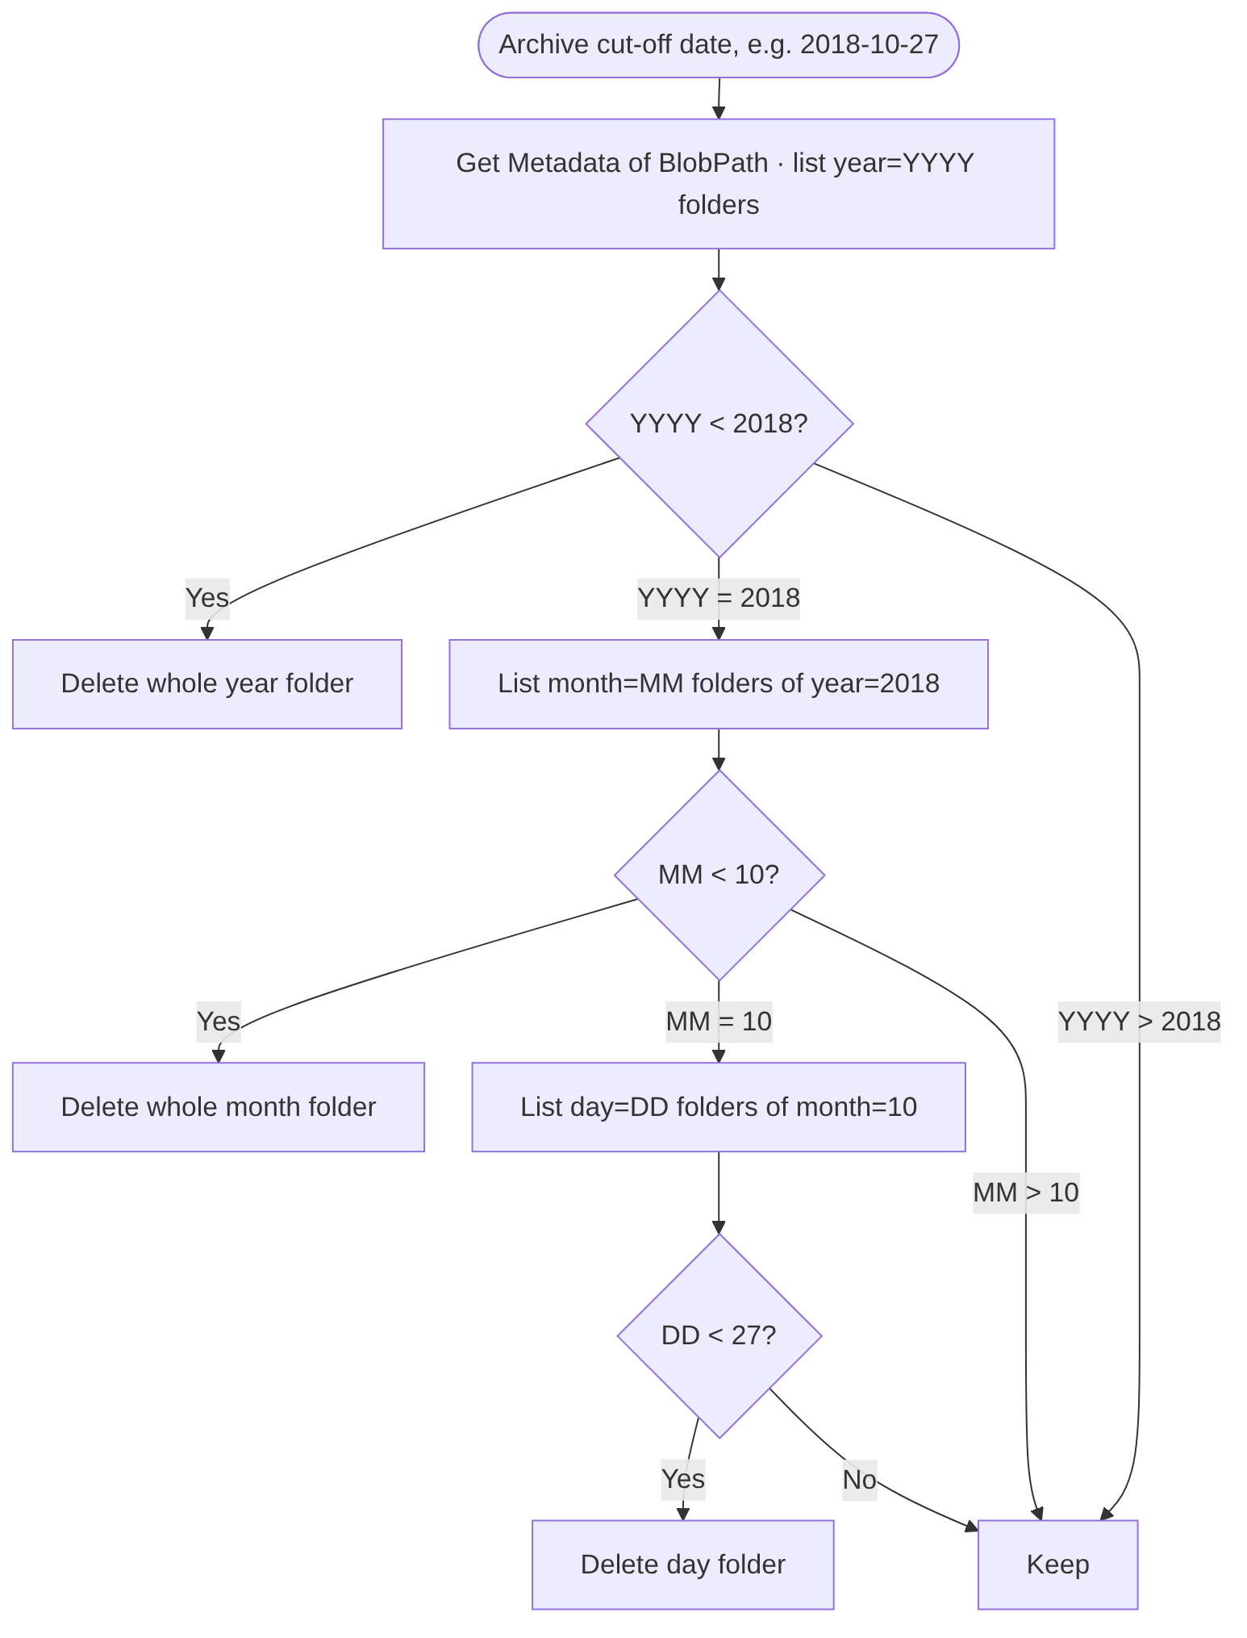
Figure 7 – Expired archive deletion – hierarchical traversal (example archive cut-off 2018-10-27)
With the MD-07 layout each Get Metadata call lists at most about 9 year folders, 12 month folders or 31 day folders, instead of about 1,830 business-date folders in one level. Whole years and months are deleted with one recursive Delete activity each.

8.6 PRC-05 Rerun and Recovery
Process ID and Name | PRC-05 Rerun and Recovery
Process Objective | Return a table to a consistent state after a failure without data loss or duplicate archive content.
Trigger and Execution Frequency | Automatically at the start of each table processing; manually by an operator after investigation.
Preconditions | Cause resolved (manual reruns); no stale lock (or released via usp_AdminCloseStaleRun).
Required Inputs | Earlier table logs; current DWH counts.
Processing Steps | 1. usp_BeginTable returns the oldest pending range.  2. Check rows remaining in the range ≤ ValidatedRowCount − RowsDeleted.  3. Remove the remaining rows of that range only, without export; mark COMPLETED with ResumedByRunId.  4. Repeat for further pending ranges, then continue normal processing.  5. A rebuild that failed before RB-08 is repeated from RB-01; a rebuild that failed after commit needs the DBA procedure.
Decision Points | Pending resume? Remaining ≤ expected? Orphan or integrity flag set?
Business Rules | DBR-06 to DBR-10
Data Validation | Remaining-rows check; post-check.
Output | Completed removal of earlier ranges.
Error Handling | Remaining > expected → ERR-VAL-03, integrity flag, nothing removed.
Logging and Monitoring | Step RESUME with ReferenceRunId; table log ResumeRowsDeleted.
Postconditions | No pending resume for the table.
Acceptance Criteria | TS-032 to TS-036.
Table 54 – PRC-05 Rerun and Recovery – process specification

8.7 PRC-06 Configuration Change
Change | Required behaviour | Source
Add table | Onboarding (PRC-01), own Initial Cut-off Run, Daily Routine from the next day. | BR-12, AC-16
Deactivate table (IsActive = 0) | Not processed from the next run. Whether its expired archive files are still deleted is TBC (OQ-07). | BRQ-04, OQ-07
Reactivate table | Rows that aged during inactivity are processed by the next Daily Routine as normal eligible data. Whether a new Initial Cut-off Run is required is TBC (OQ-07). | OQ-07
Remove table | Set IsActive = 0 instead of deleting the row; rows with log history cannot be deleted (foreign keys). | BRQ-04
Change DWH or blob years | Allowed. An increase does not restore archived or deleted data; a decrease is applied by the next Daily Routine. | NFR-02, OQ-21
Change schema, table, retention column or blob path | Rejected by the update trigger once archiving has started; requires an approved change procedure. | OQ-22
Add child table | Header table must already be configured; the child IC must complete before the header IC (DBR-18). If the header is already COMPLETED, child rows whose header rows were removed are orphans and are kept (DBR-21). | FR-023
Change ParentTableConfigId or join keys | Rejected once archiving has started for the child table (same rule as the retention column). | FR-023, OQ-22
Table 55 – Configuration change behaviour

8.8 PRC-07 Parent-Dated Processing of Child Tables
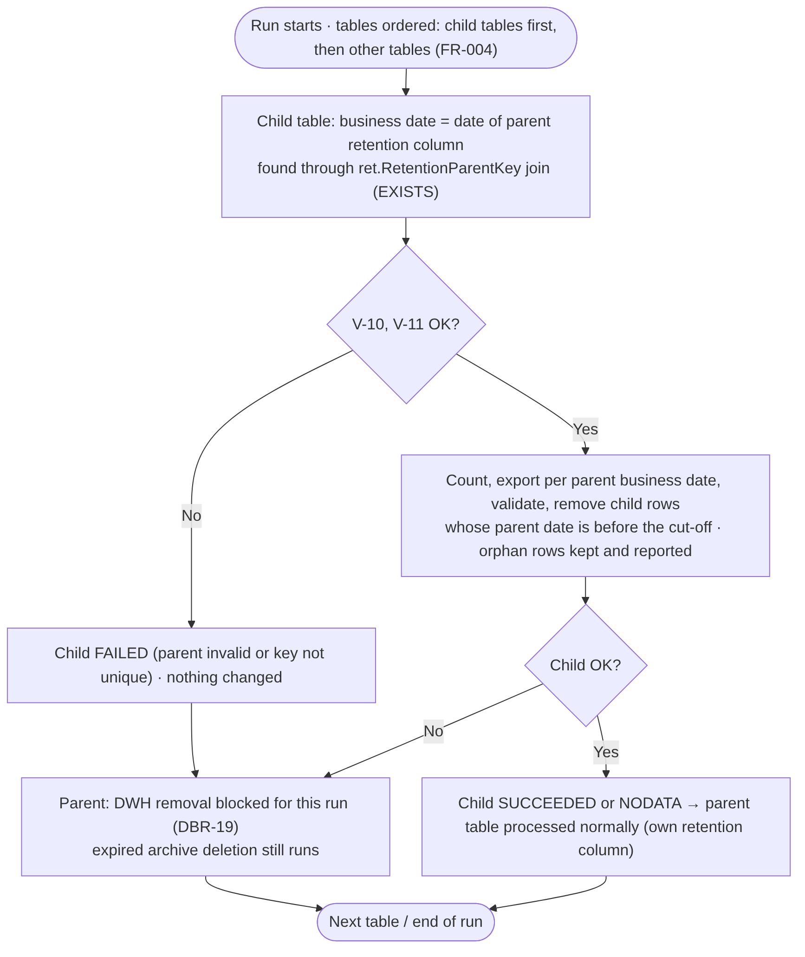
Figure 8 – Parent-dated processing of a child table and its header table
Process ID and Name | PRC-07 Parent-Dated Processing of Child Tables
Process Objective | Apply retention to child tables through their header table without changing the DWH tables, and keep child and header consistent (FR-023, MD-05).
Trigger and Execution Frequency | Part of every Initial Cut-off Run and Daily Routine for tables with ParentTableConfigId.
Preconditions | Header table configured with its own retention column; join keys recorded; same retention years as the header (DBR-20).
Required Inputs | Child and header configuration, ret.RetentionParentKey, cut-off dates of the header.
Processing Steps | 1. Order: child tables before all other tables (DBR-19); in the IC the operator schedules child tables before their header (DBR-18).  2. usp_BeginTable: lock the child; check that the header is not locked; V-01 to V-11.  3. Count per header business date with EXISTS; count orphan rows (warning ERR-PAR-01).  4. Export per business date with the join source; validate; remove eligible child rows (batch delete or rebuild with NOT EXISTS retained set).  5. Post-check: no child row with header date before the DWH cut-off.  6. Header table: if any active child did not end SUCCEEDED or NODATA in this run, skip DWH removal (DR-02 to DR-04) and log the reason; DR-05 still runs.
Decision Points | V-10 and V-11 pass? Child succeeded? Header gate satisfied?
Business Rules | BR-08, DBR-18 to DBR-21
Data Validation | V-10 header configuration; V-11 uniqueness of the join key in the header (unique index or primary key on the header columns, or a duplicate count of zero).
Output | Archive and removal for the child table; orphan count.
Error Handling | ERR-CFG-11, ERR-CFG-12 (child FAILED, nothing changed); ERR-PAR-01 (warning).
Logging and Monitoring | Step COUNT records eligible and orphan rows; step SELECT_TABLES records skipped header removals.
Postconditions | Child and header contain no rows whose business date is before the DWH cut-off, except orphan child rows.
Acceptance Criteria | FR-023 acceptance criteria; TS-050 to TS-055.
Table 56 – PRC-07 Parent-Dated Processing of Child Tables – process specification

9. Business Rules

9.1 Business Rules from the BRD
The following rules are stated in BRD Section 6 (v0.1). Identifiers are unchanged.
ID | Rule (summary) | Related FR | Condition | Expected behaviour | Boundary / exception
BR-01 | DWH keeps data of the last three years; configurable. | FR-001, FR-003 | Business date ≥ DWH cut-off date | Row retained | Business date = cut-off date is retained
BR-02 | Total retention eight years: three in the DWH, five in Azure Blob Storage; configurable. | FR-001, FR-006, FR-013 | Archive cut-off ≤ business date < DWH cut-off | Archived, then removed from the DWH | Stored as DWH + blob years (DV-02)
BR-03 | Cut-off dates = run date − retention periods. | FR-003 | Every run | Dates per table | 29 February handled by DATEADD (Section 10.4)
BR-04 | Run date in UTC+7. | FR-003 | Every run | Run date = UTC+7 date at start | Azure SQL Database server time is UTC
BR-05 | Only the date part of the business date is used. | FR-003, FR-005 | Datetime retention column | Compare with date-typed cut-off | 23:59:59 on the day before the cut-off is eligible
BR-06 | Retention column date or datetime and not NULL. | FR-002 | Each table | V-03, V-04 | datetimeoffset TBC (OQ-13); child tables use the header column (FR-023, DV-04)
BR-07 | Rolling window recalculated daily. | FR-003, FR-012 | Daily Routine | Cut-offs move with the run date | –
BR-08 | Remove only after successful validation; in the IC also expired data. | FR-008, FR-010, FR-011 | Before any removal | No removal on mismatch | Zero archived rows in the IC (DBR-03); rebuild gates (DBR-17)
BR-09 | IC removes expired data without archiving. | FR-010, FR-011 | IC, business date < archive cut-off | Removed with the archived range | Only after BR-08 is satisfied
BR-10 | Table rebuild only in the IC; Daily Routine always batch delete. | FR-009, FR-010, FR-012 | Daily Routine | Batch delete regardless of configured IC method | –
BR-11 | Default IC method by size; exceptions per technical assessment. | FR-001, FR-010 | Onboarding | Method recorded in configuration | Thresholds TBD (D-05, OQ-12)
BR-12 | IC once per table; Daily Routine from the day after all initial ICs; later tables after their own IC. | FR-004, FR-020 | Table selection | Status-based eligibility | Completion after midnight (DBR-04)
BR-13 | Tables and columns from configuration; no auto-detection. | FR-001, FR-002, FR-023 | Every run | Only configured rows processed | Join keys of child tables also configured (DV-04)
BR-14 | Expired Parquet files deleted daily, also when validation fails. | FR-013 | Daily Routine | DR-05 always runs | Needs V-05, V-06; inactive tables (OQ-07)
BR-15 | Results in log tables; no alerts. | FR-014, FR-015 | Every run | Log records | –
BR-16 | IC: small and medium first, large after downtime determined. | FR-004, FR-010 | Large-table IC | Rejected until conditions met (DBR-05) | –
BR-17 | IC within 21:00–05:00 UTC+7, scheduled with the ETL Owner. | FR-011, FR-019 | IC execution | Stop at window end | Rebuild not interrupted after RB-03
BR-18 | Daily Routine starts at 21:00 UTC+7. | FR-012 | Daily | Schedule trigger 21:00 | Overrun → next run queued
Table 57 – Business rules from the BRD

9.2 Derived Business Rules (Require Confirmation)
These rules are not stated in the BRD. They are derived to make the BRD requirements implementable and safe and require confirmation.
ID | Rule | Related FR | Expected behaviour | Basis
DBR-01 | DwhRetentionYears ≥ 1 and BlobRetentionYears ≥ 1. | FR-001, FR-002 | Invalid row rejected | BR-01, BR-02
DBR-02 | Run date and cut-off dates are fixed at run start and computed as UTC + 7 hours (no daylight saving in WIB). | FR-003 | Same dates for the whole run | BR-04, C-03
DBR-03 | In the IC, when no archived rows exist, expired rows may be removed (validation vacuously satisfied). | FR-005, FR-011 | Expired rows removed | BR-08
DBR-04 | Daily Routine includes a table only if run date > IC completion date (UTC+7 date of completion). | FR-004, FR-020 | Excluded on the completion day | BR-12, AC-16
DBR-05 | LARGE or TABLE_REBUILD tables need a downtime reference; LARGE tables only after all active SMALL and MEDIUM tables are COMPLETED. | FR-004, FR-010 | Skipped otherwise | BR-16
DBR-06 | Pre-delete recount must equal the validated total. | FR-008 | No removal on difference | BR-08, A-03
DBR-07 | Archive files are never overwritten and carry the RunId. | FR-007 | New file names per run | BRQ-06
DBR-08 | On export or validation failure, the files of the current run are removed. | FR-018 | Archive returns to prior state | BR-08
DBR-09 | A validated but incompletely removed range is resumed without re-export. | FR-017 | Remaining rows removed only | BR-08
DBR-10 | At most one active processing per table. | FR-016 | Second run skips the table | NFR-08
DBR-11 | Only active tables are processed, including in the IC. | FR-004 | Inactive tables skipped | BRD 7.3 Active flag
DBR-12 | Archive items not matching the naming pattern are never deleted. | FR-013 | Warning logged | BR-14
DBR-13 | The IC stops at the window end in a resumable state. | FR-019 | STOPPED | BR-17
DBR-14 | Deleted total ≠ validated total raises a non-blocking reconciliation warning. | FR-009 | Flag for investigation | NFR-08
DBR-15 | A supplied run date may not be later than the current UTC+7 date. | FR-003 | Run rejected | BR-04
DBR-16 | ETL writes to a table are stopped from RB-03 until RB-10 of its rebuild. | FR-010 | Rebuild fails if counts change | MD-04, R-05
DBR-17 | The original table is truncated only after the archive is validated and the retained, archived and expired counts are unchanged since RB-02. | FR-010 | No truncation otherwise | BR-08, MD-04
DBR-18 | The Initial Cut-off Run of a header table is refused until all its active child tables are COMPLETED. | FR-004, FR-023 | Header SKIPPED (ERR-CFG-07) | MD-05
DBR-19 | In the Daily Routine child tables are processed first; a header table skips DWH removal in a run in which one of its active child tables did not end SUCCEEDED or NODATA. | FR-004, FR-023 | Header removal skipped; DR-05 still runs | MD-05, BR-14
DBR-20 | Only one level: a header table has its own retention column and is not itself a child table; a child table has the same retention years as its header. | FR-001, FR-023 | V-10 fails otherwise | MD-05
DBR-21 | Orphan child rows (no header row) are never removed by the retention process; they are kept, also in a table rebuild, and reported. | FR-023, FR-010 | Warning ERR-PAR-01 | NFR-08
Table 58 – Derived business rules

10. Data Requirements and Data Processing

10.1 Data Sources and Source Data Objects
The data source is the DWH database on Azure SQL Database. The DWH table list (REF-03) contains 422 tables in schemas BI (88), bos (179), sli (101) and dbo (53). 102 tables have an entry in the retention column field. Appendix A lists them with their classification:
Class | Count | Description | Treatment in this FSD
A – Own retention column | 68 | The proposed retention column is a column of the table (for example dtmDate, Date, dtmDelivery, TransactionDate). | Can be configured as specified, after V-01 to V-09 pass and the Business / Data Owner confirms the column.
A1 – of which last-update columns | 16 | Retention column is dtmLastUpdated or dtmLastUpdate (a technical timestamp), and 1 uses dtmLastWeek. | Confirmation required that the column is the business date (OQ-04).
B – Child table (parent-dated) | 32 | No own date column; the retention column field holds a join query to a header table (for example BOS_SD_FDoItem to BOS_SD_FDo). | Processed through their header table (FR-023, MD-05) after the header table and join keys are confirmed (Appendix A.2).
C – Unconfirmed | 2 | JTI_SPV_JoinCallOutletPlan (dtmDate) and JTI_SPV_JourneyCall (dtmLastUpdated) are marked “?”. | Confirmation required (OQ-05).
D – Other remark | 1 | dbo.PNL_OPE_Depreciation has no retention column and the remark “All”. | Meaning TBC (OQ-05).
Table 59 – Classification of candidate tables
The 102 candidates hold about 1.81 billion rows and 777 GB (Total Space). 18 of them are 10 GB or larger, 17 are between 1 and 10 GB, and 67 are below 1 GB. These bands are for information only; the SMALL, MEDIUM and LARGE thresholds are set by the technical assessment (D-05). The 32 child tables hold about 165 GB and depend on 21 header tables; 6 of them inherit a last-update column from their header (OQ-04).
Data quality of the list: the list does not state data types or nullability of the proposed columns (checked at run time, V-03 and V-04). Some join queries contain errors (for example BOS_SD_RemainStockInCustItem joins a.szCustId = a.szCustId; dbo.BOS_SD_TOTrackingProduct refers to bos tables; BOS_SD_FDjrItem has a missing space). Backup or duplicate tables are included (Fact_BrandFunnel_BK, Fact_Switching_tracker_BK, JTI_SD_SalesReport_backup, JTI_SD_FdjrItemStatus_new, BOS_SD_TOTracking in both bos and dbo). These points are part of OQ-05.

10.2 Required Attributes
For each table the process needs only the retention column for selection; all columns are exported unchanged. Column metadata (name, ordinal position, data type, nullability) is read from the catalog at run time.

10.3 Data Selection and Filtering Rules
Purpose | Predicate (logical) | Process
Retained segment | col >= DwhCutoffDate | IC post-check; RB-03 insert into the new table
Archived segment | col >= ArchiveCutoffDate AND col < DwhCutoffDate | IC-01, IC-02, RB-06
Expired segment | col < ArchiveCutoffDate | IC-04 (removed with the archived segment)
Eligible (Daily Routine) | col < DwhCutoffDate | DR-01, DR-02, DR-04
Export unit | col >= d AND col < DATEADD(DAY, 1, d) | FR-006
Expired archive | year, month or day folder before the archive cut-off (Figure 7) | DR-05
Child table, eligible | EXISTS (SELECT 1 FROM <header> p WHERE <join keys> AND p.<col> < @DwhCutoffDate) | FR-023
Child table, retained (rebuild) | NOT EXISTS (SELECT 1 FROM <header> p WHERE <join keys> AND p.<col> < @DwhCutoffDate) – includes orphan rows | FR-023, RB-03
Table 60 – Selection predicates

10.4 Cut-off Date Calculation Examples
Run date | DWH cut-off (−3 years) | Archive cut-off (−8 years) | Comment
27 Oct 2026 | 27 Oct 2023 | 27 Oct 2018 | BRD 4.3 example.
28 Feb 2027 | 28 Feb 2024 | 28 Feb 2019 | Rows of 29 Feb 2024 are retained.
01 Mar 2027 | 01 Mar 2024 | 01 Mar 2019 | Rows of 28 and 29 Feb 2024 become eligible together.
29 Feb 2028 | 28 Feb 2025 | 29 Feb 2020 | DATEADD maps 29 Feb to 28 Feb in 2025; 2020 is a leap year.
01 Mar 2028 | 01 Mar 2025 | 01 Mar 2020 | Normal progression.
Table 61 – Cut-off date examples (3 + 5 years)

10.5 Data Validation
ID | Check | Rule | IC | DR | On failure
V-01 | Object exists | Schema and table exist in the current database. | Yes | Yes | ERR-CFG-01
V-02 | Retention column exists | Column exists in the table. | Yes | Yes | ERR-CFG-02
V-03 | Data type | date, datetime, datetime2 or smalldatetime; datetimeoffset excluded pending OQ-13. | Yes | Yes | ERR-CFG-03
V-04 | No NULL values | IC: full NULL count = 0. DR: per DailyNullCheckMode (FULL or METADATA). | Full | Per mode | ERR-CFG-04
V-05 | Retention periods | DBR-01. | Yes | Yes | ERR-CFG-05
V-06 | Blob path and container | Blob path present, lower case, no leading or trailing slash, unique; ArchiveContainer set and valid. | Yes | Yes | ERR-CFG-06
V-07 | Eligibility | Selection rules of FR-004. | Yes | n/a | ERR-CFG-07
V-08 | Parquet compatibility | No sql_variant, CLR or spatial types; no column names with characters Parquet does not accept (list to be confirmed in a proof of concept). | Yes | Yes | ERR-CFG-08
V-09 | No blocking flag | No orphan-file or integrity flag on ret.RetentionTableStatus. | Yes | Yes | ERR-CFG-09
V-10 | Header configuration (child only) | Header row exists, is active, has its own retention column, is not a child table, has the same retention years; join columns exist in both tables with compatible types; header not locked by another run. | Yes | Yes | ERR-CFG-11 / ERR-LCK-01
V-11 | Join key unique in header (child only) | A primary key or unique index covers the header join columns, or a duplicate count on them returns zero (IC: always counted). | Yes | Yes | ERR-CFG-12
Table 62 – Validation checks

10.6 Physical Data Design – Schema ret
The following tables are taken from the design table workbook (REF-02) without change. Review remarks are added in brackets. All DATETIME2 values are UTC+7. Constraints, indexes and triggers follow REF-05 and are summarised after the column lists.
Table | Group | Function
ret.RetentionConfig | Configuration | Central configuration: one row per table under retention.
ret.RetentionTableStatus | Configuration | Initial Cut-off status, completion date and blocking flags per table.
ret.RetentionParameter | Configuration | Global parameters: batch size, pause, IC window, retries, Daily Routine start date.
ret.RetentionRunLog | Logging | One row per pipeline execution.
ret.RetentionTableLog | Logging | One row per table per execution with all attributes and resume control.
ret.RetentionArchiveDate | Logging | Per business date snapshot and export result; basis of row-count validation.
ret.RetentionStepLog | Logging | Detailed step trail for troubleshooting.
ret.RetentionTableLock | Control | Prevents two runs from processing the same table.
ret.RetentionErrorCode | Reference | Reference list of error and warning codes.
Table 63 – Schema ret tables (design table)

10.6.1 ret.RetentionConfig
Column | Data type | Null | Default | Description
TableConfigId | INT IDENTITY | No | – | Surrogate key referenced by status, lock and log tables.
SchemaName | SYSNAME | No | – | Schema of the table under retention, e.g. BOS.
TableName | SYSNAME | No | – | Table under retention, e.g. JTI_SD_BrandDistDetail.
RetentionColumn | SYSNAME | No | – | Business date column. Must be date, datetime, datetime2 or smalldatetime and contain no NULL values; checked at run time. [Note: To change: NULL for a child table (MD-05)]
DwhRetentionYears | SMALLINT | No | 3 | Years kept in the DWH.
BlobRetentionYears | SMALLINT | No | 5 | Years kept as Parquet files in Azure Blob Storage after the DWH period. Total retention is not stored: it is calculated as DwhRetentionYears + BlobRetentionYears (3 + 5 = 8). [Note: DV-02]
BlobPath | NVARCHAR(400) | No | – | Table root folder inside the archive container. Unique; no leading or trailing slash. [Note: Lower case <schema>/<table> (MD-07)]
InitialCutoffMethod | VARCHAR(20) | No | – | Initial Cut-off Run method: BATCH_DELETE or TABLE_REBUILD.
IsActive | BIT | No | 1 | 1 = table is processed; 0 = excluded from process.
SizeCategory | VARCHAR(10) | No | – | SMALL, MEDIUM or LARGE from the technical assessment.
CreatedBy | NVARCHAR(128) | No | – | Login that created the row.
CreatedAt | DATETIME2(3) | No | Now (UTC+7) | Creation time (UTC+7).
ModifiedBy | NVARCHAR(128) | Yes | – | Login of the last change; set by trigger.
ModifiedAt | DATETIME2(3) | Yes | – | Time of the last change (UTC+7); set by trigger.
Table 64 – ret.RetentionConfig columns
Constraints: primary key TableConfigId; unique (SchemaName, TableName); unique BlobPath; checks for retention years ≥ 1, method, size category, non-empty names and blob path without leading or trailing slash. BRD 7.3 attributes “Database name” and “Total retention (years)” are represented differently (DV-01, DV-02). Changes for MD-05 and MD-07 are listed in Section 10.6.11.

10.6.2 ret.RetentionTableStatus
Column | Data type | Null | Default | Description
TableConfigId | INT | No | – | Configuration entry (primary key and foreign key).
InitialCutoffStatus | VARCHAR(10) | No | PENDING | PENDING, RUNNING, FAILED, STOPPED or COMPLETED.
InitialCutoffCompletionDate | DATE | Yes | – | UTC+7 calendar date on which the Initial Cut-off Run completed. The Daily Routine includes the table only when run date > this date.
LastInitialCutoffRunId | BIGINT | Yes | – | Last run that executed the Initial Cut-off Run for the table.
HasOrphanFiles | BIT | No | 0 | 1 = archive files of a failed run could not be removed. Blocks processing.
OrphanFilesRunId | BIGINT | Yes | – | Run that left the orphan files.
HasIntegrityIssue | BIT | No | 0 | 1 = integrity problem detected. Blocks processing.
IntegrityIssueRunId | BIGINT | Yes | – | Run that raised the integrity flag.
HasReconciliationWarning | BIT | No | 0 | 1 = deleted total differed from validated total. Informational, not blocking.
ReconciliationWarningRunId | BIGINT | Yes | – | Run that raised the warning.
FlagComment | NVARCHAR(400) | Yes | – | Reason for the last flag change, including operator comments when cleared.
ModifiedBy | NVARCHAR(128) | No | – | Login of the last change.
ModifiedAt | DATETIME2(3) | No | Now (UTC+7) | Time of the last change (UTC+7).
Table 65 – ret.RetentionTableStatus columns
Constraints: primary key and foreign key TableConfigId (cascade delete from configuration); completion date present only when status is COMPLETED; run identifiers present when a flag is set.

10.6.3 ret.RetentionParameter
Column | Data type | Null | Default | Description
ParameterSetId | TINYINT | No | – | Global parameter ID
BatchSize | INT | No | 10000 | Maximum rows per delete batch.
BatchPauseSeconds | INT | No | 3 | Pause between delete batches in seconds.
IcWindowStart | TIME(0) | No | 21:00 | Start of the Initial Cut-off Run window. Default 09:00 PM UTC+7.
IcWindowEnd | TIME(0) | No | 05:00 | End of the Initial Cut-off Run window. Default 05:00 AM UTC+7.
DailyRoutineStartDate | DATE | Yes | – | First run date on which the Daily Routine selects tables. Set by usp_ActivateDailyRoutine. [Note: FR-020]
DeleteRetryCount | TINYINT | Yes | – | Retries per delete batch on deadlock (1205) or lock timeout (1222). NULL = no retry.
DeleteLockTimeoutMs | INT | Yes | – | LOCK_TIMEOUT for delete batches in milliseconds. NULL = wait indefinitely.
DailyNullCheckMode | VARCHAR(10) | No | FULL | FULL = count NULLs in the retention column every Daily Routine; METADATA = skip the data check for nullable columns. [Note: OQ-14]
KeepRebuildStagingTable | BIT | No | 1 | 1 = keep the staging table after a table rebuild until sign-off. [Note: To remove: original table is dropped (MD-06)]
ArchiveContainer | NVARCHAR(63) | Yes | schema/table/year/month/ | Azure Blob Storage container of the archive. [Note: To change: container name only, no default path (MD-07, Section 10.6.11)]
ModifiedBy | NVARCHAR(128) | No | – | Login of the last change.
ModifiedAt | DATETIME2(3) | No | Now (UTC+7) | Time of the last change (UTC+7).
Table 66 – ret.RetentionParameter columns
Single-row table (ParameterSetId = 1). Compared with the previous FSD, the design table has no parameters for table and export parallelism; processing is therefore sequential (DEC-07, OQ-16). The Daily Routine start time (21:00) is an ADF trigger setting.

10.6.4 ret.RetentionRunLog
Column | Data type | Null | Default | Description
RunId | BIGINT IDENTITY | No | – | Unique execution identifier; also used in archive file names.
AdfPipelineRunId | UNIQUEIDENTIFIER | Yes | – | ADF pipeline run ID. Unique when present; makes usp_StartRun idempotent on ADF retries.
ProcessType | VARCHAR(20) | No | – | INITIAL_CUTOFF, DAILY_ROUTINE or VALIDATION.
RunDate | DATE | No | – | Run date in UTC+7, fixed for the whole run.
IsRunDateOverride | BIT | No | 0 | 1 = run date differs from the current UTC+7 date (manual rerun for an earlier date).
TriggerType | VARCHAR(10) | No | – | SCHEDULE or MANUAL.
TriggeredBy | NVARCHAR(256) | Yes | – | Operator identity for manual runs.
DowntimeReference | NVARCHAR(100) | Yes | – | Approved downtime reference; required for LARGE tables and TABLE_REBUILD.
StartTime | DATETIME2(3) | No | Now (UTC+7) | Run start (UTC+7).
EndTime | DATETIME2(3) | Yes | – | Run end (UTC+7); NULL while RUNNING.
Status | VARCHAR(25) | No | RUNNING | RUNNING, SUCCEEDED, COMPLETED_WITH_ERRORS or FAILED.
TablesSelected | INT | Yes | – | Tables selected for processing.
TablesSucceeded | INT | Yes | – | Tables ended SUCCEEDED or NODATA.
TablesFailed | INT | Yes | – | Tables ended FAILED or STOPPED.
TablesSkipped | INT | Yes | – | Tables skipped (not eligible or locked).
ErrorCode | VARCHAR(12) | Yes | – | Run-level error code, if any.
ErrorMessage | NVARCHAR(MAX) | Yes | – | Run-level error details.
IsClosedManually | BIT | No | 0 | 1 = closed by an operator with usp_AdminCloseStaleRun.
ClosedBy | NVARCHAR(128) | Yes | – | Operator who closed the run manually.
CloseComment | NVARCHAR(400) | Yes | – | Investigation comment entered by the operator.
Table 67 – ret.RetentionRunLog columns

10.6.5 ret.RetentionTableLog
Column | Data type | Null | Default | Description
TableLogId | BIGINT IDENTITY | No | – | Unique identifier of the table log.
RunId | BIGINT | No | – | Execution (FK to RetentionRunLog).
TableConfigId | INT | No | – | Configured table (FK to RetentionConfig).
ProcessType | VARCHAR(20) | No | – | Process type of the run.
RunDate | DATE | No | – | Run date, UTC+7.
DwhCutoffDate | DATE | Yes | – | Run date minus DWH retention.
ArchiveCutoffDate | DATE | Yes | – | Run date minus total retention.
MethodUsed | VARCHAR(20) | Yes | – | BATCH_DELETE or TABLE_REBUILD.
EligibleRows | BIGINT | Yes | – | Rows to remove from the DWH. Initial Cut-off Run: archived plus expired rows.
ArchivedSegmentRows | BIGINT | Yes | – | Initial Cut-off Run: rows from archive cut-off to the day before DWH cut-off.
ExpiredSegmentRows | BIGINT | Yes | – | Initial Cut-off Run: rows before the archive cut-off (deleted without archiving).
ExportDateCount | INT | Yes | – | Number of business dates to export.
RowsExported | BIGINT | Yes | – | Rows written to Parquet.
PreDeleteRecount | BIGINT | Yes | – | Recount of the validated range immediately before deletion.
RowsDeleted | BIGINT | Yes | – | Rows deleted from the DWH for this log's validated range.
ResumeRowsDeleted | BIGINT | Yes | – | Rows this run deleted for an earlier run's validated range (resume).
DeleteBatchCount | INT | Yes | – | Number of delete batches executed.
RebuildStagingTable | NVARCHAR(260) | Yes | – | Staging table of a table rebuild, if kept (DEC-08). [Note: To change: temporary new table name (MD-06)]
ArchiveFoldersDeleted | INT | Yes | – | Expired archive folders deleted.
ArchiveFilesDeleted | INT | Yes | – | Expired archive files deleted.
RetainedRowsBefore | BIGINT | Yes | – | Initial Cut-off Run: rows on or after the DWH cut-off before deletion.
RetainedRowsAfter | BIGINT | Yes | – | Initial Cut-off Run: same count after deletion.
IsValidated | BIT | No | 0 | 1 = archive validation passed; deletion of the range may proceed.
ValidatedRangeFrom | DATE | Yes | – | Inclusive lower bound of the validated range; NULL = unbounded.
ValidatedRangeTo | DATE | Yes | – | Exclusive upper bound of the validated range (= DWH cut-off date).
ValidatedRowCount | BIGINT | Yes | – | Rows expected to be deleted in the validated range.
DeleteStatus | VARCHAR(15) | No | NOT_STARTED | NOT_STARTED, IN_PROGRESS, COMPLETED, FAILED or NOT_REQUIRED. A validated range not COMPLETED is resumed by the next run.
ResumedByRunId | BIGINT | Yes | – | Run that completed an interrupted deletion of this range.
Status | VARCHAR(10) | No | RUNNING | RUNNING, SUCCEEDED, NODATA, FAILED, SKIPPED or STOPPED.
StartTime | DATETIME2(3) | No | Now (UTC+7) | Table processing start (UTC+7).
EndTime | DATETIME2(3) | Yes | – | Table processing end (UTC+7).
ErrorCode | VARCHAR(12) | Yes | – | First (non-warning) error code.
ErrorNumber | INT | Yes | – | SQL Server or ADF error number.
ErrorStep | VARCHAR(30) | Yes | – | Step in which the error occurred.
ErrorMessage | NVARCHAR(MAX) | Yes | – | Error details; later messages are appended.
Table 68 – ret.RetentionTableLog columns

10.6.6 ret.RetentionArchiveDate
Column | Data type | Null | Default | Description
TableLogId | BIGINT | No | – | Table log (FK).
BusinessDate | DATE | No | – | Business date of the exported rows.
RunId | BIGINT | No | – | Run that exported the date (FK).
TableConfigId | INT | No | – | Configured table (FK).
ExpectedRows | BIGINT | No | – | Rows counted in the DWH for this date before export (snapshot).
RowsRead | BIGINT | Yes | – | Rows read by the ADF Copy activity.
RowsWritten | BIGINT | Yes | – | Rows written to Parquet by the ADF Copy activity.
FileCount | INT | Yes | – | Parquet files written for the date.
FolderPath | NVARCHAR(1024) | No | – | <BlobPath>/business_date=yyyy-MM-dd. [Note: To change: <BlobPath>/year=YYYY/month=MM/day=DD (MD-07)]
FileName | NVARCHAR(400) | No | – | <schema>_<table>_<yyyyMMdd>_<RunId>.parquet; never overwritten.
ExportStatus | VARCHAR(10) | No | PENDING | PENDING, SUCCEEDED, FAILED, STOPPED, or REMOVED (files of a failed run deleted).
ValidationResult | VARCHAR(10) | Yes | – | PASSED or FAILED: ExpectedRows = RowsRead = RowsWritten.
ExportStartTime | DATETIME2(3) | Yes | – | Copy activity start (UTC+7), when supplied by ADF.
ExportEndTime | DATETIME2(3) | Yes | – | Time the result was recorded (UTC+7).
ErrorMessage | NVARCHAR(MAX) | Yes | – | Copy activity error, if any.
Table 69 – ret.RetentionArchiveDate columns
Primary key (TableLogId, BusinessDate). Also serves as the archive inventory for lineage (Section 10.11).

10.6.7 ret.RetentionStepLog
Column | Data type | Null | Default | Description
StepLogId | BIGINT IDENTITY | No | – | Unique identifier of the step record.
RunId | BIGINT | No | – | Execution (FK).
TableLogId | BIGINT | Yes | – | Table log; NULL for run-level steps.
TableConfigId | INT | Yes | – | Configured table; NULL for run-level steps.
StepCode | VARCHAR(30) | No | – | START_RUN, SELECT_TABLES, LOCK, VALIDATE, RESUME, COUNT, EXPORT, VALIDATE-ARCHIVE, RECOUNT, DELETE, REBUILD, POSTCHECK, CLEANUP, EXPIRE, END_TABLE, END_RUN or ADMIN.
ValidationCheckCode | VARCHAR(4) | Yes | – | V-01 to V-09 for a failed validation check.
BusinessDate | DATE | Yes | – | Business date for export steps.
ExpectedRows | BIGINT | Yes | – | Expected rows (snapshot).
RowsRead | BIGINT | Yes | – | Rows read (export).
RowsWritten | BIGINT | Yes | – | Rows written (export).
FilePath | NVARCHAR(2000) | Yes | – | File written or deleted.
FileCount | INT | Yes | – | Files written, deleted or removed.
BatchCount | INT | Yes | – | Delete batches executed.
RowsProcessed | BIGINT | Yes | – | Rows deleted, or folders deleted for EXPIRE.
ReferenceRunId | BIGINT | Yes | – | For RESUME: run that owns the resumed range.
Status | VARCHAR(10) | No | RUNNING | RUNNING, SUCCEEDED, FAILED, SKIPPED, STOPPED or WARNING.
StartTime | DATETIME2(3) | No | Now (UTC+7) | Step start (UTC+7).
EndTime | DATETIME2(3) | Yes | – | Step end (UTC+7).
Message | NVARCHAR(4000) | Yes | – | Informational or warning text.
ErrorCode | VARCHAR(12) | Yes | – | Error code of a failed step.
ErrorNumber | INT | Yes | – | SQL Server or ADF error number.
ErrorMessage | NVARCHAR(MAX) | Yes | – | Error details.
Table 70 – ret.RetentionStepLog columns

10.6.8 ret.RetentionTableLock
Column | Data type | Null | Default | Description
TableConfigId | INT | No | – | Locked table (primary key: one lock per table).
RunId | BIGINT | No | – | Run holding the lock.
ProcessType | VARCHAR(20) | No | – | Process type of the holding run.
AcquiredAt | DATETIME2(3) | No | Now (UTC+7) | Time the lock was acquired (UTC+7).
AcquiredBy | NVARCHAR(128) | No | – | Login that acquired the lock.
Table 71 – ret.RetentionTableLock columns

10.6.9 ret.RetentionErrorCode
Column | Data type | Null | Default | Description
ErrorCode | VARCHAR(12) | No | – | Code in the format ERR-XXX-nn.
Category | NVARCHAR(50) | No | – | Error category.
Description | NVARCHAR(400) | No | – | Meaning of the code.
IsWarning | BIT | No | 0 | 1 = warning (non-blocking), 0 = error.
Table 72 – ret.RetentionErrorCode columns

10.6.10 Mapping of BRD 7.4 Log Attributes
BRD 7.4 attribute | Column
Process type | RetentionRunLog.ProcessType, RetentionTableLog.ProcessType
Run date | RetentionTableLog.RunDate
DWH cut-off date / archive cut-off date | RetentionTableLog.DwhCutoffDate / ArchiveCutoffDate
Number of eligible rows | RetentionTableLog.EligibleRows (IC detail: ArchivedSegmentRows, ExpiredSegmentRows)
Number of rows exported | RetentionTableLog.RowsExported
Number of rows deleted from the DWH | RetentionTableLog.RowsDeleted (+ ResumeRowsDeleted for resumed ranges)
Number of archive files deleted | RetentionTableLog.ArchiveFilesDeleted
Execution status | RetentionTableLog.Status, RetentionRunLog.Status
Start and end time | RetentionTableLog.StartTime / EndTime
Error details | RetentionTableLog.ErrorCode, ErrorNumber, ErrorStep, ErrorMessage
Table 73 – Mapping of BRD 7.4 attributes to log columns

10.6.11 Design Table Changes Required
The decisions MD-05 to MD-07 require the following changes to the design table workbook (REF-02) and to the database script. They are proposed by this FSD [DER] and must be applied to the design table before build.
Object | Change | Reason
ret.RetentionConfig.RetentionColumn | Null: No → Yes. Description: business date column; NULL for a child table. | MD-05
ret.RetentionConfig.ParentTableConfigId (new) | INT, NULL, no default. Header table of a child table; foreign key to ret.RetentionConfig.TableConfigId; may not reference itself. | MD-05, FR-023
ret.RetentionConfig constraints | CHECK exactly one of RetentionColumn and ParentTableConfigId is filled. CHECK BlobPath is lower case (case-sensitive comparison) and has no leading or trailing slash. | MD-05, MD-07
trg_RetentionConfig_AfterUpdate | Also reject changes to ParentTableConfigId once archiving has started for the table. | FR-023, OQ-22
ret.RetentionParentKey (new table) | Columns below. Primary key (TableConfigId, KeyOrdinal); unique (TableConfigId, ChildColumn); foreign key TableConfigId → ret.RetentionConfig (cascade delete). Maintained by Customer users with the child configuration. | MD-05, FR-023
ret.RetentionParameter.ArchiveContainer | Remove default “schema/table/year/month/”. Value = container name only, supplied by D-02 (example: dwh-archive). CHECK 3–63 characters of lower-case letters, digits and single hyphens, not starting or ending with a hyphen. Mandatory before go-live. | MD-07, OQ-08
ret.RetentionParameter.KeepRebuildStagingTable | Remove (the original table is dropped in RB-08). | MD-06
ret.RetentionTableLog.RebuildStagingTable | Description: name of the temporary new table <table>__RBD_<RunId> during the rebuild; NULL after completion. | MD-06
ret.RetentionTableLog.OrphanRows (new) | BIGINT, NULL. Child table: rows without a header row at the time of counting (ERR-PAR-01). | DBR-21
ret.RetentionArchiveDate.FolderPath | Description: <BlobPath>/year=YYYY/month=MM/day=DD. | MD-07
ret.fn_ArchiveFolderPath | Return <BlobPath>/year=YYYY/month=MM/day=DD (two-digit month and day). | MD-07
ret.RetentionErrorCode | Add ERR-CFG-11 (V-10 header configuration invalid), ERR-CFG-12 (V-11 join key not unique in the header table), ERR-PAR-01 (warning: orphan child rows). ERR-CFG-10 of REF-05 is not needed without the DatabaseName column. | FR-023
Stored procedures (REF-05) | usp_GetTablesToProcess: order child tables first, header gates (DBR-18, DBR-19). usp_BeginTable: V-10, V-11, header lock check. usp_IdentifyEligibleData, usp_ExportSourceRows, usp_BatchDelete, usp_PostCheck: header-based predicates. usp_TableRebuild: MD-04 and MD-06 sequence. usp_GetExpiredArchiveFolders: level YEAR, MONTH, DAY. | MD-05 to MD-07
Table 74 – Design table changes required
Column | Data type | Null | Default | Description
TableConfigId | INT | No | – | Child table (FK to ret.RetentionConfig).
KeyOrdinal | TINYINT | No | – | Position of the key column, starting at 1.
ChildColumn | SYSNAME | No | – | Join column in the child table, e.g. szFDoId.
ParentColumn | SYSNAME | No | – | Matching column in the header table.
CreatedBy | NVARCHAR(128) | No | ORIGINAL_LOGIN() | Login that created the row.
CreatedAt | DATETIME2(3) | No | Now (UTC+7) | Creation time (UTC+7).
Table 75 – ret.RetentionParentKey columns (proposed)

10.7 Functions, Triggers and Stored Procedures
Functions and triggers are taken from the design table workbook. Stored procedure names are the proposals of REF-05; their contract is described in Section 11.
Trigger | Event | Behaviour
ret.trg_RetentionConfig_AfterInsert | AFTER INSERT on RetentionConfig | Creates the RetentionTableStatus row with Initial Cut-off status PENDING, so that a new table is not processed by the Daily Routine before its own Initial Cut-off Run.
ret.trg_RetentionConfig_AfterUpdate | AFTER UPDATE on RetentionConfig | Sets ModifiedBy and ModifiedAt. Rejects changes to database, schema, table, retention column or blob path once the Initial Cut-off Run is RUNNING or COMPLETED, or any range of the table has been validated, because the archive would become inconsistent.
Table 76 – Triggers (design table)
Function | Parameters | Returns | Purpose
ret.fn_NowUtc7 | (none) | DATETIME2(3) | Current date and time in UTC+7. Azure SQL Database runs in UTC, so GETDATE() is not used.
ret.fn_TodayUtc7 | (none) | DATE | Current date in UTC+7; default run date and Initial Cut-off completion date.
ret.fn_GetCutoffDates | @RunDate DATE, @DwhRetentionYears SMALLINT, @BlobRetentionYears SMALLINT | TABLE (TotalRetentionYears, DwhCutoffDate, ArchiveCutoffDate) | Total retention and cut-off dates : TotalRetentionYears = DWH + Blob years; DWH cut-off = run date - DWH years; archive cut-off = run date - (DWH + Blob) years. Example : run date 2026-10-27 with 3 + 5 years gives 8, 2023-10-27 and 2018-10-27. Single source of the formula for all procedures and for ADF.
ret.fn_IsWithinWindow | @Time TIME(0), @WindowStart TIME(0), @WindowEnd TIME(0) | BIT | 1 when a time is inside a window that may cross midnight, e.g. 09:pm - 05:00 AM.
ret.fn_ArchiveFolderPath | @BlobPath NVARCHAR(400), @BusinessDate DATE | NVARCHAR(1024) | Archive folder <BlobPath>/business_date=yyyy-MM-dd. [Note: to change to <BlobPath>/year=YYYY/month=MM/day=DD (MD-07, Section 10.6.11)]
ret.fn_ArchiveFileName | @SchemaName SYSNAME, @TableName SYSNAME, @BusinessDate DATE, @RunId BIGINT | NVARCHAR(400) | Archive file name <schema>_<table>_<yyyyMMdd>_<RunId>.parquet.
ret.fn_DelayString | @Seconds INT | CHAR(8) | Converts seconds to hh:mm:ss for WAITFOR DELAY (pause between batches).
Table 77 – Functions (design table)
Procedure | Purpose | Used in
ret.usp_StartRun | Create run record, fix run date (UTC+7); idempotent per ADF run ID. | FR-003, FR-014
ret.usp_GetTablesToProcess | Table selection per process type. | FR-004
ret.usp_BeginTable | Table log, lock, V-01 to V-09, pending resume. | FR-002, FR-016, FR-017
ret.usp_IdentifyEligibleData | Per business date snapshot. | FR-005
ret.usp_GetExportPlan | Dates, folders and file names for the ADF loop (paged). | FR-006
ret.usp_ExportSourceRows | Copy activity source for one business date. | FR-006
ret.usp_CheckExecutionWindow | IC window check. | FR-019
ret.usp_LogExportResult | Result of one Copy activity. | FR-006
ret.usp_ValidateArchive | Row-count validation. | FR-008
ret.usp_BatchDelete | Batch delete, including resume. | FR-009, FR-017
ret.usp_TableRebuild (and helpers) | Table rebuild RB-01 to RB-10 with truncate and drop (MD-06). Must be re-implemented: REF-05 v0.3 implements “stage, truncate and reload”, which MD-04 supersedes. | FR-010
ret.usp_PostCheck | Post-check and IC completion. | FR-020
ret.usp_GetExpiredArchiveFolders / ret.usp_LogExpiredArchiveResult | Expired archive deletion by year, month and day level (to be changed, Section 10.6.11). | FR-013
ret.usp_LogCleanupResult | Result of failed-run file cleanup. | FR-018
ret.usp_EndTable / ret.usp_EndRun | Close table and run, release locks. | FR-014
ret.usp_AdminCloseStaleRun / ret.usp_AdminClearTableFlag | Operator procedures. | Section 16.8
ret.usp_ActivateDailyRoutine | Set DailyRoutineStartDate. | FR-020
ret.usp_ListCandidateTables / ret.usp_ProfileRetentionColumn | Table analysis support. | FR-022
Table 78 – Stored procedures (proposed names)

10.8 Data Transformation, Retention and Deletion Rules
- Transformation – none. Rows are copied as they are. Mapping of SQL Server types to Parquet (datetime2 precision, decimal, Unicode text) is verified in a proof of concept (TS-042).
- Archival – archived segment only (BR-02); one file per table and business date (FR-007).
- Deletion – DWH removal only after validation (BR-08); batch delete in the Daily Routine (BR-10); table rebuild only in the IC (FR-010); expired archive files deleted daily (BR-14).
- Log retention – not defined in the BRD (OQ-20).

10.9 Data Reconciliation and Data Quality Controls
Control | Formula | When
Export completeness | Σ RowsWritten = Σ ExpectedRows (per date and in total) | After export
Pre-delete stability | Recount in the validated range = ValidatedRowCount | Before removal
Deletion completeness (DR) | RowsDeleted = RowsExported; remaining rows in range = 0 | After deletion
Deletion completeness (IC) | Rows removed = archived + expired; rows before the DWH cut-off = 0 | After removal
Retained data unchanged (IC) | Retained rows after ≥ retained rows before (batch delete) / = RB-02 count (rebuild) | Post-check (AC-03)
Rebuild completeness | Rows in the new table = retained count (RB-05); counts unchanged before truncation (RB-07, RB-08) | Table rebuild
Archive coverage (IC) | A file exists for every business date with archived rows | Post-check (AC-04)
Archive expiry | No day folder with business date < ArchiveCutoffDate | After DR-05 (AC-08)
Child table consistency | No child row whose header date is before the DWH cut-off; orphan rows counted and unchanged | After removal (FR-023)
Table 79 – Reconciliation controls

10.10 Data Lineage
Each archived row can be traced from its table (TableConfigId) to a business-date file whose name carries the RunId, to its ret.RetentionArchiveDate row, and to the run, table and step logs of that RunId. Removal from the DWH and later deletion of the file are recorded under the RunIds of the respective runs.

10.11 Processing Frequency and Expected Data Volume
Initial Cut-off Run: once per table. Daily Routine: once per day. The volumes in Appendix A are the current table sizes; the share of rows per segment (retained, archived, expired) is not yet known and is measured with ret.usp_ProfileRetentionColumn during the technical assessment (D-05).

11. Interface and Integration Specifications
All interfaces are internal to the Customer Azure environment. Endpoints, credentials and Integration Runtime details are TBD and are not recorded in this document (SEC-06).
Attribute | INT-01 ADF ↔ DWH database (control) | INT-02 DWH → Blob (archive export) | INT-03 ADF → Blob (list and delete)
Source / target | ADF / Azure SQL Database, schema ret | Azure SQL Database / Azure Blob Storage | ADF / Azure Blob Storage
Description | Call schema ret procedures; read result sets; write logs. | Copy the rows of one business date to one Parquet file. | List business-date folders; delete expired folders and failed-run files.
Method | Lookup and Stored Procedure activities | Copy activity (stored-procedure source ret.usp_ExportSourceRows, Parquet sink) | Get Metadata and Delete activities
Data contract | Procedure parameters and result columns per REF-05 (e.g. BeginResult, NextAction, ValidationResult, DeleteResult, CleanupRequired) | All table columns in ordinal order; ADF type mapping | Folder pattern <BlobPath>/year=YYYY/month=MM/day=DD (MD-07)
Trigger / schedule | PL-01 manual; PL-02 daily 21:00 UTC+7 | PL-03 | PL-03 (cleanup), PL-04
Authentication | TBD (OQ-17); proposed ADF managed identity as a Microsoft Entra user with EXECUTE on schema ret procedures only (SEC-02) | Same identity for source; managed identity with container-scoped data role for sink [REC] | Managed identity with container-scoped data role [REC]
Timeout and retry | Activity retry for transient errors (values TBD); long timeout for usp_BatchDelete and usp_TableRebuild | TBD | TBD
Error handling / reconciliation | Section 13 | Section 10.9 | Folders and files deleted logged
Dependencies | D-01 | D-01, D-02 | D-02
Table 80 – Interface specifications
ID | Interface | Description
INT-04 | Customer users → ret.RetentionConfig | Manual maintenance (tool TBD).
INT-05 | Operator → ADF | Trigger PL-01 and reruns; start the Daily Routine trigger.
INT-06 | Operations team → log tables | Read-only queries (FR-015).
Table 81 – Manual interfaces
Recommended settings of the archive storage account and container [REC], to be agreed with the infrastructure team (D-02, OQ-18):
Setting | Recommendation | Reason
Container | One dedicated container for the DWH archive; name in ret.RetentionParameter.ArchiveContainer (example dwh-archive). | Separate access control and policies (SEC-05).
Access tier | Cool or Cold. Not Archive. | Archive tier needs hours of rehydration before files can be read.
Lifecycle management | Not used for expiry deletion. | Lifecycle rules use the blob creation or modification date, not the business date; all files of an Initial Cut-off Run have the same creation date. Expiry is done by DR-05 (BRQ-11).
Immutability (WORM) policy | Not enabled on this container. | Would make DR-05 deletion fail (AC-08).
Soft delete | Acceptable with a short retention period, if required by policy. | Deleted files stay recoverable for that period (OQ-18).
Hierarchical namespace (ADLS Gen2) | Optional; preferred if available. | Faster and atomic folder deletion.
Table 82 – Archive storage settings (recommended)

12. Processing Flow and Sequence Diagrams
The process flows of the Initial Cut-off Run, the Daily Routine and the table rebuild are in Figures 4 to 8 (Section 8). This section adds the interaction, state and recovery views.

12.1 Daily Routine – Sequence Diagram
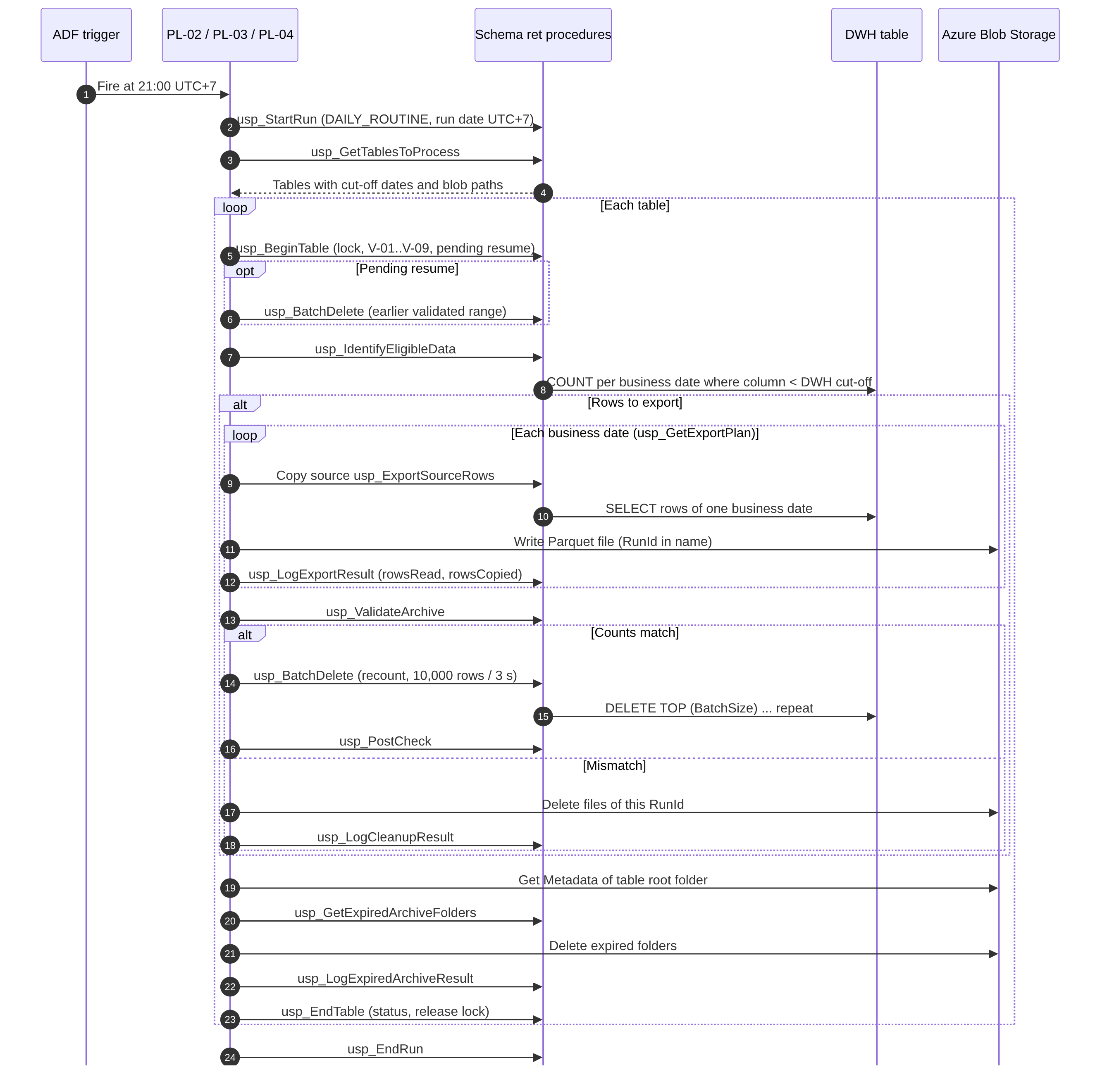
Figure 9 – Daily Routine – sequence of calls for one run
Removal is reached only through the “counts match” branch. Expired folder deletion runs for every table after the DWH branch.

12.2 Initial Cut-off Status – State Diagram
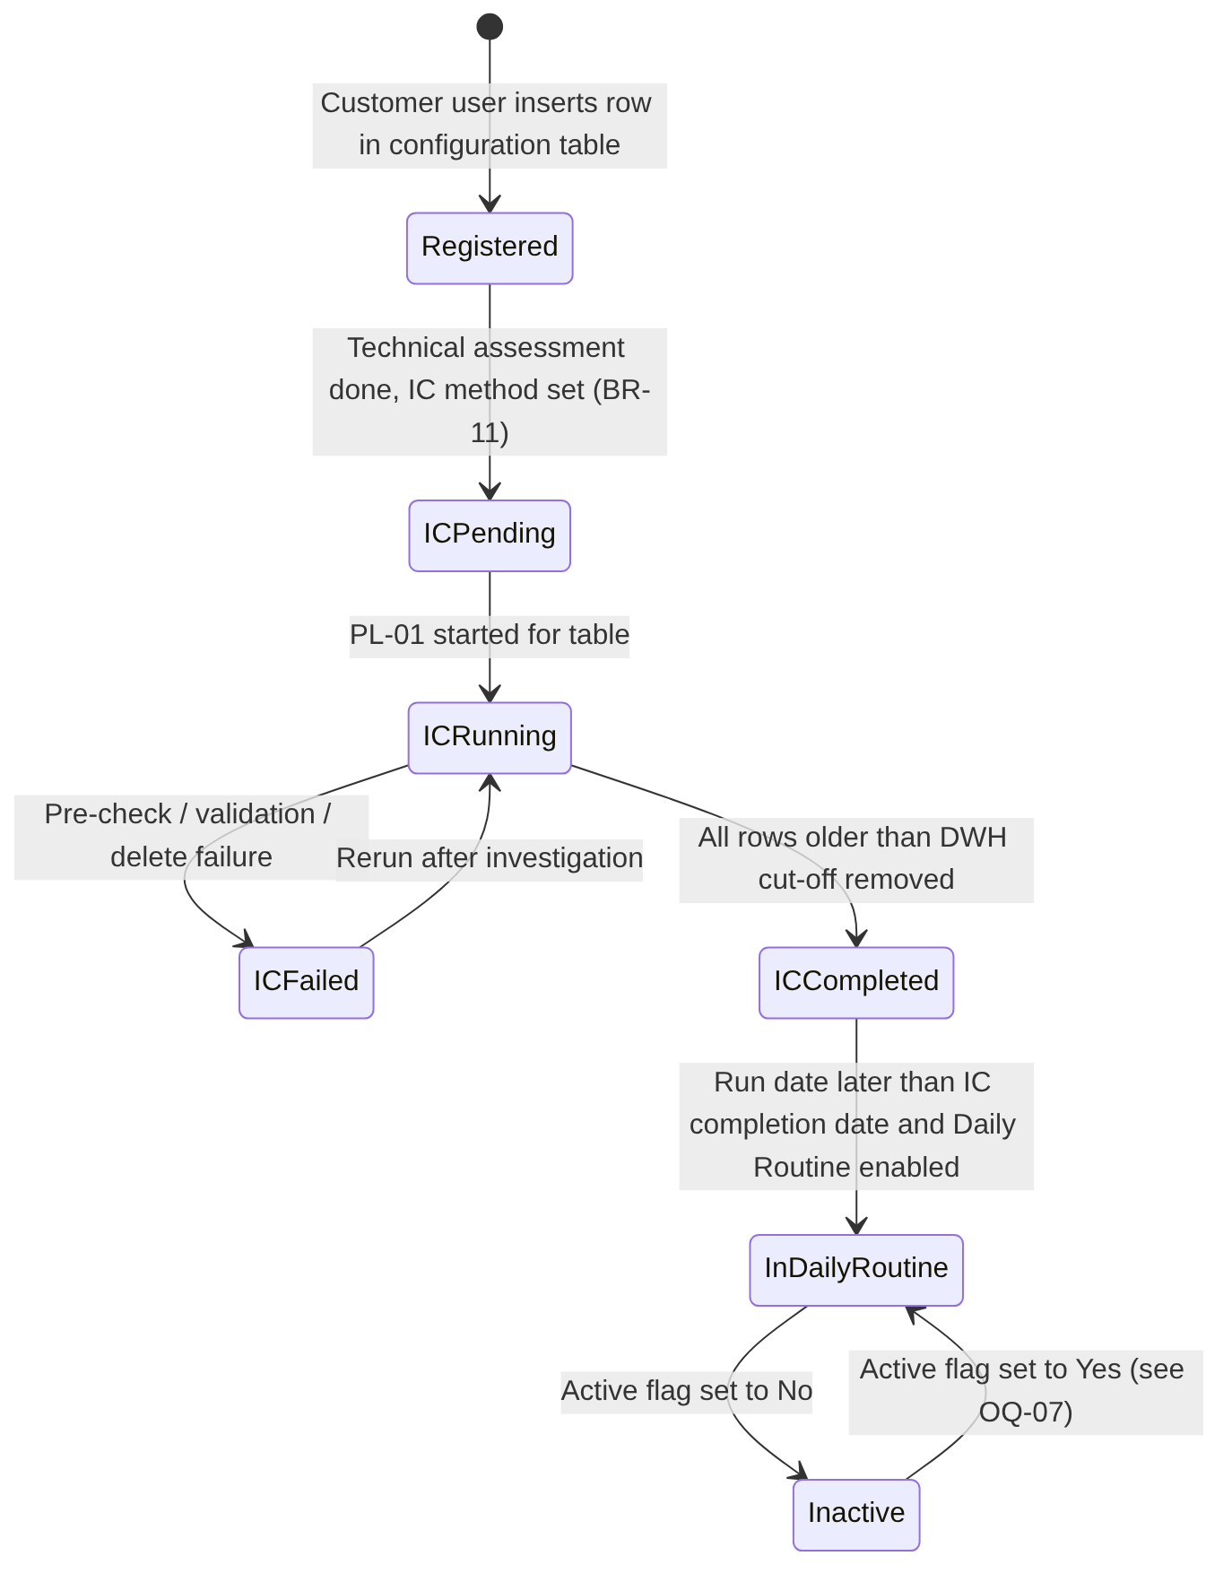
Figure 10 – Initial Cut-off status lifecycle per table
The status decides whether a table can be processed by the Initial Cut-off Run and when it enters the Daily Routine (FR-004, FR-020). STOPPED (window end) behaves like FAILED for selection and is omitted for readability.

12.3 Restart and Recovery – Decision Flow
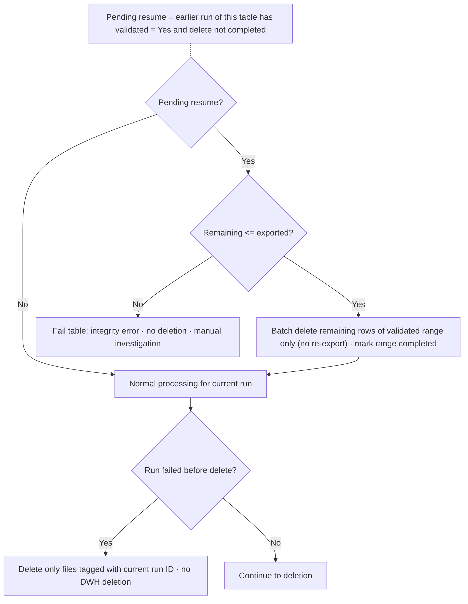
Figure 11 – Restart and recovery decision flow
At the start of every table processing, any validated but unfinished removal is completed without exporting again. A failure before removal deletes only the files tagged with the current RunId.

13. Error Handling and Recovery

13.1 Error Categories and Codes
Error codes are stored in ret.RetentionErrorCode. The table status set by each error is recorded in ret.RetentionTableLog; the run continues with the next table unless stated otherwise. ERR-RBD codes are redefined for the MD-04 rebuild sequence.
Code | Category | Description | Handling | Data change
ERR-CFG-01 to 09 | Configuration / metadata | Validation checks V-01 to V-09 failed | Table FAILED or SKIPPED | None
ERR-CFG-11 | Configuration / child table | V-10: header configuration invalid | Child FAILED; header removal skipped (DBR-19) | None
ERR-CFG-12 | Configuration / child table | V-11: join key not unique in the header table | Child FAILED; header removal skipped | None
ERR-PAR-01 | Child table (warning) | Orphan child rows found (no header row) | Warning; rows kept (DBR-21) | None
ERR-LCK-01 | Concurrency | Table lock held by another run | Table SKIPPED | None
ERR-SYS-01 | Database / connectivity | Query, procedure or connection failure | Table FAILED | None, or resumable state
ERR-SYS-02 | Run date | Supplied run date later than the current UTC+7 date | Run rejected | None
ERR-EXP-01 | Export | Copy activity failed after retries | Files of the run removed; FAILED | None
ERR-EXP-02 | Export | Target file already exists | Files of the run removed; FAILED | None
ERR-EXP-03 | Export cleanup | Files of the failed run could not be removed | Orphan flag; table blocked (V-09) | Orphan files in the archive
ERR-VAL-01 | Validation | Per-date or total row-count mismatch | Files removed; FAILED | None
ERR-VAL-02 | Validation | Recount differs from the validated total | Files removed; FAILED | None
ERR-VAL-03 | Integrity | Resume: remaining rows exceed the expected count | Integrity flag; FAILED | None
ERR-DEL-01 | Deletion | Batch delete failed after retries | FAILED; resumable | Part of the validated range removed
ERR-DEL-02 | Post-check | Rows before the DWH cut-off remain, or retained rows lost | Integrity flag; FAILED | Depends on cause
ERR-DEL-03 | Reconciliation (warning) | Deleted total differs from validated total | Warning flag | Already removed
ERR-RBD-01 | Table rebuild | Failure before truncation (RB-03 to RB-05): new table not built correctly or counts changed | New table dropped; files removed | None
ERR-RBD-02 | Table rebuild | Failure inside the truncate-and-rename transaction (RB-08) | Rolled back; new table dropped; files removed | None
ERR-RBD-03 | Table rebuild | Failure after commit (RB-09, RB-10 definition check) | DBA procedure | Table already replaced
ERR-RBD-04 | Table rebuild | Table not supported for rebuild (RB-01) | FAILED | None
ERR-ARC-01 | Expired archive deletion | Listing or deletion failed | Step FAILED; retried next day | Part of expired folders deleted
ERR-WIN-01 | Window | IC window end reached | STOPPED; resumable | None or partial validated removal
Table 83 – Error categories and codes

13.2 Error Detection
- ADF activity outcomes (success, failure, completion) on every activity of PL-01 to PL-04.
- Result sets of the schema ret procedures (BeginResult, Result, ValidationResult, DeleteResult, CleanupRequired); procedures use TRY…CATCH and return the error number and message.
- Count comparisons and post-checks (Section 10.9).

13.3 Error Logging
Every handled error is written to ret.RetentionTableLog (ErrorCode, ErrorNumber, ErrorStep, ErrorMessage) and ret.RetentionStepLog. The first non-warning error code is kept; later messages are appended. Unhandled ADF failures remain visible in ADF monitoring; the run record stays RUNNING until closed (Section 16.8).

13.4 Retry Rules
Item | Retry approach | Values
ADF Lookup, Stored Procedure, Copy, Get Metadata, Delete activities | ADF activity retry for transient failures (procedures are idempotent per run and table) | Count and interval TBD [REC: non-zero]
Delete batch (deadlock 1205, lock timeout 1222) | Retry the same batch in ret.usp_BatchDelete | DeleteRetryCount (NULL = no retry)
Validation mismatch | No automatic retry (deterministic) | –
Table rebuild | No automatic retry; rerun by the operator | –
Table 84 – Retry rules

13.5 Partial Failure Scenarios
Scenario | State after failure | Next run behaviour
Failure during export | Files of the run removed; DWH unchanged | Full export from the first eligible date
Validation mismatch | Files removed; DWH unchanged | Full export; repeated mismatch needs investigation
Batch delete interrupted | Archive complete for the validated range; part of the range still in the DWH | Resume removes the remaining rows without export (FR-017)
Rebuild fails at RB-03 to RB-07 | Original table unchanged; new table dropped; files removed | Rebuild repeated from RB-01
Rebuild fails inside RB-08 | Transaction rolled back; original table unchanged | Rebuild repeated from RB-01 after investigation
Rebuild fails at RB-09 or RB-10 | Table replaced; dependent views or definition check incomplete | DBA procedure; table FAILED until verified
Expired folder deletion interrupted | Some expired folders remain | Deleted by the next Daily Routine
Pipeline aborted (infrastructure) | Run RUNNING; lock held; possibly a leftover new table of a rebuild | Operator closes the run (usp_AdminCloseStaleRun), drops a leftover __RBD_ table, then the resume logic applies
Cleanup of own files failed | Orphan files; flag set | Blocked until manual cleanup and flag cleared
Child table failed in the Daily Routine | Child rows of the failed range still in the DWH; header removal skipped in that run | Next run processes child first; header removal resumes when the child succeeds
Table 85 – Partial failure scenarios

13.6 Duplicate Processing Prevention
- Pipeline concurrency = 1 for PL-01 and PL-02; table lock (FR-016).
- Unique file names with RunId; no overwrite (DBR-07).
- Removal of own files on export or validation failure (DBR-08).
- Resume without re-export for validated ranges (DBR-09).
- Initial Cut-off status prevents a second Initial Cut-off Run for a COMPLETED table (FR-004).
- usp_StartRun is idempotent per ADF pipeline run ID (ADF activity retry).

13.7 Restart and Rerun Behaviour
Reruns start the master pipeline again (PL-01 with the affected tables, or PL-02 manually) after the cause has been resolved. There is no restart from the middle of a pipeline run; correctness comes from the resume logic and the idempotent procedures. A Daily Routine rerun for the same day uses the same run date and processes only what is still eligible. A supplied run date may only be earlier than today (DBR-15).

13.8 Operational Escalation
No automated alerts are sent (BR-15, OS-06). Failures are found by the daily log review (R-01). Proposed escalation: Operations / Support Team → Solution Architect / Data Engineer → Database Administrator (deletion, rebuild, integrity, capacity) or Infrastructure Team (connectivity, storage). Named contacts and response times are TBD; during hypercare (until 31 March 2027) the project team supports investigation (BRQ-17).

14. Non-Functional Requirements
BRD ID | Requirement | FSD design response | Verification
NFR-01 | Incremental deletion in batches, no long transactions. | FR-009: one short transaction per batch of BatchSize rows with a pause. The table rebuild runs only in the IC within downtime; its insert is batched [REC] and the truncate-and-rename transaction is short (RB-08). | TS-024
NFR-02 | Retention periods configurable without pipeline changes. | FR-001: DwhRetentionYears and BlobRetentionYears per table. | TS-001, TS-007
NFR-03 | Daily Routine without manual intervention. | FR-012 schedule trigger; FR-017 automatic resume. | TS-020, TS-032
NFR-04 | ETL duration ≤ agreed baseline + 10%. | Sequential processing, batch pause, scheduling with the ETL Owner. Baseline TBD (D-06). | TS-038
NFR-05 | Critical ETL jobs within processing windows and SLAs. | IC window control (FR-019). The BRD defines no end time for the Daily Routine (OQ-15). | TS-038
NFR-06 | Report response degradation ≤ 10% of baseline. | As NFR-04; same database resources (R-12). Baseline TBD. | TS-038
NFR-07 | No unplanned reporting downtime. | Rebuild only within approved downtime; batch delete online. | TS-039
NFR-08 | No unexplained data loss or inconsistency. | FR-008, FR-016 to FR-018, rebuild gates (DBR-17), reconciliation controls (Section 10.9). | TS-012, TS-032, TS-035, TS-047
Table 86 – Non-functional requirements

14.1 Additional Quality Attributes
The BRD defines no numeric targets for the following attributes; none are invented here.
Attribute | Expectation | Target
Scalability | Adding tables requires only configuration (FR-001). Run duration grows with the number of tables and eligible dates. | Not defined (TBD)
Capacity | Azure SQL Database service tier limits (storage, log rate, compute) bound the table rebuild and the IC duration. | To be confirmed with the DBA (OQ-24)
Reliability | Fail-safe removal and automatic resume. | Not defined
Availability | Daily execution; no availability SLA for the pipeline itself. | Not defined (no RTO/RPO)
Maintainability | Single source for cut-off logic (ret.fn_GetCutoffDates); parameters in tables; versioned scripts. | –
Auditability | Run, table, archive-date and step logs; configuration audit columns. | Log retention TBD (OQ-20)
Table 87 – Additional quality attributes

15. Security and Audit Requirements
The BRD contains no explicit security requirements. The following are recommendations [REC] based on least privilege and the irreversible nature of the process, adapted to Azure SQL Database. They require review by the DBA and the infrastructure team.
ID | Area | Requirement / recommendation | Status
SEC-01 | Authentication | ADF authenticates to Azure SQL Database and Azure Blob Storage with its managed identity (Microsoft Entra ID), avoiding stored passwords. Method TBD (OQ-17). | REC
SEC-02 | Least privilege – database | The ADF identity receives EXECUTE on the schema ret procedures called by ADF only. Procedures that read or change DWH tables run WITH EXECUTE AS OWNER, because dynamic SQL breaks ownership chaining; the table rebuild therefore runs with owner rights to create, drop and rename tables, which the DBA must accept. | REC
SEC-03 | Configuration maintenance | Customer users: SELECT, INSERT and column-level UPDATE on the Customer-maintained columns of ret.RetentionConfig; no write access to status, parameter or log tables. | REC
SEC-04 | Log access | Operations team: read-only access to schema ret. | REC
SEC-05 | Least privilege – storage | ADF identity: data-plane write and delete on the archive container only. Read access for others TBD (OQ-19). | REC
SEC-06 | Secrets | No credentials, keys or connection strings in this document, pipeline definitions or scripts. | REC
SEC-07 | Dynamic SQL safety | Object names from configuration validated against the catalog and quoted with QUOTENAME; values passed as parameters. | DER
SEC-08 | Audit trail | Configuration audit columns set by trigger (ORIGINAL_LOGIN); optional temporal history of ret.RetentionConfig; manual runs record the operator; operator procedures require a comment. | REC
SEC-09 | Data in transit | Encrypted connections to Azure SQL Database; HTTPS to Azure Blob Storage. | REC
SEC-10 | Data at rest | Azure-managed encryption at rest for the database and the storage account; classification of archived data TBD (OQ-19). | REC
SEC-11 | Segregation of duties | Approval and execution of irreversible steps (Initial Cut-off Run, table rebuild) by different persons; the BRD names one person for all approval roles (OQ-02). | REC
Table 88 – Security and audit requirements

16. Scheduling and Operational Requirements

16.1 Execution Schedule
Process | Schedule | Trigger mechanism | Source
Daily Routine (PL-02) | Every day at 21:00 UTC+7 | ADF schedule trigger, time zone SE Asia Standard Time | BR-18, BRQ-10
Initial Cut-off Run (PL-01) | Once per table within 21:00–05:00 UTC+7 on dates agreed with the ETL Owner | Manual or one-time trigger | BR-17, D-04
Table rebuild | Within approved downtime inside the IC window | Manual trigger with downtime reference | BR-16, D-07
Table 89 – Execution schedule

16.2 Daily Routine Activation
- Confirm from ret.RetentionTableStatus that every active table of the initial implementation is COMPLETED.
- Execute ret.usp_ActivateDailyRoutine with @Confirm = 1; it sets DailyRoutineStartDate to the day after the last completion date.
- Start the ADF schedule trigger with first execution at 21:00 UTC+7 on that date, and record the activation (date, operator).

16.3 Processing Dependencies and Execution Order
- Initial Cut-off Run: SMALL and MEDIUM tables before LARGE tables (BR-16, DBR-05).
- Daily Routine: starts only after activation; tables in ascending TableConfigId order, sequential.
- Within a table: begin → resume → count → export → validate → remove → post-check → expired archive deletion → end.
- An IC for a table added later may run at the same time as the Daily Routine for other tables at 21:00 (R-10); the table lock prevents overlap on the same table.
- Child tables before their header tables: in the IC the operator schedules child tables first and the header IC is refused until they are COMPLETED (DBR-18); in the Daily Routine child tables are ordered first automatically (DBR-19).

16.4 Monitoring
Monitoring uses the log tables (FR-015) and ADF monitoring. A daily log review by the Operations / Support Team is required (R-01). No dashboards or monitoring integrations are built (OS-06, OS-08).

16.5 Operational Alerts
Not applicable: no automated alert or notification is sent (BR-15, OS-06).

16.6 Manual Intervention
Activity | When | Responsible (BRD Section 3 role)
Configuration maintenance | Onboarding and changes | Customer users
Trigger Initial Cut-off Run | Per agreed schedule | Project team with the ETL Owner
Confirm restore point; stop ETL writes for a rebuild | Before each IC / rebuild | Database Administrator / ETL Owner
Activate Daily Routine | Once | Solution Architect / Data Engineer
Daily log review | Daily | Operations / Support Team
Rerun after failure | After cause resolved | Operations / Support Team with Data Engineer
Close stale run, clear flags | After aborted runs or investigations | Data Engineer or DBA (TBC)
Table 90 – Manual intervention activities

16.7 Rerun Procedure
- Identify the failed table and step in ret.RetentionTableLog and ret.RetentionStepLog.
- Resolve the cause (configuration, connectivity, data, permissions, capacity).
- If the run is still RUNNING or a lock is held, confirm in ADF monitoring that the pipeline is no longer active and run ret.usp_AdminCloseStaleRun.
- If an orphan-file flag is set, remove the files of the failed RunId and clear the flag with ret.usp_AdminClearTableFlag.
- If a rebuild left a __RBD_ table, drop it after confirming the original table is intact.
- Start PL-01 (Initial Cut-off Run) or PL-02 (Daily Routine) within the allowed time.
- Verify the result with the monitoring queries.

16.8 Stale Run Handling
A run aborted outside the handled failure paths stays RUNNING. The operator closes it with ret.usp_AdminCloseStaleRun (status FAILED, comment required), which also closes open table logs, resets RUNNING Initial Cut-off statuses to FAILED and releases locks. Automatic closing based on elapsed time is not proposed, because a wrong release could allow concurrent processing.

16.9 Operational Responsibilities
Responsibilities follow BRD Section 3. Names are recorded only where the BRD provides them (Agus Laksono for Business / Data Owner, Project Sponsor, Solution Architect / Data Engineer and Database Administrator).

16.10 Project Deliverables Related to Operations
BRD ID | Deliverable | FSD note
BRQ-15 | Documentation: design, configuration, setup, operational guidance | Operational guide to contain Sections 13 and 16, the monitoring queries (FR-015), the configuration guide (Section 10.6.1, PRC-06) and the rebuild checklist (RB-01).
BRQ-16 | Knowledge transfer sessions | Daily log review, rerun, stale-run handling, configuration changes. Schedule TBD.
BRQ-17 | Hypercare until 31 March 2027 | The project timeline workbook shows one month of hypercare ending 25 January 2027 (OQ-30).
Table 91 – Operations-related project deliverables

19. Assumptions, Constraints, Dependencies, and Open Questions

19.1 Assumptions
BRD assumptions (A-nn) are stated in the BRD and are not independently confirmed. FSD assumptions (ASM-nn) are made by this document.
ID | Description | Impact if false | Clarification | Responsible | Status
A-01 | Retention periods (3 years DWH, 5 years Azure Blob Storage, 8 in total) agreed by the business. | Wrong data removed. | None. | Business / Data Owner | BRD assumption
A-02 | Required database and storage access provided. | Project delay. | D-01, D-02. | Infrastructure Team | BRD assumption
A-03 | Back-dated transactions do not occur. | Rows older than the cut-off may arrive after export; caught by the recount (DBR-06). | None. | Business / Data Owner | BRD assumption
A-04 | Retention columns contain no NULL values. | Rows never become eligible; V-04 fails. | None. | Customer users | BRD assumption
A-05 | Daily database backups remain in place. | No recovery from IC removal (R-02). | None. | DBA | BRD assumption
ASM-01 | Business dates are stored in UTC+7 local time. | Cut-off shifted by seven hours. | OQ-13. | TBD | Open
ASM-02 | The Integration Runtime allows ADF to reach both the database and the storage account. | Design change. | OQ-17. | Infrastructure Team | Open
ASM-03 | In-scope tables can be read while ETL loads recent data. | Export delays or blocking. | Performance testing. | DBA | Open
ASM-04 | Up to about 1,830 business dates per table are within ADF Lookup limits (export plan is paged); folder listings are small with the MD-07 layout. | Paging needed. | Testing. | Solution Architect | Open
ASM-05 | All in-scope tables are in the same database as schema ret (MD-02). | Tables in other databases cannot be processed. | OQ-28. | Business Analyst | Open
ASM-06 | Join keys of child tables are unique in their header tables, and header rows are not deleted outside the retention process. | Child rows become orphans or get several dates. | V-11; OQ-33. | Business / Data Owner | Open
Table 98 – Assumptions

19.2 Technical Constraints
- C-01 to C-05 from the BRD (Section 4.5).
- Azure SQL Database: server time UTC; no cross-database queries; full logging of all data changes; resource limits per service tier.
- No partitioning of in-scope tables (BRD 4.1): removal uses predicate-based batches or the table rebuild.
- No automated alerting (OS-06); network, Integration Runtime and storage provisioning outside scope (OS-05).

19.3 Dependencies
ID | Description | Impact | Clarification | Responsible | Status
D-01 | Network connectivity and Integration Runtime between ADF, the DWH and Azure Blob Storage | Blocks integration testing | Delivery date (R-04); IR type (OQ-17) | Customer infrastructure team | Open
D-02 | Azure Blob Storage account and container | Blocks export | Container name (OQ-08) | Customer infrastructure team | Open
D-03 | In-scope tables and retention columns entered in configuration | Blocks IC | OQ-04, OQ-05, OQ-33 | Customer users | Open
D-04 | Scheduling of each IC with the ETL Owner | Blocks IC execution | Dates | ETL Owner, project team | Open
D-05 | Technical assessment of size limits and exceptions | IC method undefined | OQ-12 | Project team, Customer | Open
D-06 | Agreed performance baseline | NFR-04/NFR-06 unverifiable | OQ-25 | Business / Data Owner, ETL team, DBA | Open
D-07 | Downtime for the rebuild of large tables | Blocks LARGE-table IC | Downtime per table; OQ-11 | ETL Owner, Business / Data Owner | Open
Table 99 – Dependencies

19.4 Open Questions
Item ID | Description | Impact | Required decision or clarification | Responsible party | Status
OQ-01 | BRD v0.1 approval status is inconsistent: header “Draft for Review”, Approval status “Pending approval (version 0.1 approved on 29 October 2026)”, approval table all “Pending”. | The FSD cannot be baselined against a BRD with unclear approval. | Confirm the BRD approval status and correct the document. | Project Sponsor | Open
OQ-02 | Meeting decisions MD-01 to MD-04 have no formal minutes or date; MD-04 is not yet in BRD 5.2. One person holds all approval roles. | Decisions not auditable; no independent review of irreversible steps (SEC-11). | Record the minutes; update BRD 5.2 / BRQ-09; confirm FSD approvers. | Project Sponsor | Open
OQ-03 | 32 candidate tables have no own date column; their retention column is a join query to a header table (Appendix A.2). | Without a decision they could not be processed and their headers could not be processed either. | Decided: option A, retention through the header table (MD-05, FR-023). Remaining items in OQ-32 and OQ-33. | Business / Data Owner, Solution Architect | Closed (MD-05)
OQ-04 | 16 candidates use a last-update timestamp (dtmLastUpdated, dtmLastUpdate) and 1 uses dtmLastWeek as retention column. | A last-update time is not the business date (BRD glossary); rows can be archived or kept by technical update date. | Confirm per table that the column is the business date, or name another column. | Business / Data Owner | Open
OQ-05 | Unconfirmed entries (“?” for JTI_SPV_JoinCallOutletPlan and JTI_SPV_JourneyCall; “All” for dbo.PNL_OPE_Depreciation); backup or duplicate tables in the list (_BK, _backup, _new, BOS_SD_TOTracking in bos and dbo); errors in join queries. | Wrong tables could be archived, or backups kept unnecessarily. | Confirm each entry; decide whether backup tables are in scope or should be dropped by the Customer. | Business / Data Owner | Open
OQ-06 | AC-07 and SC-01 require 100% of tables to have no data before the DWH cut-off after each Daily Routine; BR-08 forbids removal when validation fails. | Criteria cannot be met on a day with a validation failure. | Define how SC-01/AC-07 treat tables with a logged validation failure. | Business / Data Owner | Open
OQ-07 | Inactive tables: should their expired archive files still be deleted? Is a new IC needed on reactivation? | Archive files may be kept beyond eight years. | Decide expiry and reactivation behaviour. | Business / Data Owner | Open
OQ-08 | Archive layout and container: design table default “schema/table/year/month/” conflicted with FolderPath; container name not provided. | Build of FR-007 and FR-013. | Decided: <BlobPath>/year=YYYY/month=MM/day=DD, ArchiveContainer = container name only (MD-07). Container name still to be provided (D-02); design table to be updated (Section 10.6.11). | Infrastructure Team, Solution Architect | Decided; container name open
OQ-09 | How is the number of rows in the Parquet files determined? | Copy metrics may not satisfy a literal reading of BRQ-07. | Approve DEC-03. | Business / Data Owner, Solution Architect | Open
OQ-10 | Daily Routine export of rows older than the archive cut-off (for example after a long outage). | Unnecessary export, or deviation from BR-09. | Confirm BRD behaviour (export, then expiry deletion). | Business / Data Owner | Open
OQ-11 | Table rebuild details: dependent objects of each LARGE table; whether the archive export may run in earlier windows before the downtime. | Rebuild may fail, break dependent objects, or not fit the downtime (R-05, R-11). | Review per LARGE table; approve DEC-13, DEC-14. Treatment of the original table decided (MD-06: truncate and drop). | DBA, ETL Owner | Open
OQ-12 | Size thresholds for SMALL, MEDIUM and LARGE are not defined. | IC method cannot be assigned. | Complete the technical assessment (D-05). | Project team, Customer | Open
OQ-13 | Allowed retention-column data types and the time zone of stored business dates; the table list does not give data types. | V-03 and cut-off correctness. | Confirm types and that stored dates are UTC+7 local. | Business / Data Owner, DBA | Open
OQ-14 | Daily NULL check on large tables requires a scan (DailyNullCheckMode). | Performance versus integrity. | Choose FULL or METADATA for the Daily Routine. | DBA | Open
OQ-15 | No end time or maximum duration for the Daily Routine. | Possible overlap with ETL (NFR-05). | Define a latest end time or accept unbounded duration. | ETL Owner, Business / Data Owner | Open
OQ-16 | Design table has no parallelism parameters. | IC duration for many tables. | Confirm sequential processing (DEC-07) or add parameters. | Solution Architect, DBA | Open
OQ-17 | Authentication and Integration Runtime type for Azure SQL Database and Blob Storage (managed identity, private endpoints). | Security design and connectivity. | Confirm with the infrastructure team (D-01). | Infrastructure Team | Open
OQ-18 | Blob soft delete, versioning or immutability policies on the archive container. | Deleted files may remain recoverable, or deletion may fail. | Confirm policies and their acceptability. | Infrastructure Team, Business / Data Owner | Open
OQ-19 | Data classification of archived data; archive access; retrieval needs. | Access control; possible scope gap. | Confirm classification and access needs. | Business / Data Owner | Open
OQ-20 | Retention period for the log tables. | Unbounded log growth. | Define log retention. | Business / Data Owner, DBA | Open
OQ-21 | Behaviour when retention periods change (no restore of archived or deleted data). | Expectation mismatch. | Confirm Section 8.7. | Business / Data Owner | Open
OQ-22 | Schema changes of in-scope tables after onboarding; change of retention column. | Archive files with different schemas per date. | Define a change procedure. | Solution Architect, DBA | Open
OQ-23 | Is adding an index on the retention column allowed (C-04, OS-03)? | Counting and deletion may scan large tables. | Decide per table in the technical assessment. | DBA, Business / Data Owner | Open
OQ-24 | Azure SQL Database service tier: maximum size, log rate and space for a rebuild (new table and original table exist at the same time). | Rebuild or IC may fail or exceed the window. | Confirm capacity per LARGE table with the DBA. | DBA | Open
OQ-25 | Agreed baseline for ETL duration and report response time (D-06). | NFR-04 and NFR-06 cannot be verified (R-09). | Agree the baseline before performance testing. | Business / Data Owner, ETL team, DBA | Open
OQ-26 | Large-table gate (DBR-05) for tables added after the initial implementation. | Unclear precondition. | Confirm that only the downtime condition applies. | Business / Data Owner | Open
OQ-27 | Reduced history in reports after the IC (OS-04). | Users may see missing data. | Confirm acceptance and communication. | Business / Data Owner | Open
OQ-28 | BRD 7.3 lists “Database name”; the design table omits it; BRD TBC-11 is still open although MD-02 places all objects in one database. | BRD and design differ (DV-01). | Close TBC-11 and update BRD 7.3. | Business Analyst | Open
OQ-29 | BRD 7.3 “Total retention (years)” versus design BlobRetentionYears. | BRD and design differ (DV-02). | Update BRD 7.3 or approve a change request. | Business Analyst | Open
OQ-30 | Hypercare: BRD (IS-13, BRQ-17) until 31 March 2027; timeline workbook one month ending 25 January 2027. | Contractual scope unclear. | Confirm the hypercare end date. | Project Sponsor | Open
OQ-31 | BRD 7.3 example shows schema name “RET” for JTI_SD_BrandDistDetail; the table list shows schema bos, and ret is the schema of the retention objects. | Customer users may enter a wrong schema. | Correct the BRD example. | Business Analyst | Open
OQ-32 | Parent-dated retention (MD-05) is not covered by the BRD: BR-06 and BR-13 assume a retention column of the table itself. | FR-023 has no approved business source. | Raise a BRD change request: amend BR-06, BR-13, BRD 7.3 and add a requirement for child tables (DV-04). | Business Analyst, Project Sponsor | Open
OQ-33 | Join keys of the 32 child tables to be confirmed: errors in the list (BOS_SD_RemainStockInCustItem joins a.szCustId = a.szCustId; dbo.BOS_SD_TOTrackingProduct refers to bos tables; aliases swapped for BOS_PUR_FPoReceipt_sItem); uniqueness of the keys in the header tables; indexes on the child join columns. | Wrong or slow joins; V-11 failures. | Confirm Appendix A.2 per child table during the technical assessment. | Business / Data Owner, DBA | Open
Table 100 – Open questions
Responsible parties are the BRD roles for the subject; they are proposals until confirmed.

19.5 Decisions Required
Item ID | Decision | Options / proposal | Status | Related
DEC-01 | Run date source | Run date = ret.fn_TodayUtc7 (UTC + 7 hours) or an earlier date supplied by ADF; GETDATE() not used because Azure SQL Database runs in UTC. | Proposed | OQ-13
DEC-02 | Status attributes | Separate system-maintained ret.RetentionTableStatus (design table). | In design; approval pending | –
DEC-03 | Parquet row-count method | A: DWH count per date versus Copy rows read/written (proposed). B: read back and count the files (higher cost). | Open | OQ-09
DEC-04 | Archive layout | <container>/<BlobPath>/year=YYYY/month=MM/day=DD/<schema>_<table>_<yyyyMMdd>_<RunId>.parquet; BlobPath lower case; hierarchical expiry deletion. | Decided (MD-07) | OQ-08
DEC-05 | Export mechanism | Copy activity per business date with stored-procedure source ret.usp_ExportSourceRows. | Proposed | RSK-11
DEC-06 | Resume design | Resume validated range without re-export; remove own files on failure. | Proposed | –
DEC-07 | Parallelism | Sequential processing of tables and dates (no parameters in the design table). | Proposed | OQ-16
DEC-08 | Original table after rebuild | Truncate and drop inside the RB-08 transaction. | Decided (MD-06) | OQ-11
DEC-09 | Parameter storage | Single-row ret.RetentionParameter (design table). | In design; approval pending | –
DEC-10 | IC window behaviour | Stop at the window end (export, batch delete); rebuild not interrupted after RB-03. | Proposed | BR-17
DEC-11 | Lock mechanism | ret.RetentionTableLock plus pipeline concurrency = 1. | In design; approval pending | –
DEC-12 | Authentication | ADF managed identity; EXECUTE only; procedures WITH EXECUTE AS OWNER. | Proposed | OQ-17
DEC-13 | Rebuild name swap | Truncate, drop and rename in one transaction (clarifies MD-04 steps 4 and 5). | Proposed | OQ-11
DEC-14 | Rebuild validation gates | RB-05 retained count, RB-07 archive validation and recount, RB-08 re-check before truncation. | Proposed | BR-08
DEC-15 | Child tables without own date column | Option A: retention through the header table (FR-023). | Decided (MD-05); BRD change request pending | OQ-03, OQ-32
Table 101 – Decisions required

19.6 Risks and Potential Impacts
BRD risks R-01 to R-12 remain valid and are addressed as follows: R-01 (FR-015, Section 16.4), R-02 (RB-01, PRC-02 precondition), R-03 (accepted), R-04 (D-01, D-02), R-05 (RB-01, OQ-11), R-06 (RB-03 batching, OQ-24), R-07 (FR-002), R-08 (Section 16.10), R-09 (OQ-25), R-10 (FR-016, TS-031), R-11 (FR-019, Section 8.4 note), R-12 (batch delete, TS-038). Additional risks:
ID | Risk | Likelihood | Impact | Mitigation | Status
RSK-11 | Per-date export in the IC (about 1,830 Copy activities per table for five years) takes longer than the window. | Medium | Medium | Performance test; window stop and resume (FR-019); export in earlier windows (OQ-11). | Open
RSK-12 | Dynamic SQL with configuration values could fail or be misused. | Low | High | SEC-07; V-01, V-02. | Open
RSK-13 | ADF Get Metadata output limits exceeded. | Low | Low | Hierarchical layout limits each listing to about 31 items (MD-07). | Open
RSK-14 | Schema changes over time produce files with different schemas. | Medium | Low | OQ-22. | Open
RSK-15 | Stale locks after aborted runs block processing. | Medium | Low | Section 16.8; daily log review. | Open
RSK-16 | No index on the retention column makes counting and deletion slow and lock-heavy. | Medium | High | OQ-23; technical assessment. | Open
RSK-17 | Log writes fail and executions are not recorded (SC-04). | Low | Medium | ADF monitoring as secondary record. | Open
RSK-18 | Copy metrics do not detect a corrupt file written after counting. | Low | High | DEC-03 option B or sampled read-back. | Open
RSK-19 | Child and header tables become inconsistent (child rows orphaned or header removed before child). | Medium | High | Ordering and gates DBR-18, DBR-19; orphan rows kept (DBR-21). | Open
RSK-20 | ETL writes during a rebuild are lost when the original table is truncated. | Medium | High | DBR-16, DBR-17; count checks RB-05, RB-07, RB-08. | Open
RSK-21 | Insufficient database space for the new table during a rebuild of a large table. | Medium | High | RB-01 capacity check; OQ-24. | Open
RSK-22 | EXISTS joins on large child tables (up to 111 million rows) are slow without indexes on the join columns. | Medium | High | Index check in the technical assessment (OQ-23, OQ-33); performance test. | Open
Table 102 – Additional FSD risks

